AROOSTOOK COUNTY
HAZARD MITIGATION PLAN

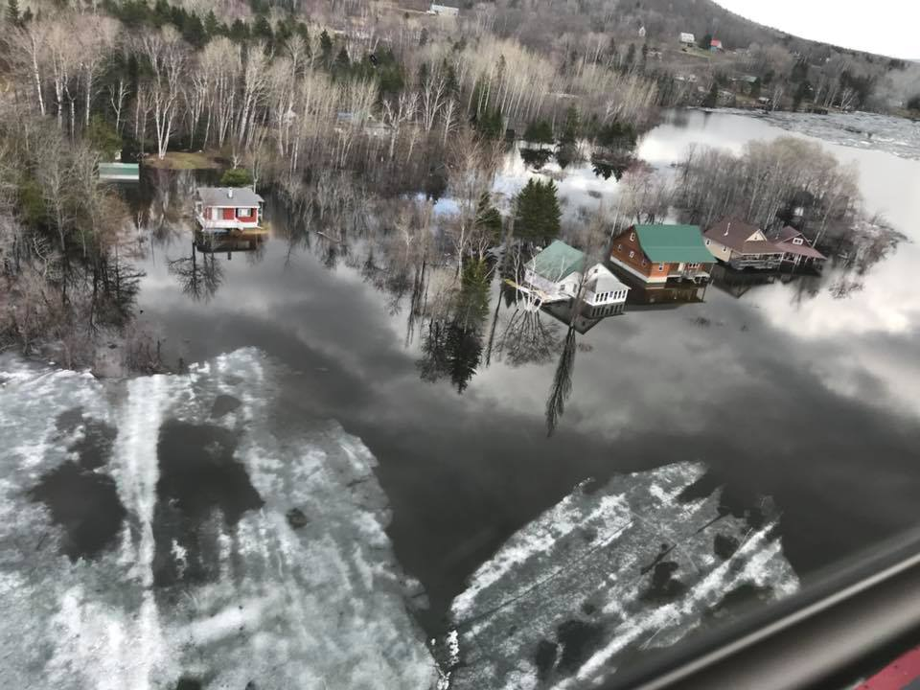

Photo by Aroostook County Emergency Management Agency

Prepared By:

Aroostook County
Emergency Management Agency

2021 Update

