Agency
Warming and Cooling Centers Operations Guide

Definition of Centers

- A Warming or Cooling Center is a temporary facility that is made available during extreme temperature conditions when normal coping mechanisms in the home are ineffective or unavailable.

- During power outages Centers can be opened to provide public information, charging stations for electronic devices, and power for medical equipment.

- Centers are not overnight shelters or homeless shelters. They are open for a limited number of hours for a limited number of days and provide limited services. Centers are not day care for children, the elderly, or others who cannot care for themselves. It is assumed that individuals who use the Centers can return to their homes when the Centers are closed.

How to Use the Operations Guide

- This Operations Guide is a tool for municipalities, non-profits, faith-based organizations, and others that intend to operate a warming or cooling center.

- All elements of the Operations Guide might not be relevant or required in all situations or in all jurisdictions. A Center can scale up or down (expand or contract) throughout an incident. The cause, scope, and duration of the incident, the demographics of the community, and the available resources will drive decisions about the size of the Center, the hours of operation, and the services that are provided.

- This Operations Guide contains the most common elements of Warming and Cooling Centers. Additional considerations might be required. Operators should tailor the Operations Guide to the unique aspects of their jurisdiction.

- Before opening a Center, operators should consult with their legal counsel and insurers to determine if all legal requirements are met and liability issues are covered.

- Complete the Directory for your jurisdiction.

Coordination with Emergency Management Agencies

The operation of Centers, especially during large-scale emergencies and disasters, should be coordinated with the emergency management system in the municipality and county where Centers are opened to
- Ensure that the Center is meeting all applicable laws and regulations.
- Avoid duplicating efforts of other agencies/organizations.
- Obtain support from a broader system if public needs exceed the operator’s capabilities (e.g., transition to an overnight shelter, access to social services, additional staffing); and
- Maintain situational awareness (knowing what is going on with all aspects of the emergency) so that operators can make informed decisions.

The Maine Emergency Management Duty Officer should be notified at 207-851-8898, when Centers are opened. The MEMA Duty Officer will notify the MEMA Individual Assistance Officer and Mass Care Coordinator. MEMA Individual Assistance Officer and/or Mass Care Coordinator will notify the MEMA Public Information Officer and 211 Maine that Centers are being opened.

Opening and closing of Centers will be posted on the Maine Emergency Management Agency (MEMA) WebEOC, platform by the MEMA Individual Assistance Officer or Mass Care Coordinator when notified by Local Municipal or County Emergency Management Agency of a Center Opening.

If a Center is to be part of a larger response, successful coordination with other parts of the response requires that operators be trained in the National Incident Management System (NIMS) and the Incident Command System (ICS). Free online training is provided by the Federal Emergency Management Agency (FEMA). ICS forms might be used in lieu of the forms provided in this Guide.

Services

- Prior to opening Centers, operators should determine the services that the public will need and the operator’s ability to meet them. Minimal needs include tables and chairs, television, charging stations, and information updates regarding the incident. Prolonged or particularly severe temperature conditions might require expanded services.

- If food is to be provided, consultation with the local health authorities is especially important before opening a Center. Pre-planning might be required to meet health regulations.

- Staff who are certified in psychological first aid, first aid, cardiopulmonary resuscitation (CPR), and automated external defibrillation (AED) should be available during operating hours. Medical services beyond first aid are not provided at Centers.

- Staff should be aware of how they can support individuals with functional needs. Service animals must be allowed to accompany their owners. The Center facility must be compliant with the Americans with Disabilities Act (ADA).

- Operators should be prepared to accommodate pets.

Facilities

Facilities should be selected carefully to ensure that:
- Public transportation stations are nearby and available.
- Features are compliant with the Americans with Disabilities Act (ADA) (See www.ada.gov.);
- Safety hazards are mitigated.
- Roads to the facility are kept open.
- The facility is available for the duration of the incident.
- The space will accommodate the expected number of people.
- Kitchen facilities are available if food is to be served.
- The heating/ventilation/air conditioning system is operable, or generators are available;
- Lavatory capacity is sufficient for the expected number of people;
- Number of electrical outlets is sufficient for charging stations and medical equipment;
- Refrigeration is available for medications; and
- Space is available for specialized purposes (e.g., first aid, play, quiet, pets).

Staffing

- Centers can be operated by volunteers and/or employees of government agencies or non-governmental organizations (e.g., non-profit, faith-based, community).

- All staff members should receive the following training:
- National Incident Management System: https://training.fema.gov/is/courseoverview.aspx?code=IS-700.a
- Incident Command System: https://training.fema.gov/is/courseoverview.aspx?code=IS-100.b and https://training.fema.gov/is/courseoverview.aspx?code=IS-200.b
- Including Individuals with Functional Needs: https://training.fema.gov/is/crslist.aspx?all=true
- Psychological First Aid: http://www.nctsn.org/content/psychological-first-aid
- First Aid/CPR/AED
- Bloodborne Pathogens
- Food Safety

- All staff members should receive Job Action Guides for the tasks they will perform (e.g., ensuring health and safety of all guests and staff; greeting guests; signing them in; orienting them to the Center; making them comfortable; assisting with charging of electronic devices; providing verified information about the emergency; assisting individuals with functional needs and accommodating diverse populations; assisting with pets; ensuring food safety; and maintaining records).

When to Open a Center

The existence of several factors could lead to the opening of Centers:
- Wind chill (combination of temperature and wind speed) and heat index (combination of temperature and humidity) as indicated by the National Weather Service (NWS) in the following charts. Center operators will need to determine the levels that will trigger the opening of Centers in their jurisdiction.
- Power outages that render heating and cooling system inoperable; and
- Individuals without heating or cooling in their homes.

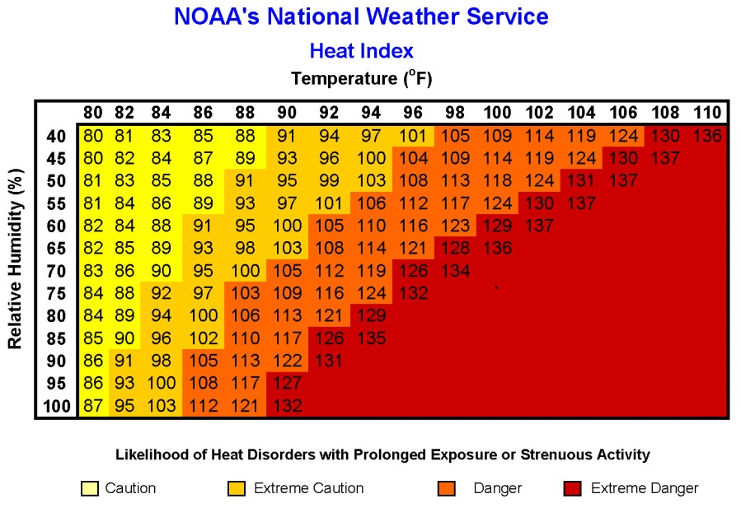

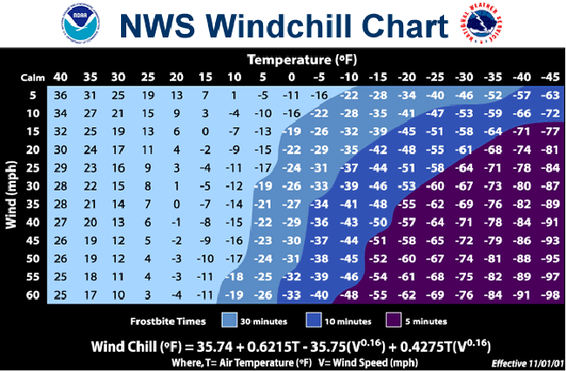

Transitioning to a Shelter

A Center is designed for non-continuous (non-24/7) operation. If a heat or cold-related emergency persists or is predicted to persist beyond the operational hours of the Center, and it is not safe for individuals to return to their homes, a shelter might need to be opened.

Before an emergency occurs, Center operators should discuss the logistical and legal considerations involved in operating a shelter with their legal counsel and the American Red Cross. Options are as follows:
- Shelter operated by the American Red Cross.
- Shelter operated jointly by the American Red Cross and another agency or organization.
- Shelter operated by an agency or organization and supported by the American Red Cross; or
- Shelter operated by an agency or organization without American Red Cross involvement.

If a shelter is being considered, Center registration personnel should poll the Center guests to determine who will be able to return to their homes safely and who will require overnight sheltering.

If a shelter is required and Center operators have chosen to employ model 1 or 2 above, the Center operator should contact the American Red Cross. Contact American Red Cross 24-hour Disaster Services 1-833-583-3111 to request Shelter Assistance.

If the operators have chosen model 3 or 4, they should activate their shelter plan.

Sheltering is beyond the scope of this Guide, so if Center operators have chosen to employ model 3 or 4 above, they will need to write a separate sheltering plan that begins with the decision to open a shelter.

Warming & Cooling Center Checklist

Before an Incident

1 | Educate the public.
- Identify outreach opportunities.
- Consider all segments of the population (e.g., individuals with functional needs, pets)
- Determine information to be disseminated (e.g., prevention of heat and cold illnesses)
- Develop pre-scripted social media/mass notification messaging.
- Secure printed materials in languages prevalent in the community.
- Train presenters if presenting to groups.
- Disseminate information.

2 | Determine triggers for opening and closing Centers.
- Heat Index
- Wind Chill
- Power Outages
- Anticipate the need for shelter operations. Review your shelter plans and/or consult with the American Red Cross for shelter guidance.

3 | Determine methods of notifying the public of Center availability.
- Mass notification system (phone, email, text, door-to-door, public access television, radio, television, social media)
- Notification methods for individuals who are blind or who have low vision and individuals who are deaf or hard of hearing.
- Public Information Officer (PIO) to handle media inquiries.

4 | Determine transportation service needs.
- For individuals with disabilities and access and functional needs (e.g., wheelchairs, service animals)
- For individuals who are not near public transportation or the Center is not near public transportation
- For individuals who rely on public transportation that may not be operating an emergency

5 | Determine potential facilities and establish Memorandum of Understanding (MOU) with owners.
- Near public transportation  - Adequate capacity  - Easy to find  - Ample, free parking  - ADA-compliant  - Intact HVAC  - Generator |  | - Ample electrical outlets  - Lavatories  - Large common area  - Rooms for specialized purposes (e.g., first aid, play)  - Accommodations for pets  - Health authorities consulted about food service

6 | Determine personnel.
- Center Manager  - Registration Workers  - Disaster Animal Response Team  - Health Authorities  - Custodians  - Fire Inspector  - Security |  | - Safety Officer  - Volunteer Manager  - Interpreters  - First Aid/CPR/AED Providers  - Food Servers  - Parking Lot Attendants  - PIO

7 | Determine equipment, supplies, and forms. Store at facilities, if possible.
Office  - Tables/Chairs  - Television  - Battery-powered Radio  - Weather Radio  - Small Refrigerator for Medications  - Forms  - Office Supplies  - Radios (Communications)  - Batteries  - Surge Protectors  - Fire Extinguisher  - Flashlights  - Signage  - Staff Identification (vests, shirts, badges)  Registration and Common Area  - Tables/Chairs  - Registration Forms  - Pens  - Hand Sanitizer  - Waste Containers  - Charging Stations  Dining  - Tables/Chairs  - Table covers  - Plates, Cups, Napkins, Utensils  - Food Service Gloves  - Cooler, Ice  - Food Thermometer  Information  - Bulletin Board/Pushpins  - Easel/Newsprint/Markers  First Aid  - First Aid Kit/AED  - Personal Protective Equipment  - Cots/Blankets |  | Entertainment Area  - Television/DVD Player  Play Area  Pet Area (To be supplied by owner)  - Registration Forms/ID tags  - Crates, leashes, muzzles  - Food/water with bowls  - Disposable pads/cleaning supplies  - Litter Boxes/Litter  Indoor Signage/Tape  - Registration  - Hours of Operation  - Rules of Conduct  - Common Area  - Dining Area  - Information Area  - Entertainment/Play Area  - Emergency Exits  - Evacuation Plan  - Lavatories  Outdoor Signage/Tape  - Street signs  - Door signs  Forms  - Media Release Templates  - Directory  - Registration  - Ground Rules  - Staff Check-In/Out  - Resource Check-in/Out  - Resource Request  - Staff Hours Tracking  - Expense Tracking  - Inventory  - Injury/Illness Report  - Safety and Security Incident Report  - Activity Log  - Job Action Guides  - Work Schedule

8 | Determine policies and procedures.
- Who will authorize the opening and operation of the Center?
- Will assistance be required from the American Red Cross or other organizations?
- How will the Center be financed?
- Does the facility and operator of the Center have appropriate insurance?
- Will personnel be paid, volunteer, or both?
- How will personnel be vetted and credentialed?
- What will the hours of operation be?
- Will registration be required?
- What will the scope of service be (e.g., seniors only)?
- How will registered sex offenders be accommodated?
- What is the policy for unaccompanied minors?
- Will food, snacks, beverages be served?
- How will food, snacks, and beverages be procured?
- How will media requests to visit the Center be handled?
- How will you handle offers of donated food and other goods?
- Where will pets be housed? Another area of Center facility or a different facility?
- How will pets be housed? (Service animals must be permitted to remain with owners.)
- Will emotional support animals be permitted in the Center?
- Animals cannot have fleas and must have up-to-date rabies vaccination.
- No toys, books, stuffed animals due to possibility of pest infestations (e.g., bed bugs).
- What will the Rules of Conduct be?
- Guests must check in and out.
- Respect people, personal property, and privacy. No weapons, alcohol, illegal drugs, matches, or tobacco use.
- No photographs may be taken.
- Media must be accompanied by the Center Manager
- News updates and emergency information will be posted at a designated location within the Center.
- Prescription and over-the-counter drugs in original containers only
- Service animals permitted in Center. Pets/therapy animals in Pet Area only.
- Children must always be supervised.
- Keep items off the floor to prevent trips and falls and for wheelchair accessibility.
- Guests are responsible for their own valuables.
- Center is not liable for loss or damage to personal vehicles or property.
- Appropriate dress, including shirts and shoes, always required.
- Share electrical outlets and charging stations.
- Wash hands frequently, especially after using the lavatory and before handling food.
- Management reserves the right to remove individuals from the Center for non-compliance with conduct rules.

During an Incident

9 | Initial Assessment
- Consult National Weather Service and the NOAA for information.
- Temperatures to be expected.
- Do expected temperatures meet criteria?
- Expected duration of the incident?
- Number of calls from the public?
- Number of people to expect at the Center.
- Demographics of expected population (e.g., functional needs, pets)?
- Services that will be needed?

10 | Activation
- Receive authorization to open Center from appropriate person in municipality/organization.
- Select facility.
- Receive agreement from facility and activate MOU, if applicable.
- Activate paid and volunteer staff. Emphasize no self-deployment.
- Move equipment and supplies to facility if not already staged there.
- Notify the following entities that a Center is being activated. (Refer to Directory for contact information.)
- Law enforcement of potential traffic increase and need for security
- Fire inspector
- Health authorities
- Office of Emergency Management (Municipal and County)
- American Red Cross

Notify the MEMA Duty Officer Provide the following information:
- Your organization’s name
- Street address and travel instructions, such as nearest intersection
- Phone number
- Is the facility accessible for individuals with functional needs?
- Services available
- Items that guests should bring
- Hours open
- Who qualifies?
- Fees
- Required documents
- How to access (walk in?)
- Determine a transportation plan.

11 | Set Up
- Set up separate areas – Registration, Common, Dining, Information, Entertainment, Play, Quiet, Pets
- Determine off-limits areas.
- Post indoor signage. Outdoor signage should be posted just prior to opening.
- Inspect facility. Note existing damage. Mitigate hazards.
- Brief staff. Provide Job Action Guides.
- Ensure all staff are assigned and trained according to their capabilities.

12 | Notification
r When Center is operational, notify:
- Maine Emergency Management Agency Duty Officer
- Public through mass notification systems, media/social media, internet sites
- Use templates to craft your message.
- Include location, dates, and hours of operation of Center.
- Inform public of transportation options.
- Explain provisions for pets.
- Provide safety information.

13 | Ongoing Operation
- Mitigate health and safety hazards. Ask everyone to report unsafe conditions.
- Document all staff hours and expenses.
- Establish shift and break schedules.
- Ensure that no one works past the maximum number of hours.
- Ensure that there are never fewer than two workers per shift.
- Ensure that an activity log is maintained (i.e., document all unusual circumstances on the designated form).
- Ensure that reports are completed for each incident of illness or injury to staff and guests.
- Ensure that guests check in and out whenever they enter or leave the premises.
- Determine at Registration if guests have special dietary needs.
- Ensure snacks and water are always available.
- Determine when meals will be served, source of the meals, and food to be served. Consider special dietary needs.
- Transport guests to and from the Center according to transportation plan.
- Provide first aid by qualified individuals.
- Assist guests with functional needs.
- Ensure that food preparation and service areas comply with health department regulations.
- Refer donors to Center Manager. Consult with health authorities regarding donated food.
- Ensure sanitary conditions in all areas.
- Report daily census to County Emergency Management Agency.
- Begin planning for next operational period.
- Talk to guests to ensure that their needs are being met.
- Monitor need for scaling up, scaling down, and demobilizing.

14 | Closing
- Give 24-hour notice of Center closing.
- Notify
- Employees and Volunteers
- Guests
- Offices of Emergency Management (Municipal and County)
- 211 Maine
- American Red Cross
- Media/social media, internet sites
- Law Enforcement
- Fire Inspector
- Health Authorities
- Ensure that all guests have transportation to their residence.
- Remove outdoor signage at closing time.
- Ensure equipment is clean and in good working order before storing.
- Repair or replace damaged equipment and/or signage.
- Replenish expended supplies.
- Ensure that facility is returned to its pre-activation condition or better.
- Inspect facility with owner and document concerns.
- Debrief staff and guests.
- Collect and file paperwork (registration, check-in/out, activity logs, tracking sheets, injury/illness reports).

After an Incident

15 | Follow up
- Conduct an after-action meeting to include all paid and volunteer staff.
- Determine successes, shortfalls, and suggestions for improvement.
- Write an Improvement Plan with individuals assigned to accomplish objectives.
- Assign an individual to ensure that suggested improvements are implemented.
- Put new procedures into place for the next Center as needed.

Media Release
For Immediate Release
Date:
Contact:
Organization:
Address:
E-mail:
Phone:

Notice of [Warming/Cooling] Center Opening

In response to the [name of emergency], the [organization name] is operating a [Warming/Cooling] Center at [building name and address]. The facility complies with the Americans with Disabilities Act.

The Center is open to [general public/residents of ______].

Operating hours are daily from _________ to __________ until further notice.

Individuals who need transportation to the Center should call [organization] at ________________.

The following services will be available:
- [Electrical outlets for charging electronic devices and operating medical equipment]
- [First Aid (call 9-1-1 for serious injuries or illnesses)]
- [Food/snacks and water]
- [Information about the current situation]
- _________________________________________

Service [and emotional support] animals are permitted in the Center. Pets will be accommodated at [building name and address]. Owners should expect to toilet and feed their animals.

Residents should bring their disaster kit, including:
- Prescribed Medications/Medical Supplies
- Electronic Devices and Charging Cords
- Pet crates, food/bowls, leashes, muzzles, litter/litter boxes, and disposable pads.
- _____________________________

[Provide safety information.]

For information call _________________________. Do not call 9-1-1 except for life-threatening emergencies that require police, fire, or emergency medical services.

###
Media Release
For Immediate Release
Date:
Contact:
Organization:
Address:
E-mail:
Phone:

Notice of [Warming/Cooling] Center Closing

In anticipation of [temperatures returning to normal levels/power restoration], the [organization] will be closing the [Warming/Cooling] Center at [building name and address] on [date] at [time].

Individuals who require transportation to their homes should contact the Center Manager.

Individuals who cannot safely return to their homes should contact the United Way 2-1-1 for alternate accommodations.

[Provide safety information for returning home.]

For information call _________________________. Do not call 9-1-1 except for life-threatening emergencies that require police, fire, or emergency medical services.

###

Directory
(To be completed by Center Manager)

American Red Cross  (If shelter must be opened) |  |  | 24-hour Disaster Services 1-833-583-3111
Center Manager
Local Emergency Management Director
County Emergency Management Director
Custodian(s)
City or Town Manager
General Assistance or Social Services Administrator
Disaster Animal Response Team
Dispatch Center Non-emergency
Facility Owner
Fire Chief
Fire Inspector
Fire Non-emergency
Interpreters (Foreign languages and sign language)
Media Contacts
Police Chief
Police Non-emergency
Public Information Officer
Safety Officer
Maine Department of Health and Human Services |  |  | (207) 795-4300
The Salvation Army
2-1-1 Maine  (For health and human services referrals) |  |  | www.211maine.org or 1-877-463-6207
Volunteer Manager
County Administrator
Maine Emergency Management Agency Duty Officer |  |  | 207-851-8898
Warming/Cooling Center Registration
Yes No 1. Do you or does anyone in your household need medical care or have safety concerns right now?
Yes No 2. Are you or anyone in your household required to register with a state or local government agency?
Yes No 3. Do you or does anyone in your household need transportation assistance?
Contact Information for Service:

Date/Time Arrival: |  | Date/Time Departure:
Name of Registrant: |  | Gender: |  |  | Birth Date:
Street Address:
City, State, Zip:
Phone:
Other Household Members (Attach additional sheet if necessary.)
Name: |  | Gender: |  |  | Birth Date:
Name: |  | Gender: |  |  | Birth Date:
Name: |  | Gender: |  |  | Birth Date:
Name: |  | Gender: |  |  | Birth Date:
Emergency Contact Information
Name of Contact #1: |  | Phone: |  |  | Relationship:
Name of Contact #2: |  | Phone: |  |  | Relationship:
Service Animal/Emotional Support Animal
r Dog r Miniature Horse r Emotional Support Animal
Which household member uses the services of the animal?
What service(s) does the animal perform?
Pets
Name: | Type: |  |  | Color:
Name: | Type: |  |  | Color:
Special Dietary Needs /Accommodations
Actions/Referrals

Ground Rules

- ___________________________________________________________________
- ___________________________________________________________________
- ___________________________________________________________________
- ___________________________________________________________________
- ___________________________________________________________________
- ___________________________________________________________________
- ___________________________________________________________________
- ___________________________________________________________________
- ___________________________________________________________________
- ___________________________________________________________________
- ___________________________________________________________________
- ___________________________________________________________________
- ___________________________________________________________________
- ___________________________________________________________________
- ___________________________________________________________________
- ___________________________________________________________________
- ___________________________________________________________________
- ___________________________________________________________________

Inventory

Quantity | Item | Storage Location
Resource Check-In and Out

Quantity | Item | To Whom | Time Out | From Whom | Time  In

Resource Request
Submit to Resource Distributor
Center Manager Approval Required

Quantity | Item | Requested By | Date | Time

Work Schedule

Shift Date | Shift Times | Position | Worker Name

Staff Check-In and Out

Date __________________________________________________

Location __________________________________________________

Name | Time In | Time Out

Staff Hours Tracking

Date __________________________________________________

Location __________________________________________________

Approved By __________________________________________________

Name | Organization | Volunteer/Paid | Time In | Time Out | Total Time
 |  | r Volunteer r Paid
 |  | r Volunteer r Paid
 |  | r Volunteer r Paid
 |  | r Volunteer r Paid
 |  | r Volunteer r Paid
 |  | r Volunteer r Paid
 |  | r Volunteer r Paid
 |  | r Volunteer r Paid
 |  | r Volunteer r Paid
 |  | r Volunteer r Paid
 |  | r Volunteer r Paid
 |  | r Volunteer r Paid
 |  | r Volunteer r Paid
 |  | r Volunteer r Paid
 |  | r Volunteer r Paid
 |  | r Volunteer r Paid
 |  | r Volunteer r Paid
 |  | r Volunteer r Paid
 |  | r Volunteer r Paid
 |  | r Volunteer r Paid
 |  | r Volunteer r Paid
 |  | r Volunteer r Paid

Expense Tracking

Date __________________________________________________

Location __________________________________________________

All expenditures must be authorized by the Center Manager.
Item | Vendor | Unit Cost | Quantity | Total Cost

Warming/Cooling Center
Injury/Illness Report

1. Date | 2. Time | 3. Location/Address

4. Name of Injured/Ill Person | 5. Date of Birth | 6. Affiliation (If Any)
7. Address | 8. Phone | 9. E-mail

10. Nature of Illness or Mechanism of Injury

11. SAMPLE History
Signs/Symptoms
Allergies
Medications/Medical Conditions
Pertinent Past History
Last Oral Intake
Events Leading to the Incident

12. Narrative

13. Care Provided

14. Disposition | 15. Instructions Provided
r Transported by EMS
r Released to ___________________
r Released to self
r Left Center
r Remained at Center

16. What steps were taken to prevent a recurrence?

17. Witness #1 Name | 18. Phone | 19. E-mail
20. Witness #2 Name | 21. Phone | 22. E-mail

23. Name of First Aid Provider #1 | 24. Name of First Aid Provider #2
25. Name of First Aid Provider #3 | 26. Name of First Aid Provider #4

27. Signature of Injured/Ill Person | r Signature unavailable due to nature of the incident.

28. Name of Person Completing Report

29. Signature of Attending First Aid Provider | 30. Name Printed

Warming/Cooling Center
Safety and Security Incident Report

1. Date | 2. Time | 3. Location/Address

4. How was incident discovered?
r Observed by Security r Observed by Safety Officer r Reported by Staff r Reported by Guest

5. Nature of Incident
r Safety Hazard r Unruly/Uncooperative Individual/Group r Violence/Threat of Violence

r Other ____________________________________________________________________________

Was 9-1-1 was called? r Yes r No Time of Call ____________ Time of Arrival _____________

Case Number, if applicable______________________________________________________________

6. Description of Incident

7. Action(s) Taken

8. Parties Involved in Incident
Name #1 | Date of Birth | Phone
Address
Name #2 | Date of Birth | Phone
Address
Name #3 | Date of Birth | Phone
Address
Name #4 | Date of Birth | Phone
Address

9. Outcome of Incident
r Hazard mitigated by _________________________________________________________________
r Incident resolved. Party/parties remained on premises.
r Unruly/uncooperative individual/group left premises.
r Law Enforcement (9-1-1) arrived and assumed control of incident.
r Other _______________________________________________________________________

10. Staff Involved in Incident
Name #1 | Name #2
Name #3 | Name #4

11. Responding Law Enforcement Agency(ies) | 12. Responder Names
 | Name #1
 | Name #2
 | Name #3

13. What steps were taken to prevent a recurrence?

14. Name of Person Completing Report | 15. Signature

16. Name of Safety Officer or Security Worker | 17. Signature

18. Name of Center Manager | 19. Signature
Warming/Cooling Center Activity Log

Date: | Location:

Time | Major Events | Personnel Involved | Actions Taken

