AROOSTOOK COUNTY EMERGENCY MANAGEMENT AGENCY

Small Unmanned Aerial Systems (sUAS)

STANDARD OPERATING POLICY

Effective March 2025

Contents

- Preamble PG.3
- Objective PG.3
- Standard Operating Policy:
  - Aroostook County sUAS Capabilities PG.3
  - Area of Operations PG.4
  - UAS Mission Intent PG.5
  - Mission Vetting PG.5
  - Prohibited Uses PG.6
  - Compliance with Maine Law PG.8
  - Transparency of Operations and Use PG.9
  - Deployment PG.9
  - Operations PG.10
  - Communications & Coordination PG.11
  - Maintenance Requirements PG.11
  - Training PG.12
  - Reporting Requirements PG.12
  - Pre-flight & UAS Set up Checklist. PG.14
  - Mission Planning Worksheets PG.14
- Complaints PG.16
- Attachments PG.17 - 22
- NFPA Guides/Resources (FRAT, Preflight list, P.A.V.E. etc.)
- Complaint From

Preamble
Operations of sUAS are Mission Based and not specifically aircraft based. Small Unmanned Aerial Systems and Small Unmanned Aerial Vehicles are interchangeably in this document. This policy is to be reviewed and revised every three years or sooner on an as needed basis.
OBJECTIVE
To utilize small unmanned aerial systems (UAS) in support of an emergency incident on behalf of the Aroostook County Emergency Management Agency (AKEMA) in support of another local or state agency to provide video, still photography, audio, or some other legal and authorized capability. The drone program situational use is emphasized for flood monitoring, difficult remote access (ie, Bogs or swamps) situations, Fires and disaster Surveys. The UAS is to be flown in accordance with state and federal laws including but not limited to the Federal Aviation Administration (FAA) with safety as the first priority to protect responders, victims, and the aircraft itself. AKEMA is responsible as the registered owner to ensure the UAS is airworthy and that it is operated and maintained in strict compliance with the manufacturer’s operational and maintenance recommendations. These responsibilities as well as all FAA regulations extend to the Pilot in Command (PIC). AKEMA has two FAA COA’s (attached) to be followed in conjunction with this policy. If there is any disagreement between this policy and the COA, the COA will be considered the correct document to follow.

UAS Standard Operating Procedure
Capabilities
- Live video recording & streaming
- Still photography
- Thermal Imagery
- Communication

Area of Operations
The primary Area of Operations will be within the boundaries of Aroostook County within the state of Maine. Within the Area of Operations the airspace is classified primarily as “E” & “G”. Special care and considerations will be taken when situations require operating near the Canadian Airspace. The pilot will respect the Airspace of our neighbors and shall not enter Canadian Airspace without Propper authorizations and permissions prior to the flight. Operations within the County will follow the AKEMA jurisdictional COA.
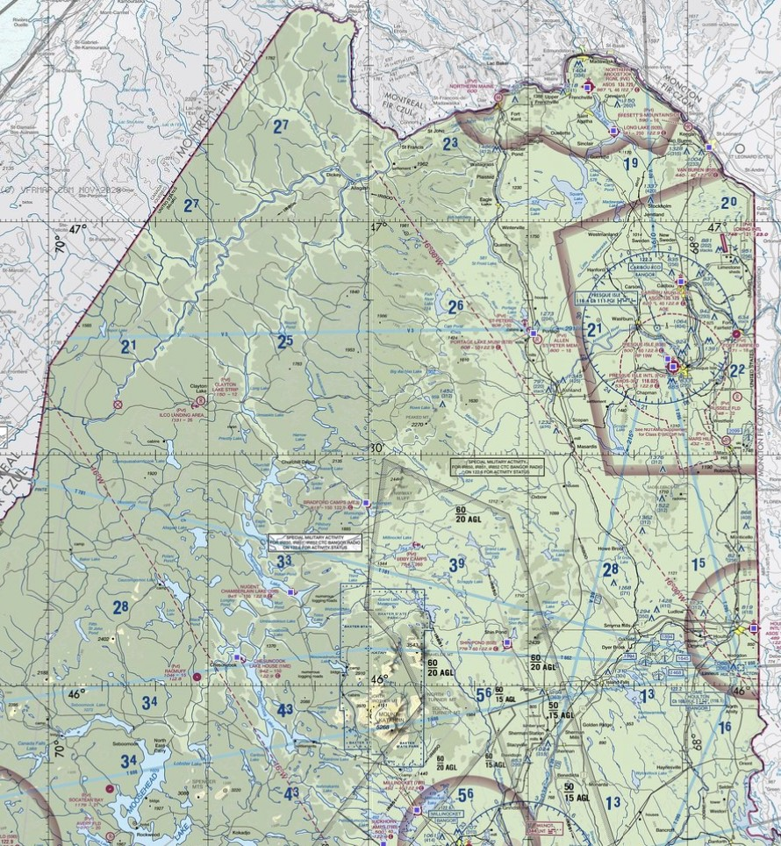
VFR Map of the primary area of operations and surroundings.
  - The Secondary area of operations would include the remainder of the state of Maine as is feasible pursuant to the requesting public safety agency. Airspace -considerations in other counties include two airports with Classes “C” and “D” airspace. Operations outside the county will follow the AKEMA FAA Blanket COA.
UAS Mission Intent
Small Unmanned Aerial Vehicles (UAS) shall be authorized for use only for the following purposes:
  - Search and rescue
  - Mass casualty search (train derailment, plane crash, terrorism, etc)
  - Fires (locating hotspots, forest fires, urban firefighting, etc)
  - Damage assessments (property and environmental, etc)
  - Law enforcement tactical operations & criminal investigations
  - General scene assessment & public safety of mass gatherings
  - Bridge and Dam inspection (flooding, ice jams, etc)
  - HazMat incidents
  - Environmental assessments from significant weather events
  - Flight indoors to minimize risks to first responders.
  - Any time a danger to a first responder can be minimized by a UAV.
  - Monitor and assess critical infrastructure and emergency incident situational awareness.
  - Training

Mission vetting
- A request for use of the Department’s UAS must specify the purpose of the deployment and be consistent with the Department’s overall mission.
- The requesting agency official must have authorization from their agency to request mutual aid.
- All missions must be approved by the Aroostook County EMA Director or their designer in conjunction with the requesting official- e.g., Fire Chief within Aroostook, Regional Forest Ranger (LT) etc.

Prohibited Uses
- Invasion of privacy (eavesdropping).
- Monitoring or video recording of public unless legally authorized.
- Personal use or in conflict with the private sector (IE; fun, and recreation), although this does not include planned training flights.
- Infringement of Civil Rights and Liberties as described below:

Respect for civil rights and civil liberties is a core tenet of our democracy. In executing the Department’s law enforcement and national security mission, personnel must rigorously support and defend the U.S. Constitution and continue to uphold the laws, regulations, and policies that govern our activities and operations.

As with all investigative methods, UAS operations must be consistent with the U.S. Constitution. The Fourth Amendment protects individuals from unreasonable searches and seizures and generally requires law enforcement to seek a warrant in circumstances in which a person has a reasonable expectation of privacy. Moreover, Department personnel are prohibited from using UAS for the collection, use, retention, or dissemination of data in any manner that would violate the First Amendment, or the lawful exercise of other rights secured by the U.S. Constitution and laws of the United States.

Department personnel are prohibited from using UAS in any manner that would discriminate against persons based upon their ethnicity, race, gender, national origin, religion, sexual orientation, or gender identity, in violation of law. Department personnel must be trained to understand and abide by all relevant federal legal standards applicable to the use of UAS, and to seek advice from legal counsel as necessary.

In addition, UAS is only used in connection with properly authorized investigations and activities. Statutory authorities, the Attorney General’s Guidelines, and other relevant agency policies and guidance define the scope of authorized investigations and activities and context of these existing safeguards.

Further, even within the context of properly authorized activities, personnel often must choose among different investigative methods that are operationally sound, reasonable, and effective, but may be more or less intrusive relative to individuals’ privacy and civil liberties. Prior to using UAS, Department personnel must assess the relative intrusiveness of the proposed use of UAS, and balance it against the investigative need. This is both a logical process and an exercise in judgment, but the overall principle remains; in deciding whether to use UAS, Department personnel must consider and, if reasonable based on the facts and circumstances of the investigation, use the least intrusive means to accomplish an operational need.

Accordingly, AKEMA personnel shall, prior to deployment of new sUAS technology and at least every three years, Assess the existing policy and procedures relating to the collection, use, retention, and dissemination of information obtained by sUAS, to ensure that privacy, civil rights, and civil liberties are protected. Furthermore, the Director & Chief pilot Shall randomly audit quarterly, any flights and information contained below to ensure these policies are followed, confirm that policies and procedures are in place, and provide meaningful oversight of individuals who have access to sensitive information (including any PII) collected using UAS,

    - Any information collected by sUAS is only used to the extent in which is consistent with and relevant to an authorized purpose.
    - Retention of Information collected using a sUAS that may contain personally identifiable information (PII) shall not be retained for more than 180 days unless retention of the information is determined to be necessary to an authorized mission of the retaining agency, is maintained in a system of records covered by the Privacy Act or is required to be retained for a longer period by any other applicable law or regulation.
    - All missions will comply with the Privacy Act of 1974 (5 U.S.C. 552a) in applicable circumstances.
    - All flights will be tracked and recorded by a secure system as required by the Privacy Act, with data access being limited to internal staff only. This pertains to all data covered under the UAS capabilities.
    - As required by law, data stored on the secure system will be purged or deleted as soon as feasible per investigation or mission requirements.
    - Data obtained by sUAS is only disseminated as required by the mission to internal staff and the requesting agency(s). Data that is not maintained in a system of records covered by the Privacy Act shall not be disseminated outside of the agency unless dissemination is required by law, or fulfills an authorized purpose and complies with agency requirements.
    - UAS recorded data will not be collected, disseminated or retained solely for the purpose of monitoring activities protected by the U.S. Constitution, such as the First Amendment’s protections of religion, speech, press, assembly, and redress of grievances (e.g., protests, demonstrations).
    - Collection, use, dissemination, or retention of UAS recorded data should not be based solely on individual characteristics (e.g., race, ethnicity, national origin, sexual orientation, gender
identity, religion, age or gender), which is a violation of the law
.

Compliance with Maine Law: Title 25; Part 12; Ch 551; REGULATION OF UNMANNED AERIAL VEHICLES

- With respect to § 4501; part 5, the AKEMA has adopted written minimum standards and policies and protocols for use of UAVs on behalf of law enforcement agencies including the following:
- All persons operating unmanned aerial vehicles will be certified by the FAA and trained for the intended type of flight.
- Prior authorization from the chief administrative officer of the law enforcement agency seeking the use of AKEMA unmanned aerial vehicle is required.
- Approval by the Attorney General or chief prosecuting attorney for the appropriate jurisdiction (signed warrant or valid consent) must be obtained for the deployment of an unmanned aerial vehicle for criminal investigative purposes.
- Use of visual, thermal, and zoomed imagery are permitted. No facial recognition is permitted, and NO UAV will be equipped with any type of weapon.
- Flight pre-planning, incident briefings, flight above 200’ above ground level at a speed of 5 mph or more will be used to minimize and avoid the inadvertent visual recording of 3rd parties or private spaces not under investigation.
- Any unnecessary video recordings which are unrelated to the investigation will be erased.
- The number of UAV’s deployed to a single incident or investigation will be managed by the UAV Operations Director.
- Operators of a UAV will take all precautions available to avoid hazards to persons or property with appropriate take off and recovery sites as well as no flight over people.
- Annual Unmanned Aerial Vehicle Report will be submitted to the Maine Commissioner of Public Safety on behalf of law enforcement agencies supported by the AKEMA prior to 1 July. [25 M.R.S.A. § 4501(6)]
- An AKEMA pilot of a UAV who intentionally uses the UAV without proper authorization or in deviation of the standards set forth in this policy shall be subject to disciplinary action.

Transparency of Operations and Use

  - Our agency is committed to transparency in operations. Our public website (WWW.facebook.com/akema.maine) describes our special response team and the scope of response. This will serve as a public notice of operations.
  - This policy, which outlines all procedures the UAS team will follow, will be published on the AKEMA website (aroostookema.com).
  - Due to the nature of some missions not all upcoming operations are scheduled, and some missions will require no public notification, due to sensitivity or scene safety (i.e., Hazardous materials incident, Flash flooding, etc.). For scheduled missions that are not sensitive in nature, the agency or those requesting AKEMA UAS resources may provide public notification of scheduled operations before, during, or after a mission is complete.

Deployment
- At a minimum, each deployment shall meet the following minimum requirements:
- Training and certification requirements provided by State and Federal law.
- Procedures in place to minimize inadvertent audio or visual recording of private spaces or individuals.
- Procedure in place for destroying any unnecessary audio or visual recording without further duplication or dissemination.
- The pilot(s) will follow recommended minimum altitude and speeds at which the UAS may fly to minimize invasion of privacy.
- Procedure in place to avoid hazards to persons or property on land and in the air.
- Use methods of tracking and recording the flight of each UAS mission.
- Compliance with rules and regulations promulgated by the FAA.
The procedures referenced above shall be developed and implemented prior to deployment of UAS on any approved mission.
- Once a UAS mission has approval the following procedure will be adhered to for each deployment:
- Initiate Incident and or Unified Command.
- Recommended designated personnel as needed depending on incident (the Air Operations team):
- Incident Commander (IC)
- Pilot in Command (PIC)
- Liaison Officer (LO)
- Visual Observer (VO)
- Communication Specialist (CS)

Operations
- Only AKEMA qualified, trained part 107 certified pilots will launch and fly the UAS. Aircrews will employ Crew Resource Management (CRM) to optimize effectiveness and safety.
- Incident Commander will ensure all other organizations are aware of the air operations underway and that coordination is established with supported elements and other supporting units.
- Air Operations team will:
    - De-conflict manned from unmanned aircraft.
    - Establish areas of operation and assignments for sUAS
    - Safety is the responsibility of everyone on the team.
    - Ensures that proper resources support all air operations.
    - Ensure additional batteries are prepared and charged.
    - Maintains connectivity with cellular devices.

Communications and Coordination

- Interoperable communications (radio, phone, satellite up-link, Internet, etc.) established with supported elements and adjacent organizations.
- ICS forms will be kept to document and report any and all UAS missions.
- All video recording will be archived and maintained for evaluating value against cost of the UAS after the video is evaluated for unnecessary recordings which may constitute an invasion of privacy or other content outside the scope of the mission.

Maintenance Requirements
  - Aircraft are to be inspected and maintained in accordance with manufacturer recommendations.
  - Batteries, weekly charge for all UAS kits
  - Inspection of UAS Kits for completeness
  - Replacement of propellers that have damage.
  - Placing unsafe batteries out of service when necessary

Training
  - The UAV Team Chief Pilot will ensure all training missions will be conducted over non-residential areas.
  - Pilots will Maintenance current with Part 107 license.
  - All UAV air operations missions will be in complete compliance with FAA regulations (14 CFR Part 107) and Maine law (LD-25).
  - Pilots will receive opportunities to train at least monthly to develop proficiency under different circumstances.
  - Pilot skills, qualifications, and flight hours will be recorded in their flight log and maintained on file.

Reporting Requirements
- Post incident an After-Action Report (AAR) is to be submitted to the Director of Aroostook County Emergency Management Agency. The Director will be provided with a year-end summary of UAS operations from the chief pilot as required and be made available to the public for review, by a request to the director. A form for information requests can be found at WWW.AROOSTOOKEMA.COM under Drone Team Info.
- Documentation of all UAS activities associated with mission operations is required regardless of the airspace in which the UAS operates except those designated as for “training”.
- Electronic recording of flight data will be captured and made available as required.
- After an incident or accident that meets the criteria of 14 CFR Part 107, or the COAs and within the prescribed timeframe shall be reported in accordance with the rules and regulations.

- All accidents/mishaps involving UAS operations where any of the following occurs:
- Fatal injury, where the operation of a UAS results in a death occurring within 30 days of the accident/mishap.
- Serious injury, where the operation of a UAS results in:
- Hospitalization for more than 48 hours, commencing within 7 days from the date of the injury occurred.
- A fracture of any bone (except simple fractures of fingers, toes, or nose)
- Severe hemorrhages, nerve, muscle, or tendon damage
- Involving any internal organ
- Involves second- or third-degree burns, or any burns affecting more than 5 percent of the body surface.
- Total unmanned aircraft loss
- Substantial damage to the unmanned aircraft system where there is damage to the airframe, power plant, or onboard systems that must be repaired prior to further flight.
- Damage to property, other than the unmanned aircraft
- Any incident/mishap that results in an unsafe/abnormal operation including but not limited to:
- A malfunction or failure of the unmanned aircraft’s on-board flight control system (including navigation)
- A malfunction or failure of ground control station flight control hardware or software (other than loss of control link)
- A power plant failure or malfunction
- An in-flight fire
- An aircraft collision involving another aircraft
- Any in-flight failure of the unmanned aircraft’s electrical system requiring use of alternate or emergency power to complete the flight
- A deviation from an ATC clearance and/or Letter(s) of Agreement/Procedures
- A deviation from rules and regulations
- A lost control link event resulting in:
- Fly-away
- Execution of a pre-planned/unplanned lost link procedure.

Pre-Flight Unpacking, Set-up, and power up checklist
- ___ Pilot conducts self-safety assessment and is determined safe to fly.
- ___ Pilot has a current part 107 license, COAs and Pilots Logbook.
- ___ Pilot reviews airspace, weather and other concerns.
- ___ Open case and verify all components, documents and logs are present.
- ___ Remove UAS and deploy each motor arm.
- ___ Inspect condition of each propeller blade for nicks and damage
- ___ Registration markings are present, legible, and correct.
- ___ Remove safety cover over gimbal assembly.
- ___ Insert fully charged battery in drone.
- ___ Confirm UAS has micro-SD Card installed.
- ___ Confirm Payloads and or cameras are secured.
- ___ Remove controller from case and verify battery level.
  - Install battery to pilot controller.
  - Using the Smart Controller simply power up and extend antenna if needed.
  - Confirm the software is up to date.
- ___ Power up hotspot and connect pilot controller through “Settings.”
- ___ Power up UAS positioned in a safe take off location and connect to pilot controller.
- ___ UAS status lights are green or equivalent for take-off.
- ___ Anticollision lights and Propper flash patterns are on.
- ___ Create and select appropriate mission to join if applicable.
- ___ Confirm video is transmitting to pilot controller and map location is correct.
- ___ After confirming any calibration or UAS alerts have are resolved, launch as required.

Mission Planning Worksheet
- ___ Authorization from AKEMA Director/ Deputy/ Chief Pilot
- ___ Identify and document expected results (ie. Pics, video)
- ___ Analyze area of operation using all available resources to identify safety, airspace (B4UFLY APP), liability, Weather (1800wxbrief.com) and visibility concerns.
- ___ Select best location for point of departure (POD) where pilot will have unobstructed line of sight.
- ___ PIC to brief AKEMA Director/ Deputy/ Chief Pilot on any anomalies or safety concerns prior to flight.

Mission Planning & Execution
- ___ Conduct Risk Assessment of the mission and make go/no go decision.
- ___ Issue (D)NOTAM Per COAs
- ___ Review airspace requirements and verify no temporary flight restrictions.
- ___ Notify any airport authorities or control tower if operating within 5NM
- ___ Perform pre-flight checklist.
- ___ Remain at or below 400AGL
- ___ Brief support team and other participants or agencies as necessary
- ___ Prosecute objective and avoid distractions and interruptions.
- ___ Monitor changing conditions, incident, weather, and available resources.
- ___ Seek feedback from mission specialists and adapt as required to achieve objectives
Mission Completion
- ___ Safely return aircraft to departure point.
- ___ Conduct post flight inspection of aircraft
- ___ Remove SD card for download and Archive data.
- ___ Secure UAS for next mission
- ___ Sign and document pilots flight log and aircraft log as necessary.
- ___ Hot-Wash support team as necessary and note lessons learned.
- ___ Cancel (D) NOTAM per COAs
- ___ Debrief Incident commander as requested and provide After Action Report to EMA Director.

Mission Contingencies
- ___ Lost-link procedure for command and control (C2) are dependent on the Manufacturer’s built in auto return feature which will direct the UAS to automatically land at its (POD).
- ___ Lost comm procedure includes the communication of the Pilot-in-Command (PIC) and Air Traffic Control (ATC) or between the PIC and Visual Observer(s) (VO). In any instance when comms is unreliable or inoperable the PIC shall initiate procedures to abort the mission and return the UAS to its (POD) until such time as radio or telephone communication can be re-established.
- ___ At any time, safety is compromised for the aircraft or personnel any participant can call “Knock it Off” which is to be strictly observed by the PIC with the return to POD for any safety concerns.
- ___ Select alternative landing zone (LZ) in the event of damage to aircraft or another incident.
- ___ Post support team in surrounding locations to view UAS and retrieve if required.

Complaints
Anyone wishing to file a complaint, or a civil liberties complaint may do so by contacting the AKEMA Director and providing the following information: (A form is also attached)
1. Complainant Name
2. Full mailing address
3. E-mail address
4. Telephone number
5. Nature of complaint
6. Date and location for which complaint is founded
7. Allegation of activity affecting Civil Liberties
8. Signature of complainant

The AKEMA Director will acknowledge receipt of the complaint and initiate an investigation and follow up on the complaint within in a timely manner. The AKEMA Director can be contacted via telephone at (207)493-4328, Or the complaint form attached to the policy can be filled and emailed to eoc@aroostookema.com, delivered in person or mailed to Director AKEMA 158 Sweden St., Caribou Maine 04736.

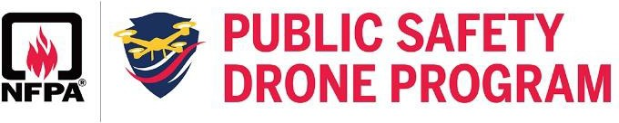

LIST OF ESSENTIA PRE-FLIGHT OPERATIONS
Pre-Flight Operations are essential to the success of your mission because they help ensure that your UAS and equipment is ready to go.
There isn't a standard list of protocols because sUAS programs typically develop their own, but the majority of Pre-Flight Operations are similar across organizations because there are "standard" items that should be included.

Inspect UAS and Calibrate Instruments
UAS manufacturers normally supply a “recommended” basic checklist that should be incorporated into your organizational checklist. When checking your UAS before a flight, some things you may want to consider include:
  - The UAS and components are free of damage
  - Registration markings are present, legible, and correct
  - Propellers are free of defects or damage
  - UAS batteries are secure and sufficiently charged for mission
  - Gimbal moves freely and at full range
  - GCS batteries are sufficiently charged for mission
  - Sensor payload is secured and correct for mission
  - SD card is inserted and has sufficient memory
  - Software is current and compliant
  - Compass and IMU calibration are green
  - GPS/GLONASS is minimum locked
  - UAS status lights are green
  - Correct flight mode is selected
  - Anti-collision/strobe lighting is flashing
  - Positioning sensors are clean and clear of obstruction

Verify Startup Functionality
Before taking off on your mission, once you have visual confirmation that your UAS is ready to fly, a good next step would be to verify the startup functionality of the vehicle. Some important items to consider include:
  - Motors are running smoothly, with no abnormal noise
  - Home point is set and correct location is verified
  - RTH Altitude is set for in-flight obstacle clearance
  - Telemetry data is present with no anomalies
  - Verify hover functionality by taking off to 3-5' altitude
  - Verify gimbal movement matches input

Attend to Crew Resource Management (CRM)
Part of your Pre-Flight checklist includes ensuring your crew is ready to execute their mission. It is essential to:
  - Communicate roles and responsibilities. For example, What part of the airspace is the RPIC monitoring, and what part is the VO responsible for? What are first responders doing on the ground and what are their roles in case of an emergency? The Incident Commander (IC) or IC Team is patched in with the RPIC throughout the operation and they’ll be providing specific guidance about capturing data. *Note: The IC or IC Team will most likely only be speaking to data acquisition to safeguard against “task
saturation” because they have so much to do.
  - Confirm crew readiness/alertness.
  - Establish communication processes.
  - Identify known risks and establish contingency plans.

Assess Atmospheric Conditions
External weather conditions can affect your ability to accomplish your mission. Before flying, it may be helpful to consider:
  - Current and forecasted weather for the mission duration
  - Visibility distance
  - Cloud cover
  - Wind speed

