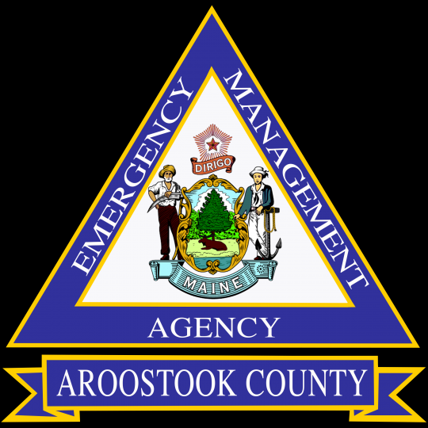

Mass Care Awareness for Aroostook County, Local and Tribal Emergency Management Agencies

Prepared By Brian C. Goff
Aroostook County EMA
Community Outreach Planner
July 2025

TABLE OF CONTENTS

Section Page

Introduction 3

Definitions 4

Mass Care Sheltering 6

Mass Care Feeding 10

Mass Care Reunification 12

Distribution of Emergency Supplies 13

References & Resources 15

Appendix: Maine State Shelter Plan 17

Introduction

This mass Care Considerations document has been prepared to serve as a tool for Aroostook County, Local and Tribal Emergency Managers to help in planning for Natural or Human caused Disasters or an Event that requires Mass Care assistance. The information has been provided to serve as a platform to share the best practices which may help in situations requiring Mass Care Assistance. Mass Care focuses on four primary areas:

- Disaster/Emergency Sheltering
- Emergency Feeding
- Family Reunification
- Distribution of Emergency Supplies
As a supplement to this guide, the Maine Shelter Plan and Information on Cooling & Warming Center Best Practices has been included in this document.

Mass Care Assistance
The Aroostook County EMA is available to provide coordination and technical assistance to communities, agencies and organizations related to mass care needs. Resources that are available include technical assistance, training and site visits. For assistance feel free to reach out to The Aroostook County Emergency Management Agency at (207)493 -4328 or by email at eoc@aroostookema.com. Our agency is located at 158 Sweden Street, Caribou Maine 04736.

Definitions
Congregate Shelter
A Congregate Shelter or a Disaster Shelter is a place for people to live temporarily, when they cannot live in their current residence. The main reason between a warming or cooling center and emergency shelter is that an emergency shelter specializes in people fleeing a specific situation, such as a natural disaster or man-made disaster. Another difference from a warming/cooling center is that people staying in disaster shelters are provided places to sleep and or eat for an extended period. If the shelter is run by the Red Cross facilities are ADA compliant and non-acute medical care and disaster mental health services may be available.
Non-Congregate Shelter
A Non-Congregate Shelter is the term used for emergency shelters that provide accommodation in a way that provides private space for guests. Non-congregate Shelters are generally provided by a Hotel or Motel Room. College or University Dorm and Cam
Cooling Shelter
A Cooling Center is a facility that has been opened for a short-term operation, due to extreme heat conditions. They are typically operated at Town Halls, Libraries, Recreation Centers ands Churches, operated during normal business hours.
Warming Center
A Warming Center is a facility opened for short-term operations due to a specific emergency event. Warming Centers are often open during regular business hours. They are usually opened when temperatures or a combination of precipitation, wind chill, wind and temperature, have or may become dangerous. Their essential purpose is preventing death or injury related to exposure to the elements.
Evacuation Center (TEP)
Evacuation Centers or Temporary Evacuation Centers provide temporary shelter for people displaced from their homes following a disaster. The term Temporary Evacuation Point is often used to stage individuals out of harm’s way until Shelters can be set up. These facilities vary by location and by the extent of the damage to the area. Evacuation Centers are not typically equipped for overnight sheltering.

Warming Shelter
A Warming Shelter is a short-term emergency shelter that operates when temperatures or a combination of precipitation, wind chill, wind and temperature become dangerously inclement. It is a place where people can go to stay warm and dry when conditions outside are not favorable. These facilities provide sleeping accommodations and may provide additional resources for Homeless or unhoused individuals. Warming Centers are like Homeless shelters, except that they are only open when the weather is bad. Their man goal is to make sure that nobody is left out in the cold.

Homeless Shelter
A Homeless Shelter is a facility that provides temporary housing and support services for individuals and families experiencing homelessness. These shelters offer a safe and secure space to stay, often with basic amenities like beds, food, and hygiene facilities. Some shelters also provide additional services like job training, medical care and case management to help residents transition to more stable housing.

MASS CARE DISATER/EMERGENCY SHELTERING CONSIDERATIONS
The location of and decision to open and operate a Disaster / Emergency Shelter is at the sole discretion of local MEA and Municipal Officials in collaboration and coordination of County EMA. The exception being that a Local or County EMA may plan with a government or non-government Agency or Origination regarding opening and management.
Local Emergency Management Agencies are encouraged to identify and survey primary and secondary facilities for Emergency Sheltering use. As part of the preparedness process the development of a shelter plan can become a helpful tool in the event that there is a need for Sheltering due to a disaster or human caused event.
Facilities to consider for primary & secondary Disaster/Emergency Shelters:
- Schools (Public & Private K-12, Colleges and Universities)
- Recreation Centers
- Community Rooms
- Libraries and Meeting Rooms
- Grange Halls
- Fraternal Halls
- YMCA Facilities
- Municipal Buildings
Facility Considerations should include, but not limited to the following:
- Safe Location & Accessibility to the Community, including roads and transportation.
- Capacity for anticipated shelter residents that would use the facility
- ADA compliance and Functional needs Accessibility.
- Compatibility to allow normal operations and use during sheltering.
- Generator Power or the ability to connect to a temporary power source.
- Safety & Security
- Ability to support Pet Sheltering needs.
- Impact on Community Infrastructure and Recovery Needs
- Ability to sperate feeding and dominators areas
- Adequate toilet and Shower facilities
- Ability to Co-Locate those with disabilities with General Population
- Isolation area for those with allergies or medical issues.
- Considerations for Nursing Mothers
- Childcare and Child friendly recreation areas.
- Life Saving Equipment (First Aid Kits, AED’s, Smoke & CO2 Detectors)
Capacity Considerations
-Capacity is determined by measuring the area of staging or sleeping area of building, only not entire building. (The dormitory r stagging area capacity shall not exceed the posted occupancy of room being used for Center or Shelter.)
Cooling & Warming Centers
-20 Square Feet Per Person of an area where individuals will be staged.
Evacuation Center or Temporary Evacuation Center
-20 Square Feet Per Person of an area where individuals will be staged.
Disaster/Emergency Shelter
-40 Square Feet Per Person of Dormitory area where individuals will sleep.
-110 Square Feet Per Person of Dormitory area where individuals will sleep during a Communicable Disease Outbreak, Example Covid-19 Protocols.
- 100 Square Feet Per Person of Dormitory area where individuals will sleep during long-term sheltering or individuals with Medical Needs.
Commonly Used Shelter Supplies
- Cot or Sleeping Mats
- Blankets
- Pillows
- Tarps or Flooring paper to Cover Floor where Cots are Placed
- Cones
- Trash Bags
- Blue Painters Tape
- Easel Pads, Markers and Easel Stands for Signage
- Maine Shelter Handbook or FEMA Shelter Guide
- Cleaning Supplies

Potential Partners to Staff Disaster/Emergency Shelters
- Municipal Staff & Volunteers
- Civic or Fraternal Croups
- Private and Non-Profit Agencies
- Community CERT Teams
- Civil Air Patrol Squadrons
Cooling and Warming Center Considerations
Here are a few considerations for operating a Cooling or Warmi9ng Center
- Identify Facilities before the need arises
- Common Sites Include
2. Municipal Offices
3. Senior Centers
4. Libraries
5. Community Centers
6. Fraternal Sites

- Monitor Weather to Determine Cooling or Warming Center Open Hours. Cooling and Warming Centers may be opened during extreme heat, or cool periods will provide a source of relief for those who are unable to stary cool or warm

- Make sure the space has good and reliable air conditioning and hear sources. The space should be accessible to people with disabilities and people who use mobility devices.

- Some activities you can offer are coloring, crosswords, books, playing cards and movies. This can help create a feeling of trust and comfort and kids keep happy. If you plan to offer toys that can be shared, be sure to sanitize them before

