ELEMENT B. RISK ASSESSMENT

Note: All disaster declarations that included Aroostook County are included in this Risk Assessment.
B1. Risk Assessment Requirements
Does the plan include a description of the type, location and extent of all natural hazards that can affect the jurisdiction? Does the plan also include information on previous occurrences of hazard events and on the probability of future hazard events? (Requirement CFR §201.6(c)(2)(i)

It is essential in any hazard mitigation plan to identify the hazards that exist in the town or multi-town region and how vulnerable the community is to the particular hazard. This is known as the Risk Assessment. Numerous reports, studies, plans, and other technical resources were used to inform this process, in addition to the comments and survey responses provided from local jurisdictions. These include but are not limited to prior Aroostook County Hazard Mitigation Plans approved in 2011, 2016 and 2021, the 2023 Maine State Hazard Mitigation Plan, the “Maine’s Climate Future, 2020 Update” report, and numerous disaster declaration and hazard mitigation reports provided by FEMA, U.S. Army Corps of Engineers, and other state and federal resources.

Climate

Seasonal temperatures, annual precipitation, prevailing wind directions and geographical features can all profoundly affect both the occurrence and severity of natural hazards.

Aroostook County is located entirely in the northernmost of Maine’s three climatic divisions. The northern division (#1 on the map on the next page) encompasses 17,916 square miles (54%) of the state. This division is least affected by marine influences and it contains most of the central and western mountainous regions. It includes all of Aroostook County.

Temperature: The mean annual temperature in the northern division is about 38ºF. Temperatures average about 64ºF in July and August, and about 18ºF in January and February.

Precipitation: The northern division’s average annual amount of precipitation, based on long-term records dating back to 1895, is 40.9 inches. This includes the conversion of all snowfall to a water-equivalent. Average monthly precipitation is between three and four inches, with November being the wettest month, and February being the driest month.

Prevailing Winds: Prevailing wind direction varies with both season and location. Local influences such as orientation of a valley also may play a key role in dictating prevalent wind direction at any one location. Most of the county is under northwest to west-northwest winds throughout much of the year and particularly during the winter. During the summer, southwest to southerly winds may become quite frequent.

Climate Divisions of Maine

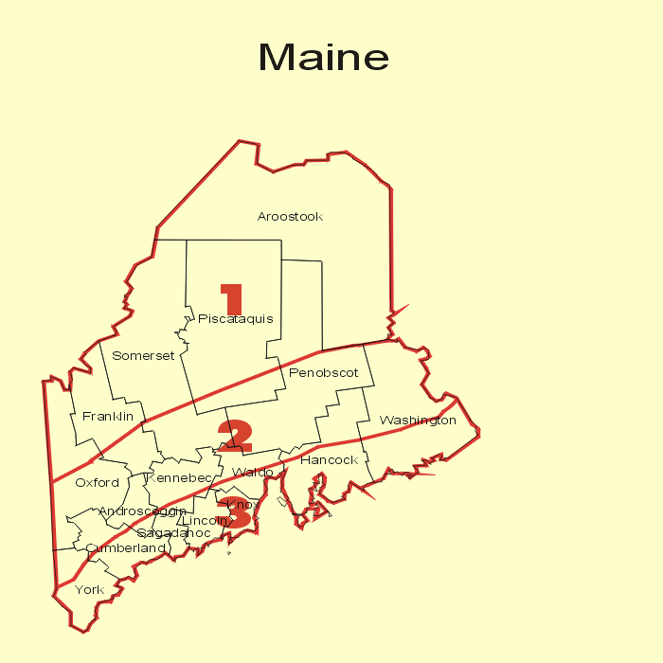

Geography: Overall, the terrain across much of Aroostook County is hilly. The present-day landscape is a direct result of glacial erosion and deposition from the large ice sheets that completely covered Maine as recently as about 14,000 years ago. A variety of glacial deposits cover the county, providing a rich variety in the overall landscape as well as abundant sand and gravel for construction material. Many of these deposits also are excellent sources of ground water (aquifers) for household and industrial water supplies. In addition, glacial deposits and erosion are directly responsible for the lakes found in Aroostook County.

Extensive wetland areas that provide habitat for many ecosystems are also a result of past glaciations in combination with existing climatic conditions. Maine is the most forested state in the United States with 90% of its land area in woodland (about 85% in Aroostook County). Historically, this has supported a considerable lumber and paper products industry. Many logging roads provide the only access into vast unsettled areas. These forests also provide habitat for abundant wildlife, and together with the large number of lakes are a great resource for sports and recreation.

Climate Change
Long term global climate trends, which include changes in temperature and precipitation, may affect the State of Maine and Aroostook County. The National Aeronautics and Space Administration (NASA) website states that unlike weather, which is short-term and variable, climate represents the average atmospheric conditions over long periods, typically 30 years or more.”

The report “Maine’s Climate Future, 2020 Update,” prepared by the University of Maine, reports that “Rapid warming in the Arctic can affect the weather we experience in Maine and conditions in the Gulf of Maine (Schmitt 2007). As arctic air warms, there is less of a temperature difference between the North Pole and the continental United State, leading to weaker westerly winds. Recent studies have suggested that weakened westerlies may lead to a more wavy Jet Stream, so called “blocking” storm patterns, and Polar Vortex dips that allow Artic air, still very cold, to plunge into Maine during winter (page 14).”

“Changes in the distribution of winds and sea-surface temperature across the North Atlantic, and Gulf Stream position, are likely amplifying regional warming and precipitation cycles, and have the potential to further affect seasonal shifts in the environment over the coming decades (Saba et.al. 2016, Thomas et.al.2017) (page 14).”

Temperature Changes in Maine.: Excerpts from the report “Maine’s Climate Future, 2020 Update,” prepared by the University of Maine, include the following:

“Temperatures are increasing statewide. Average annual temperature has increased 3.2ºF in the last 124 years, and the rate of warming has increased most notably since 1960. The six (6) warmest years on record have occurred since 1998. Indeed, the Northeast is warming faster than any other region in the U.S., and is projected to warm 5.4ºF when the rest of the world reaches 3.6 ºF (page 3)…The growing season (the period between the last frost and first frost) is more than two weeks longer than it was in 1950, mostly due to later frosts in the fall (page 4).”

The following chart, taken from the “Maine’s Climate Future, 2020 Update,” demonstrates significant year-to-year variations in Maine’s average annual temperature with periods of relative cold and relative warmth, but an upward trend in annual average temperatures.
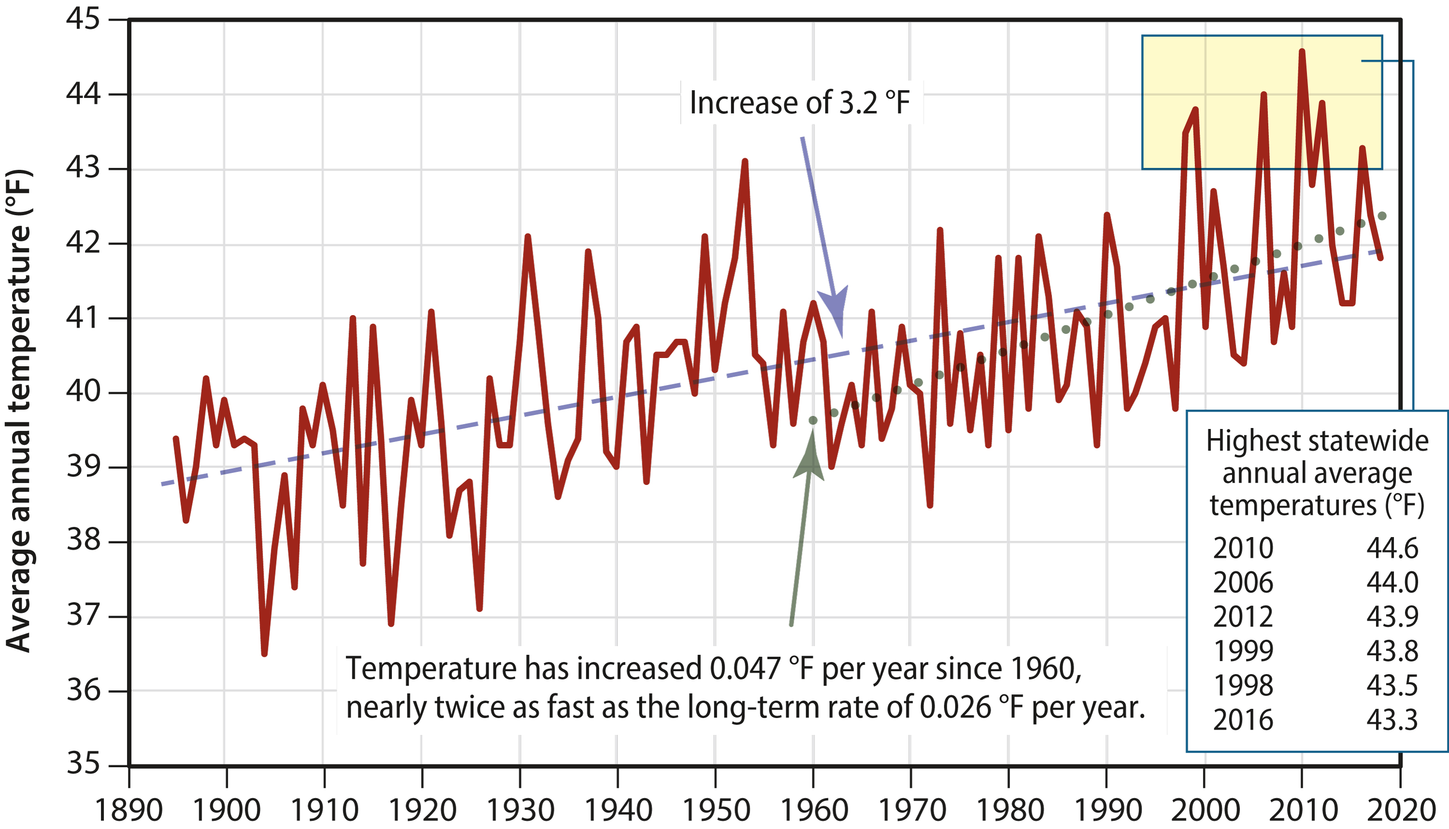

Source: Maine’s Climate Future, 2020 Update, University of Maine, page 3.

Precipitation Changes in Maine. Maine’s Climate Future, 2020 Update, reports that:

“Average annual precipitation has increased 15% (5.8 inches) since 1895, and the increase has come in the form of more rain and less snow. Since 1895, depth of annual snowfall has decreased 20% (2.3 inches). As with temperature, the rate of increase has accelerated in recent decades (page 5).

“Communities across the state are experiencing more heavy or “intense” precipitation events (Fernandez et. al. 2015)…Increased precipitation means increased volume of runoff to local streams, rivers, and ultimately the Gulf of Maine (Vincent et. al. 2015, Huntington et. al. 2016). These higher floods and flows can…damage roads, bridges and properties (page 6).”

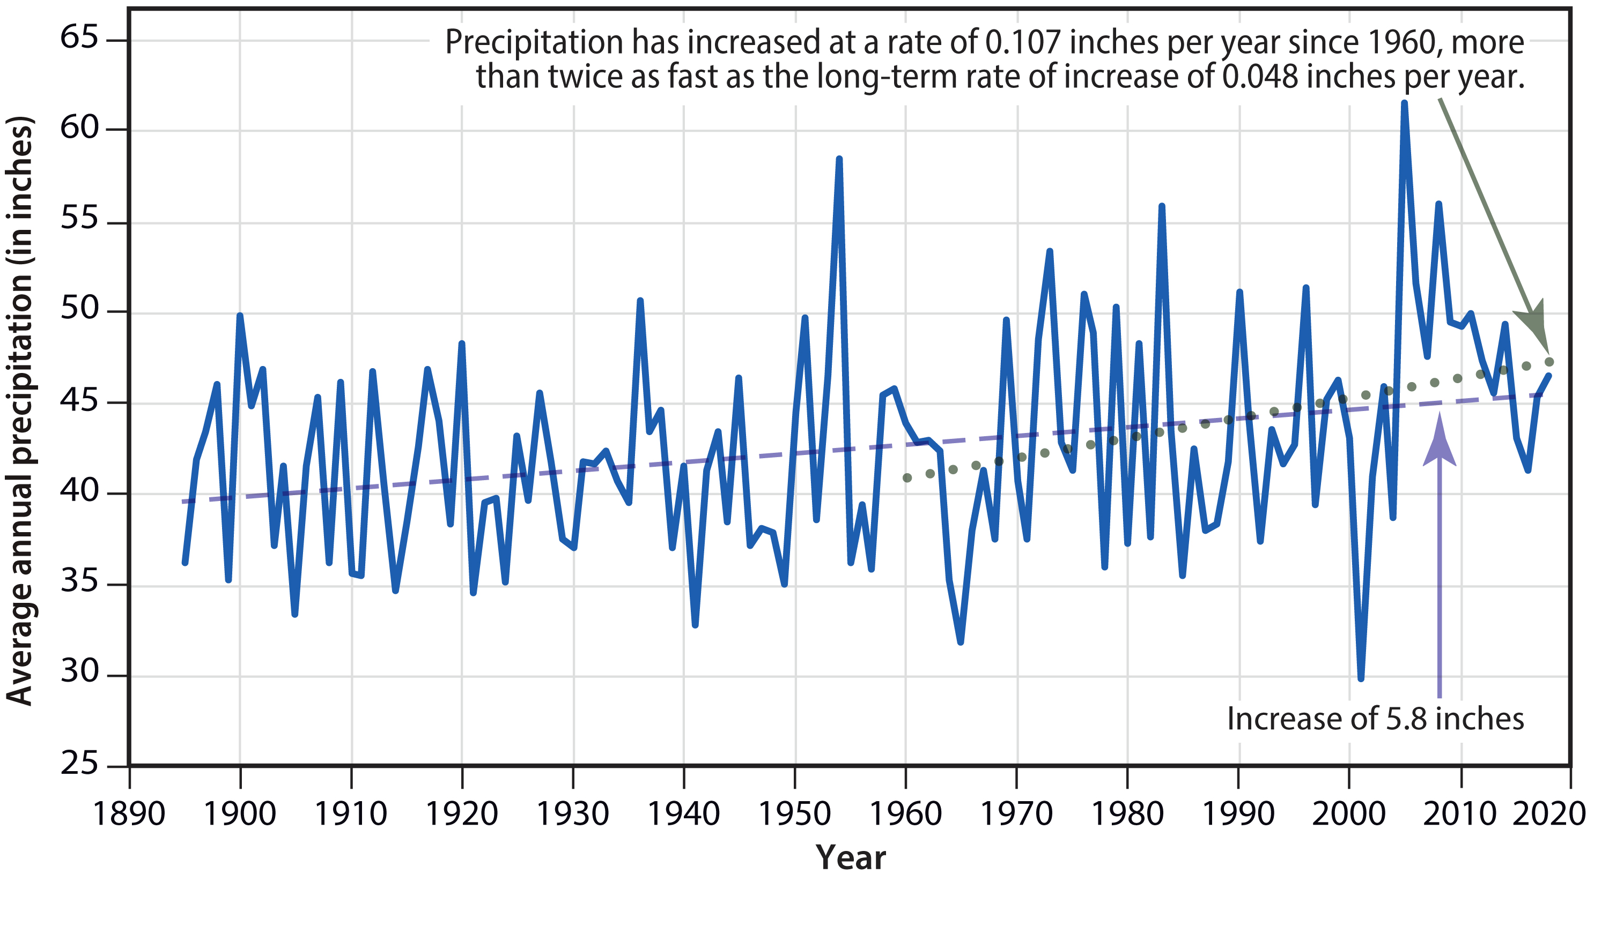

Source: Maine’s Future, 2020 Update, University of Maine, page 5.

B1-a. Description of Hazards
The plan must include a description of all natural hazards that can affect the jurisdiction(s) in the planning area and their assets, such as dams, located outside the planning area. This requirement may be met with either a narrative description or definition.

The plan must provide the rationale if omitting any natural hazards that are commonly recognized to affect the participant(s) in the planning area. There is no prescribed method for explaining the omission, but the plan must demonstrate the lack of risk to the participant(s) that omits the hazard.

The following table notes each hazard, Aroostook County’s vulnerability to that hazard and the probability that each hazard will occur in the future.

The following hazards will be examined in detail in this mitigation plan: Flooding, Severe Summer and Winter Storm, Wildfire and Drought. A determination that these are the most significant hazards in Aroostook County was made through personal communication and by reviewing data, reports, local surveys and records and information contained in earlier versions of this plan. While several hazards have a high likelihood of occurring, the other factors of the hazard/vulnerability analysis relegate them to non-significant/lower priority hazards.

The Aroostook County Hazard Mitigation Planning Team agreed that flooding was the most serious hazard in Aroostook County. There was general agreement that ice jams, combined with spring snow melt and sometimes heavy rains are a leading cause of flooding in Aroostook County. The year 2008 proved to all participants that the focus on flooding was a valid concern and area to elaborate on. The year 2008 was devastating to many communities especially the ones near the St. John River along the St. John Valley corridor. Fort Kent was hit the hardest followed by Van Buren. Other communities that received a great deal of damages included Island Falls, Washburn and the community of Wallagrass, more specifically the Soldier Pond area. Having had to deal with such major flooding, proved to all participants that mitigation should be addressed in greater detail and in some areas expanded. Identifying projects for mitigation is now on every one’s radar and is being addressed.

Flooding and related hazards were identified through an extensive process that utilized input from members of the Hazard Mitigation Planning Team, survey returns from Aroostook County municipalities, a review of the Maine State Hazard Mitigation Plan 2023, hazard mitigation zoom workshops, public input, researching past disaster declarations in the county, and a review of current maps.

The hazards profiled in this plan, and the basis for their selection, are summarized in the table below.

Summary of Hazards Profiled in this Plan
Hazard | How Identified | Why Identified
Flooding | Review of 2020 hazard mitigation survey returns from Aroostook County municipalities, a review of the Maine State Hazard Mitigation Plan 2023, hazard mitigation zoom workshops, FEMA flood studies, flood maps, state data on disaster declarations, committee and local knowledge, Flood of 2008 | There is a history of flooding in many parts of the county, particularly along the Aroostook and St. John Rivers. The County also contains twelve high hazard dams and six significant hazard dams that could, in the event of a dam failure, cause loss of life or serious property damage. There have been no major dam failures in the county in recent decades, but In 1954, a hurricane washed out dams in Mars Hill and Easton.
Severe Winter Storms | Review of past disaster declarations,  committee and local knowledge, records from 1998 ice storm, Maine State Hazard Mitigation Plan 2023 | Maine is frequently hit with blizzards and major “northeaster” storms. In 1998, a major ice storm hit Maine, knocking out power in many locations for days. The impacts of winter storms include wind damage.
Severe Summer Storms | Review of past disaster declarations, Committee and local knowledge, Maine State Hazard Mitigation Plan 2023 | Summer storms are often accompanied by high winds, road and culvert washouts.
Wildfires | Review of Maine Forest Service records, committee and local knowledge, Maine State Hazard Mitigation Plan 2023 | Many areas of the county are forested. Wildfires have been numerous but they have generally been small. Wildfires can destroy land cover which, in turn, can cause erosion and sedimentation and exacerbate flooding.
Drought | Drought Advisory Committee,  Planning Team and local input,  Maine State Hazard Mitigation Plan, 2023, experience with drought. | Severe, multi-year droughts occurred in Maine in the 1960’s, 1980’s and 2000 to 2003, 2016, 2018 and 2020. In 2020, Aroostook County experienced severe drought condition. The U.S. Department of Agriculture designated Aroostook County as a drought disaster area

The following table identifies the hazards that were either eliminated from further consideration in the Plan or included in other hazard profiles. Factors for eliminating them from further consideration include a lack of historical evidence, lack of overall county-wide severity, or a low likelihood for the event to occur. Even though these potential hazards are not profiled in the plan, there is no guarantee that they would not or could not occur and cause damage. The Hazard Mitigation Planning Team made the decision to keep this plan simple by profiling only the top five hazards.

Hazards that were Eliminated from Further Consideration
Hazard | How Identified | Why Eliminated
Avalanche | Review of USGS Maps, Maine State Hazard Mitigation Plan 2023 | There are no mountains in the county that hold large amounts of snow that would create avalanches and no documented cases of avalanches in the county.
Blight/Infestation | Maine State Hazard Mitigation Plan 2023, Planning Team, and local knowledge | Even though the county is heavily dependent on potato farming and timber production, state government, private businesses and the general public have responded to incidents of blight and infestation with spray programs, surveys, and restrictions on plant/aquaculture cultivation and plant importation.
Earthquake | Maine Geological Survey, historical records, Maine State Hazard Mitigation Plan 2023 | Although earthquakes are common in Maine, no significant motion has been shown for any fault since the last ice age about 20,000 years ago. Northwestern Aroostook County is one of three areas in Maine with the most seismic activity, but this area is largely uninhabited, and there has been only one earthquake with a magnitude greater than 3 (3.8) since 1979.
Hurricanes | Review of past disaster declarations, historical data, Planning Team,  Maine State Hazard Mitigation Plan 2023 | Maine is hit by a hurricane about every 10-20 years. However, hurricanes are very rare in Aroostook County; one occurred in the county in 1977. Strong, localized, and brief gusts approaching hurricane strength are sometimes experienced with winter and summer storms (see profile for summer storms).
Landslides | Review of Maine Geological Survey records, Maine State Hazard Mitigation Plan 2023 | Landslides are virtually unknown in Aroostook County. However, sometimes steep embankments can be subject to landslides, as was the case along a small section of Bradbury Road in Fort Kent. Aroostook County does not have any mountains or areas of steep terrain that could potentially be subject to landslides. However, this does not mean that landslides cannot occur.
Subsidence | Review of Maine Geological Survey records | There have been no known cases of land subsidence in Aroostook County.
Tornado, severe winds | Review NWS records, Maine State Hazard Mitigation Plan 2023 | On average, 1-2 tornadoes occur in the State of Maine every year, but there has been no loss of life or major damage in many years (but see profiles of winter and summer storms for high wind damages).
Winds | Review NWS records  Maine State Hazard Mitigation Plan 2023 | Strong winds associated with severe winter and summer storm events are included in those hazard descriptions.
Pandemic | Statewide experience, 2020, news reports, AKEMA monitoring | AKEMA has a separate pandemic plan which is available from AKEMA

The following chart is a compilation of the Hazard Mitigation Planning Team’s research efforts to determine what disaster events have occurred in Aroostook County during the last century. The team found few disasters during the first half of the 20th century. This is due in part to the poor records that were kept at the time, the fact that there was very little development in the county before 1950; and the fact that the residents mostly lived in homes built in the 19th Century which were built to withstand winter storms and were built out of known flood areas. After 1950, people began to build in flood-prone areas and in less hardy structures. In addition, there was very little threat from wildfire before the 1950’s, because most of the land had been cleared for farming. After the 1950s, many farms fell to ruin and the fields grew up into forests.

Historical Summary of Hazard Events in Aroostook County
Year | Month | Day | Estimated Damage | Type of Damage | Declaration
1934 | June | 3-5 | $300,000 Multi-County | Fire | n/a
1951 | April | 12 |  | Flood | n/a
1973 | May | 6 |  | Flood | SBA
1973 | July | 1 |  | Flood | SBA
1973 | Dec |  | $3,000,000 Multi-County | Flood | n/a
1974 | May | 26 | $3,000,000 Aroostook | Flood | n/a
1976 | April | 2 | $200,000 Aroostook | Flood | n/a
1976 | August |  |  | Crop Damage | SBA
1976 | Aug | 9-19 | “Belle” Aroostook | Flooding, Agricultural (potato) loss | SBA
1977 | Aug | 10 | $4,000,000 Aroostook | Hurricane | SBA
1978 | Jan | 10 | Unknown | Winter storm | Presidential
1979 | April | 30 | $648,500 Multi-County | Flood | SBA
1991 | April | 10-12 | $14,400,000 Aroostook | Severe ice jams & Flooding | Presidential
1992 | May | 19 | Aroostook - Allagash | 1,150 acre Fire | FSA-2080-ME
1993 | Mar | 13-14 | unknown | Winter storm | EM-3164
1994 | April | 15 | $5,700,000 Aroostook,  Fort Fairfield | Flooding, ice jams, damage to 71 homes and businesses | Presidential
1998 | Jan | 5-25 | $1,496,635 | Ice storm, power outages, loss of heat, refrigeration, sanitary services, forestry damages | DR-1198
2000 | Mar-Apr |  | $448,690 | Flood | DR-1326
2003 | Jan-Mar |  | $312,475 | Severe winter conditions: frozen pipes | DR-1468
2003 | Feb | 2-4 | $345,182 | Severe Winter Storm | EM-3174
2003 | Dec | 6-15 | $202,126 | Severe Winter Storm | EM-3190
2003 | Dec | 14-15 | Unknown | Severe winter storms and severe cold | EM 3194
2005 | Feb | 10-11 | $334,405 | Severe Winter Storm | EM-3206
2005 | March | 9 | $498,000 | Severe Winter Storm | EM-3209
2005 | March-May | 28-3 | $262,989 | Flood | DR-1591
2005 | Dec | 25-27 | $512,603 | Severe Winter Storm | EM-3265
2008 | Apr-May | 30-3 | $TBD | Flood | DR-1755
2009 | July |  | $200,000 (Insured) T17-R3 & Fort Kent | Micro-burst – NWS Caribou | No
2010 | Dec | 12-19 | TBD | Severe winter storms, widespread flooding | DR-1953
2017 | Feb | 13 | Unknown | Statewide blizzard, winter storm | n/a
2017 | Mar | 14 | Unknown | Statewide blizzard | n/a
2020 | Jan | Ongoing | TBD | Covid-19 pandemic | DR-4522
2020 | Sept |  | Unknown | Severe drought conditions | U.S. Dept. of Agriculture
2024 | Jan | 9-13 | Unknown | Maine severe storms and flooding | DR 4764 -ME
2023 | Sept | 14-15 | Unknown | Hurricane (statewide) | EM 3598

B1-b. Location for Each Identified Hazard
The plan must include information on location for each identified hazard.

See discussion below for each of the profiled hazards.

B1-c. Extent of the Hazards
The plan must provide the extent of the hazards that can affect the planning area. When describing extent using charts or scales (e.g., Saffir-Simpson scale for hurricane and wind speed; enhanced Fujita scale for tornado), the plan must document how the scale applied to each jurisdiction.

See discussion below for each of the profiled hazards.

B1-d. Previous Events
The plan must include information on previous hazard events for each hazard that affects the planning area. At a minimum, this includes any state and federal major disaster declarations for the planning area since the last update.

See discussion below for each of the profiled hazards.

B1-e. Probability of future events
The plan must include the probability of future events for the identified hazards that can affect the planning area. Probability may be met in a variety of ways; however, general descriptions must be quantitatively defined.

Probability must include the type, location and range of anticipated intensities of identified hazards.

See discussion below for each of the profiled hazards as well as the discussion of climate change on the preceding pages.

B1-f. When Hazard Risks Differ Across the Planning Area
For multi-jurisdictional plans, when hazard risks differ across the planning area and between participating jurisdictions, the plan must specify the unique and varied risk information for each applicable jurisdiction and their assets outside the planning area.

See discussion following profiles of the hazards.

Flooding

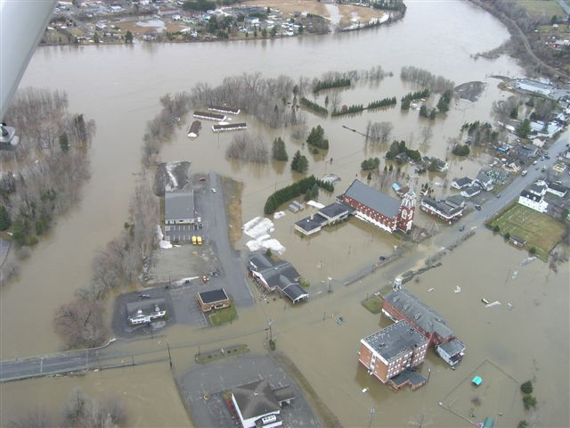

Fort Kent-May 2008 Photo courtesy of Maine Forest Service

Flooding

“St. John River Basin. The St. John River Basin includes portions of Aroostook, Somerset, Piscataquis, and Penobscot Counties. The river basin drains 1,650 square miles from a vast area in both Canada and northern Maine. The St. John River runs 420 miles and has a considerable drop in elevation in the upper section followed by generally flat topography with rolling hills. The state’s only National Scenic Waterway, the Allagash, which forms the headwaters of the St. John basin, is world renowned for its wilderness canoeing. The St. John forms Maine’s northernmost border. Because of the wide channel and steep banks, the main stem of the St. John River has relatively moderate flooding. Some tributaries of the St. John, such as the Aroostook River, are prone to flooding. There is, however, very little development at risk in the St. John Basin. Maine’s two most significant levees, Fort Kent and Fort Fairfield, are in this basin. The Fort Kent levee was built in the late 1980’s, and has since seen numerous updates. The Fort Fairfield levee was built in 2001. In 2008, a flood on the Saint John River came within three inches of the top of the levee but did not overtop it. Despite the height of the water, the levee withstood the flood (Maine State Hazard Mitigation Plan, 2023, page 3-18).”

In 2010, FEMA published a report, “Living Behind the Levy Fort Kent, Maine: Knowing the Threat, Anticipating the Vulnerability.” As stated in the Executive Summary, this document has three main objectives:

- Focus decision-making on key recovery actions related to local capacity, debris management, temporary housing, and redevelopment;
- Evaluate the factors that make Fort Kent most susceptible to damage and the resources it has available for a potential recovery effort;
- Identify options that the community could consider as starting points for either pre- or post-disaster planning efforts.

Flooding in Aroostook County has many causes. Ice jams from the spring thaw, severe storms and saturated farm fields are just some examples of the causes. The Aroostook County Emergency Management Agency (AKEMA) has copies of flood maps for the towns that participate in the National Flood Insurance Program.

In the springtime, AKEMA monitors the following rivers at the following points:

- Aroostook River: Masardis, Washburn, Fort Fairfield
- St. John River: 9 Mile Bridge, Dickey, Fort Kent
- St. Francis River: Connors
- Big Black River: Depot Mountain
- Fish River: Fort Kent
- Allagash River: Allagash
AKEMA has also conducted a survey of all Aroostook County dams. This was done by visiting each dam, getting pictures and creating site maps. Once that was complete, the information was placed in a resource guide, divided by town, which also includes dam owners, ID numbers and emergency contact information.

Types of Flooding in Aroostook County: Flooding is a temporary inundation of normally dry land as a result of: 1) the overflow of inland waters; and/or 2) the unusual and rapid accumulation or runoff of surface waters from any source. Note: the nature of Aroostook County’s geology and hydrology is such that flooding is usually fast rising but of short duration. There are several different types of potential flooding in Aroostook County:

- Dam failure: The sudden release of water resulting from structural collapse or improper operation of the impounding structure. Dam failure can cause rapid downstream flooding, loss of life, damage to property, and the forced evacuation of people.

- Flash flood: A flood event occurring with little or no warning where water levels rise rapidly due to heavy rains, ice jam release, or rapid snow melt.

- Ice jam: An accumulation of floating ice fragments that blocks the normal flow of a river. During a thaw or rainstorm, the rapid increase in discharge from snow melt and/or rainfall can rapidly lift and break up a thick ice cover and carry it downstream as an ice run. Ice runs can jam in river bends or against the sheet ice covering flatter reaches. The resulting ice jams can block flow so thoroughly that serious flooding may result within an hour of their formation. Failure of an ice jam suddenly releases water downstream. Damages from ice jam flooding usually exceed those of clear water flooding because of higher than predicted flood elevations, rapid increase in water levels upstream and downstream, and physical damage caused by ice chunks. Moving ice masses can shear off trees and destroy buildings and bridges above the level of the flood waters.

- Lacustrine: (Lake Flooding) occurs when the outlet for the lake cannot discharge the flood waters fast enough to maintain the normal pool elevation of the lake. During a base flood event, normal increases in water surface elevations on most Maine lakes and ponds range from 1 to 5 feet. However, in Maine there are some examples where the base flood event will reverse the flow of the outlet stream. In such instances, river and base flood elevations can rise more than 15 feet above normal pool. While this can impact individual sport camps built near the water's edge, there are no records of major damages so this type of flood will not be further addressed in the Plan.

- Riverine/riparian: Periodic overbank flow of rivers and streams, usually the result of spring run-off, but can also be caused by major rain storms. This is the major type of flooding in Aroostook County.

- Urban: Overflow of storm sewer systems, usually due to poor drainage, following heavy rain or rapid snow melt. The combined sanitary and storm water systems that some urban areas installed years ago cause flooding of sanitary sewerage when riparian floods occur. Runoff is increased due to a large amount of impervious surfaces such as roof tops, sidewalks and paved streets.

- Beaver Dam Flooding: Flooding resulting from back-up and overflow of water resulting from beaver dams.

Nature of the Hazard from Dam Failure: Maine dams were constructed incrementally over a period of 300 years. Businesses harnessed the abundant fast flowing rivers and rocky rapids for the development of energy and transportation. Many dams throughout the country are now aged, and in Maine the majority of these structures are nearly 100 years old and beyond the normal design life of civil engineering works. Many are low head dams constructed using local materials of stone, timber and earth. Based on anecdotal information obtained at a September 19, 2006 meeting in Caribou, a 1954 hurricane resulted in a deluge that washed out the Mars Hill and Easton dams, as well as several roads. Dam failure is not a frequent occurrence. Given the age of most dams in Maine, the possibility of failure increases with time but is not predictable. Dam failure generally has a lower probability of occurring than riverine flooding, but it can and does occur, with potentially large impacts.

Maine law, consistent with federal law, classifies the hazard potential of dams as High, Significant or Low. If they failed, High Hazard dams could cause loss of life; Significant Hazard dams could cause significant property damage and Low Hazard dams would generally cause damage only to the owner's property. Therefore, it's possible that a small (low head) dam located above a large community could be rated High Hazard while a structurally larger dam sited in an unpopulated area could be a Low Hazard potential.

In Aroostook County, there are twelve (12) High Hazard dams and six (6) Significant Hazard dams, as shown in the table below. Only one of the dams shown in the table, Scopan, is regulated by the Federal Energy Regulatory Commission (FERC). The rest are regulated by the Maine Emergency Management Agency. The county also has 38 low hazard dams that are not included in the table.

Aroostook County High Hazard and Significant Hazard Dams
High Hazard Dams
MEMA ID | Dam  Name | Other  Name | River | Town | Owner Name
134 | Josephine | Lake Josephine | Prestile Stream | Easton | McCain Foods USA Inc.
135 | Christina | Lake Christina | Prestile Stream | Fort Fairfield | McCain Foods USA Inc.
136 | Bryant Pond | n/a | Libby Brook | Fort Fairfield | Fort Fairfield
138 | Libby Brook | n/a | Libby Brook | Fort Fairfield | Fort Fairfield
141 | Durepo Brook | n/a | Durepo Brook | Limestone | Limestone
142 | Trafton Lake | Webster Brook | Limestone Stream | Limestone | Limestone
143 | Noyes Mill | Noyes Pond (Corp) | Noyes | Limestone | Limestone
144 | Community Pond | Limestone Community | Limestone | Limestone | Limestone
148 | Mantle Lake | Mantle Lake Outlet | Mantle Brook | Presque Isle | Presque Isle
151 | Hanson Brook | n/a | Hanson Brook | Mapleton | Presque Isle
154 | Violette Brook | n/a | Violette Brook | Cyr Plantation | Van Buren Water District
414 | Scopan | Squa Pan | Scopan Stream | Masardis/  Ashland | InClime, Inc
Significant Hazard Dams
MEMA ID | Dam  Name | Other  Name | River | Town | Owner Name
150 | Arnold Brook | n/a | Arnold Brook | Presque Isle | Presque Isle
152 | Hunnewell Lake | n/a | Thibeault Stream | St. John Plantation | IFW/State of Maine
653 | Smith Farm | n/a | Smith Brook | Westfield | H.Smith Farm Family Limited Partnership
823 | McCrum’s Pond | n/a | Rideout Brook | Westfield | Neil Grass B.D. Grass & Sons LLC
999 | Jack’s Pond | n/a | Tributary of North Meduxnekeag River. | Monticello | Laurice Grass-Bell & Michael Foster
1006 | Schools Farm  Dam | Littleton Irrigation Pond | Unnamed | Littleton | Seedpro Inc.
Source: MEMA and AKEMA

Nature of Flood Hazard other than Dam Failure. Severe flooding can cause loss of life, property damage, disruption of communications, transportation, electric service and community services, crop and livestock damage, health issues from contaminated water supplies, and loss and interruption of business. Ironically, firefighting efforts can be compromised if fire fighters and equipment are responding to a flood emergency.

Generous precipitation (about 41 inches a year) contributes to the flood potential. The low pressure system over the eastern seaboard and the tendency of some storms to follow one another in rapid succession provide heavy, combined moisture. Water abundance is one of Aroostook County’s most valuable natural resources and its primary hazard.

Location of Flooding Hazard: Aroostook County's susceptibility to flooding is further exacerbated by the wide-ranging weather variables as discussed in the climate section. Due to seasonal (and regional) factors such as heavy rains, rapidly melting snow pack and/or ice jams, major flooding most frequently occurs between December and May. Based on MEMA data, the most flood prone months are April, January and March respectively. Floods can also be caused by hurricanes.

Location of Municipal Flood-Prone Areas. The following is a summary of areas that are subject to flooding and/or that have had repeated flood damages in specific jurisdictions, as identified in the Aroostook County Hazard Mitigation Planning Municipal Survey 2015, and susequently modified in 2021 and 2026.

- Allagash: Ice jam flooding at Allagash/St. Francis town line. Also can have flooding near 460 Dickey Road.
- Amity: We have several major culverts on Mountain Road, Estabrook Road, Lycette Road and Tracy Road that can lead to issues when beavers are active.
- Ashland: The Aroostook River along Route 11 and the Garfield Road.
- Blaine: Dam at Robinson Pond, low areas of the Kinney Road, E Plantation Road and East Blaine Road.
- Bridgewater: Route 1 corridor between Fire Station and Boundary Line Road; Dead Brook area of Packard Road; Whitney Brook Bridge on Tannery Street; and Boundary Line Road.
- Caribou: Grimes Road.
- Castle Hill: Dudley Road – Dudley Brook.
- Caswell: Willard Road sometimes washes out.
- Chapman: Dockendorf Brook, washout in 2024.
- Crystal: Most flooding incidents only cause road closures, usually very small property damage, depending on flood conditions and severity of such. Areas where Fish Stream crosses Crystal Road (Route 159). Crystal Road (5 Mile Corner) where it crosses Crystal Brook – does not usually flood, but has a very old bridge, and is a major connecting artery – this could cause travel disruptions if this area flooded or bridge was damaged.etreat Road – poor drainage of large swampy area - floods road from a few hours up to 24 hours after heavy spring rains. Pine Tree Road at Crystal/Island Falls townline – Cold Brook Bridge (Route 159). Winding Hill Road has poor drainage in areas and would cause washouts.
- Cyr Plantation: Madore Road.
- Dyer Brook: None.
- Eagle Lake: Residents living in the thorouoghfare of the Eagle Lake in the Plaisted area.
- Easton: Lakes Christina and Josephine are in floodplains. Route 10 (at Presque Isle/Easton border) and Route 1A (north of Easton Center).
- Fort Fairfield: Fort Fairfield has three major hazards; the Aroostook River in the spring, Libby Brook Dam, and Bryan Pond Dam. A dam failure at Bryan Pond dam would contribute to a failure at Libby Brook Dam creating a flood area that would impact a majority of the urban area of the community. A dike failure along Main Street would affect the major artery of town and most local businesses.
- Fort Kent: St. John River; Fish River; Cross culvert and driveway culvert on North Perley Brook Road near Black Lake Road (Fort Kent has been awarded a Hazard Nitigation Grant to remediate this issue); Ferry Road along Fish River to old Fish River bridge site; most of East Main Street, SW Collins lumberyard, and the Blockhouse picnic area.
- Frenchville: We have identified four stream crossings which do not meet the 100 year storm event criteria. We also have upwards of an additional 50 culverts which could be at risk in a 100 year storm event.
- Grand Isle: River flooding always being monitored, but with very limited damages recorded.
- Hamlin: None.
- Haynesville: River properties along Mattawamkeag River. No damages/ no repeated damages.
- Hodgdon: Jackins Settlement Road; Little Road; Hillview Avenue; north side of Hodgdon Mills Road (by the fire department).
- Houlton: Green Street area, Sugarloaf Street, Pearce Brook area. Snowmelt combined with heavy rainfall causes flooding of Meduxnekeag River, streams and low-lying areas throughout Houlton.
- Houlton Band of Maliseet Indians: The HBMI is situated along the Meduxnekeag River in Littleton and Houlton. This river is susceptible to ice jams and flooding in the spring, but it is not typical that any home or structures wuld be threatened. There is an un-named tributary which has washed out on the Bell Road, preventing access to the Tribal Administration buildingh and the EOC.2
- Island Falls: The town is surrounded by water, and several areas are in the FEMA floodzone. In general, flooding incidents cause road closures, usually very small property damage, depending on flood conditions and severity of such. Dyer Brook crossing Houlton Road – ice jams in spring. Old Patten Road – sometimes goes to Sewall Street (within the FEMA floodplain).
- Limestone: Low lying areas.
- Linneus: Bither Brook crossing on Folsom Road and Burton Road; Beaver Brook crossing of South Oakfield Road; intersection of Bates Ridge Road and Drews Mills Road; Erosion of gravel surface; Burton Road Hill; Erosion of gravel surface heavy rain event and spring melt South Oakfield Road Crow Hill; Gravel surface erosion during spring melt and heavy rain events.
- Littleton: Foster Road.
- Ludlow: Lamb Brook at Ludlow Road.
- Madawaska: N/A.
- Mapleton: Tea Kettle Brook has had a new culvert and the road has been improved a couple of years ago (it may not be a problem now). Parsons Road – Aroostook River.
- Mars Hill: The area from the Prestile Stream dam south along the Prestile Stream has in the past been susceptible to high water, particularly during the spring runoff period.
- Masardis: Route 11, Main Street in town, Aroostook River, and St. Croix Stream all converge onto Main Street. Also Garfield Road in spring when flats flood.
- Mi’kmaq Nation: Spruce Haven at 114 Doyle Road in Caribou has been identified as a potential flood area.
- Monticello: We have several roads or town ways that are susceptible to flooding. These have not changed. The roads or town ways have not changed either so we alleviate the problem the most cost effective at the moment. To reconstruct the road or change any route of travel we burden the yearly budget.
- Nashville: None.
- New Canada: Daigle Pond.
- New Limerick: Area between 678 Drews Lake Road and 731 Drews Lake Road is low; west end of Drews Lake Road is also vulnerable.
- New Sweden: Rista Road, Jepson Road, School Land Road, Thomas Road.
- Orient: Properties near East Grand Lake.
- Perham: None.
- Portage Lake: All areas along the lakeshore and edges of the Fish River and its tributaries.
- Presque Isle: Egypt Road, Washburn Road, Phair Junction, possibly Dyer Street. Reed Plantation: All areas around Mattawamkeag River.
- St. Agatha: Brook Road would need a buffer zone created. Bosse Road washes out and also the connector between Flat Mountain and Morneault Road.
- St. Francis: ice jam flooding at Kelly Crossing west to 337 Main Street; Thibodeau Brook west to 985 Main Street; Narrow Gauge west to St. Francis/Allagash town line.
- St. John Plantation: St. John Plantation is along the St. John River, so all low lying areas are susceptible.
- Sherman: Molunkus Stream goes through down town Sherman.
- Stockholm: Areas along the Madawaska River would be about the only places that could potentially flood. No flood damage in recent years.
- Unorganized Territory: County-wide in the Unorganized Territory.
- Van Buren: Anywhere within town limits that borders the St. John River and Violet Stream. It is not an annual event but is closely monitored during ice outages and heavy rainfall.
- Wade: Residents along the Aroostook River on Gardner Creek Road always have the issue of flooding during the ice out period in the spring. Quite often they find themselves stranded for several days or more. We have received a grant for a new bridge bridge at one of the most critical areas of flooding on this road. We are in hopes to get this started in the summer of 2026-2027.
- Wallagrass: The combination of the Fish River putting out of Eagle Lake, one of the biggest water bodies in the area, and Soldier Pond creates significant flooding hazard in the “downtown” area of Wallagrass, otherwise known as Soldier Pond. There have been several flooding events in this area, otherwise known as Soldier Pond. There have been several flooding events in this area which is a critical intersection for the town. Additionally, there is a stream that puts into Soldier Pond which also has presented flooding issues and is currently experiencing erosion due to high water levels at various times of the year.
- Washburn: Gardner Creek Road. A bridge just below the old McCains site. The Annis Road floods most years. When that floods, there is no other alternative route to get off of that road.
- Westfield: Tweedie Road.
- Westmanland: Little Madawaska Lake Road used to flood yearly. The community did some repairs there and hope that is taken care of.
- Weston: Some lakeshore frontage designated in the FEMA flood mapping dated 1975. The only other potential would be from blocked culverts that might lead to road flooding.
- Winterville Plantation: Red River Road near Route 11. In 2008, area camps flooded.
- Woodland: Carson Road, Everette Road, David Road, Margeson Road, Thomas Road, McIntyre Road, Church Street.
- Caribou Utilities District: Flooding on Grimes Road could cause power outage at wastewater treatment plant.
- Presque Isle Utilities District: Water suppply is under the influence of Aroostook River, water quality may degrade. Well pumps and equipment could becomoe submerged and inoperable. Wastewater plant is located in a low lying area, flooding could impact treatment operations as well as hydraulicly limit effluent flow.

Extent. The majority of the flood damage in the county is caused by winter runoff in the springtime, which undercuts or overtops local roads. When Maine has an above average snowfall for the winter and then warmer temperatures and rainfall suddenly arrive in the spring, the snow pack melts off more quickly than the watersheds can handle. This can cause local water bodies to overflow their boundaries and flood nearby road surfaces. Typically, the road damage is not major, although it can absorb the municipal road budget for an entire year and does happen in several towns almost every year.

The St. John River Basin drains a vast area in Canada and Northern Maine and has a considerable drop in elevation in the upper section. Because of the wide channel and steep banks, the main stem of the St. John River has relatively moderate flooding. Some tributaries of the St. John, such as the Aroostook River, are prone to flooding.

The following is a summary of the extent of flooding, based on flood crests monitored by USGS river gages and reported by the National Weather Service in Caribou. A flood crest is the maximum height to which floodwaters rise before receding. The National Weather Service defines minor, moderate and major flood stages indicating the degree to which flood crests overflow the natural banks of the river and begin to cause flood damage in the local area.

St. John River at Fort Kent:

- Record: 30.1 feet
- Major Flooding 26.5 feet
- Moderate Flooding 24.5 feet
- Minor Flooding 22.5 feet

Recent Crests | Historic Crests
- 17.15 ft on 04-15-2024 | 1. 30.07 ft on 04-30-2008
- 15.56 ft on 12-20-2023 | 2. 27.31 ft on 4-30-1979
- 19.61 ft on 04-19-2023 | 3. 26.95 ft on 05-01-1974
- 17.99 ft on 04-17-2022 | 4. 26.60 ft on 04-17-1994
- 14.16 ft on 04-11-2021 | 5. 26.33 ft on 04-19-1983

Aroostook River at Washburn

Flood Crests

- Record 21.1feet
- Major Flooding 20 feet
- Moderate Flooding 17 feet
- Minor Flooding 14 feet

Recent Crests | Historic Crests
- 10.11 ft on 04-15-2024 | 1. 21.14 ft on 04-18-2015
- 10.03 ft on 12-20-2023 | 2. 20.91 ft on 12-24-1973
- 19.66 ft on 04-19-2019 | 3. 19.66 ft on 04-20-2019
- 14.99 ft on 04-21-2018 | 4. 17.80 ft on 04-08-1990
- 21.14 ft on 04-18-2015 | 5. 17.47 ft on 04-12-1991

Fish River at Fort Kent

Flood Crests
- Record: 13.9 feet
- Major Flooding 13 feet
- Moderate Flooding 12 feet
- Minor Flooding 11 feet

Recent Crests | Historic Crests
- 8.02 ft on 04-16-2024 | 1. 13.93 ft on 04-30-2008
- 8.78 ft on 04-25-2023 | 2. 12.43 ft on 4-30-1973
- 8.64 ft on 04-29-2022 | 3. 12.02 ft on 05-03-2018
- 7.59 ft on 04-12-2021 | 4. 11.75 ft on 04-26-1983
- 8.49 ft on 05-11-2020 | 5. 11.49 ft on 05-16-1961

The following maps, obtained from FEMA’s Map Service Center, show floodplains in portions of Fort Kent and Allagash. Most communities in Aroostook County have not been mapped to this extent.

Fort Kent

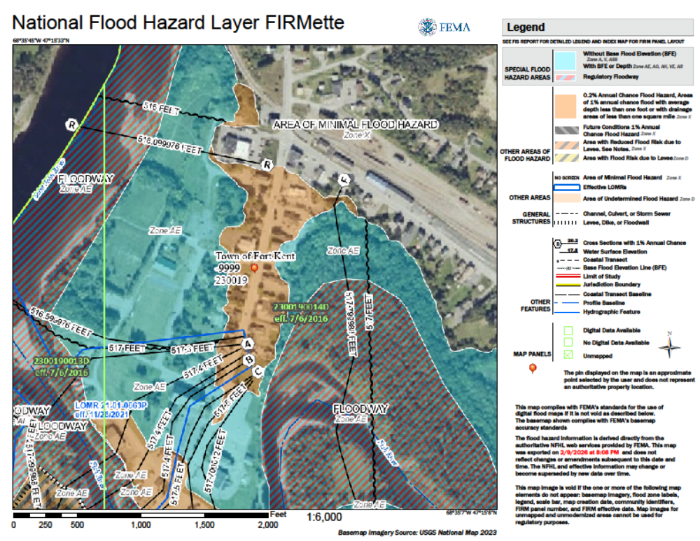

Allagash
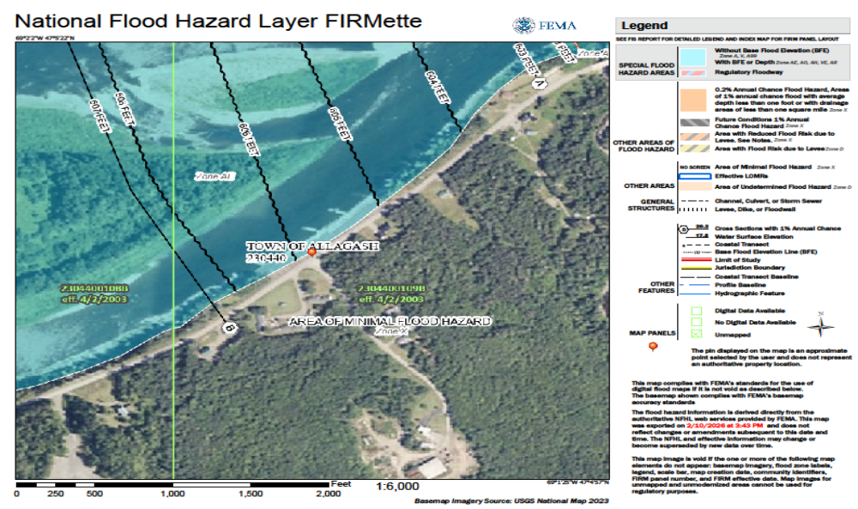

Previous Occurrences. Some flooding occurs every year, but some of the most significant and widespread flooding events are shown in the table below. Some of these flooding events resulted in disaster declarations.

Historical Summary of Flooding in Aroostook County
Year | Month/Day | Estimated Damage | Type of Damage | Declaration
1951 | Apr 12 | Unknown | Flood | n/a
1973 | Apr 24 | Unknown | Flood | Declaration denied
1973 | May 6 | $908,404 | Flood | SBA
1973 | Jul 1 | Unknown | Flood | SBA
1973 | Dec 20-26 | $3,000,000 Multi-County | Severe ice jams and flooding | Declaration denied
1974 | May 26 | $3,000,000 Aroostook | Flood | n/a
1976 | Apr 2 | $200,000 Aroostook | Flood | n/a
1976 | Aug 10-11  Hurricane Belle | Unknown | Crop Damage | SBA
1979 | Apr 30 | $648,500 Multi-County | Flood | SBA
1991 | Apr 10-12 | $1,899,139 | Severe ice jams & Flooding | DR-901
1993 | Apr 9-15 | $240,396 | Flooding | DR-988
1994 | Apr 15 | $5,700,000 Aroostook,  Fort Fairfield | Flooding, ice jams, damage to 71 homes and businesses | DR-1029
2000 | Mar 28-  Apr 26 | $448,690 | Flood | DR-1326
2005 | Mar 29-  May 8 | $262,989 | Flood | DR-1591
2008 | Apr 28-  May 14 | $TBD | Flood | DR-1755
2010 | Dec 12-19 | TBD | Severe winter storms, widespread flooding | DR-1953
2016 | Sep 19 | Unknown | Flash flooding, road closures | n/a
2018 | Apr 26 - May 8 | $2,800,000 | Flooding from rain/snow melt, road closures, wash-outs, structural damage to homes and recreational structures | n/a

Fort Fairfield – 1994 Flood. On Saturday night, April 16, 1994, Fort Fairfield was deluged by a massive flood of historic proportions. The following is an excerpt from a New York Times article dated April 18, 1994:

“Spring arrived with a vengeance over the weekend in this town in northeastern Maine when an ice jam clogging the Aroostook River burst, sending large blocks of ice into town on a wave of frigid waters.”

“Like outsized pieces of some frozen jigsaw puzzle, the ice slammed into buildings and cars on Saturday night, forcing 60 people to evacuate their homes. Ten (10) feet of water flooded Main Street, damaging more than a score of businesses….”

Two (2) Canadian Customs officers from nearby Perth-Andover, New Brunswick, were drowned when the ice jam broke and the flood trapped them in their car at the border five miles east of here.”

The information contained in the paragraphs below was obtained from Fort Fairfield’s Community Development Director/Floodplain Coordinator, Tony Levesque. This brief overview focuses on major outcomes and does not describe the challenges, setbacks, unanticipated expenses or the many complications that were encountered.

The deluge of 1994 affected approximately 130 single family homes and apartment units, and 43 businesses. Six (6) of the homes were rendered uninhabitable. Most of the businesses and homes were located in and around the downtown on the south side of the river. Approximately 35 dwellings, two (2) mobile home parks and an apartment building were located on the north side.

The Town teamed up with a number of federal, state and local agencies, as well as the Maine Congressional Delegation, to respond to the devastation. All parties worked hard and cooperatively on desired outcomes. The town hired a relocation coordinator and administrative assistant to help with the workload.

Actions included using a patchwork quilt of grant funds to develop a plan of action, move people out of the floodplain on the north side of the river, and build a dike to protect the downtown. By 1997, the Town had completed all of its prioritized purchases as outlined in the plan of action. On the north side of the river, several structures were elevated out of the floodplain. A number of people were relocated to one of two town-created subdivisions as well as other available properties in Fort Fairfield. A park and a boat ramp were established on the now-vacant floodplain properties. Acquisition and relocation costs totaled about $2.95 million.

On the south side of the river, grant funds were used to construct a 2,100 foot dike in the year 2000 to protect the downtown. This involved purchasing property for the dike, establishing interceptors, gates and pump stations to manage sanitary waste, storm water, streams and ground water flowing from terrain above the downtown. During flooding events, gates are closed on storm drains that normally flow by gravity through the dike to the river so that water is diverted to the interceptor and discharged by high pressure pumps through the dike and into the river.

The dike has subsequently protected the town from a number of floods, including several that potentially would have been worse than the flood of 1994. Fort Fairfield’s efforts have resulted in the elimination of all 17 repetitive loss structures.

Fort Kent Flood of 2008. As reported in various newspaper and other accounts, between April 30 and May 1, 2008, heavy rains combined with snowmelt to create record flooding of the St. John and Fish Rivers. In Fort Kent, flood waters caused the evacuation of over 600 people and flooded many homes and businesses, an elderly apartment complex, and many roads including Routes 1 and 161.

Five (5) feet of water entered Fort Kent Housing, an apartment complex for senior and disabled residents. The century-old St. Louis Catholic Church, caught between the rushing waters of the two rivers, suffered extensive damage when three feet of water entered the church, ruining pews, carpeting, a new organ, furniture and electronics and filling the 10-foot basement. A 31-foot levee protecting a portion of the downtown was almost overtopped when flood waters reaching an elevation of 30.14 feet. Flood waters also came within a foot of the International Bridge connecting Fort Kent with New Brunswick, Canada. The sanitary sewer system stopped working when sewer collection pumps went offline.

The response to the disaster was immediate. The Red Cross, Border Patrol, State Police, Game and Fire Wardens, and Fire Department were on the scene to assist in the evacuation and provide support. Approximately 70 National Guard personnel assisted homeowners in the St. John Valley in cleaning out their homes and property and piling trash at the roadside to be picked up by town crews. Residents who did not suffer damage helped others to clean out their homes and cellars. Volunteer firefighters pumped water from the church (one cellar wall crumbled from the pressure of the water). Firefighters also used huge pump trucks to wash the mud and debris from East Main Street. Public Works Department employees removed a temporary gravel berm that had been created to stop the waters of Fish River from flooding the west side business district. Volunteers from outside the community came to help. Following initial cleanup efforts, five private homes and the senior housing complex were acquired and demolished through a combination of HMGP grant funds and private money.

Probability of Occurrence: The most widely adopted design and regulatory standard for floods in the United States is the 1% annual chance flood and this is the standard formally adopted by FEMA. The 1% annual flood, also known as the base flood, has a 1% chance of happening in any particular year. It is also referred to as the “100-year flood.” The probability of flooding of homes, commercial and governmental buildings and critical facilities located in flood-prone areas is 1% in any given year.

The probability of a dam failure of a high hazard or significant hazard dam in Aroostook County is low (a non-zero percent chance over a 10-year period).

Severe Winter Storms

Aroostook County has had severe frost and freeze-ups, extreme snowfall amounts, and ice jams. Maintaining heavy equipment, properly insulating pipes and mitigating water runoff issues are just a few of the things that are being done to reduce the effects of some of these storms.

Severe winter storms do not ordinarily have an immediate impact on flooding. They add to the snow pack, which in the January thaw or springtime can lead to rapid snowmelt, runoff and flooding. Ice jams can exacerbate flooding by temporarily blocking, then releasing, large volumes of water, often with disastrous downstream impacts.

Severe winter weather conditions are characterized by low temperatures, strong winds, and often large quantities of snow.

Types of Severe Winter Storms in Maine. A single winter storm may include one or more of the following. The descriptions below are derived primarily from the Maine State Hazard Mitigation Plan, 2023.

  - Blizzard. Sustained winds and frequent gusts of 35 miles per hour (mph) or more with heavy falling or blowing snow limiting visibility to ¼ mile or less that persists for three or more hours. The combination of conditions along with subfreezing temperatures brings potentially life-threatening traveling conditions.

        - Extreme cold: Temperatures that are much colder than local and seasonal average conditions. Health effects of extreme cold temperature are often exacerbated by wind chill. In Maine, these temperature definitions range from -35ºF in the North to -25 ºF in the Southwest.

        - Freezing Fog: Tiny, super-cooled liquid water droplets in fog can freeze instantly on exposed surfaces when surface temperatures are at or below freezing. Some surfaces that these water droplets may freeze on include tree branches, stairs and rails, sidewalks, roads and vehicles. Extreme caution should be taken if travel is necessary. Freezing fog in Maine is a rare occurrence that is normally confined to valleys.

        - Freezing Rain and Ice Storms: Freezing rain is liquid water precipitation that freezes upon impact with the sub-freezing surface. Any amount of freezing rain can be dangerous for travel conditions on untreated roads. An ice storm is used to describe occasions when damaging accumulations of ice are expected during freezing rain situations. Mean radial ice coating at least one fourth inch in thickness is heavy enough to begin to damage tree branches, overhead wires, and similar objects. A mean radial ice coating of one half inch is heavy enough to produce destructive widespread power outages.

        - Heavy Snow: A heavy snow is generally defined as a snowfall of 6 to 8 inches or more within 24 hours which disrupts or slows transportation systems and public safety departments’ response capability.

        - High Winds: High winds are common during the winter months, especially at higher elevations. In addition to potential damaging winds, high winds in winter often coincide with cold temperatures to cause wind chill. High winds and blowing snow can lead to development of dangerous snow drifts and white out conditions that pose roadway hazards.

        - Nor’easter. Winter storms can threaten Aroostook County any time from November through April. The Gulf Stream follows a path up the eastern seaboard, bringing major storms with it to the Gulf of Maine. Air streams containing much colder air flow down from Canada and collide with the Gulf Stream over the New England region. Nor’easters, the most severe storms in Aroostook County, occur during the winter, spring and fall. They rarely develop during the summer.

        - Sleet Storm: Sleet is defined as pellets of ice composed of frozen or mostly frozen raindrops of refrozen or partially melted snowflakes. These pellets of ice usually bounce after hitting the ground or other hard surfaces. Heavy sleet is a relatively rare event defined as an accumulation of ice pellets covering the ground to a depth of one half inch or more. Sleet can be extremely slick and hazardous to drive on compared to snow, but it doesn’t drift or cause low visibilities.

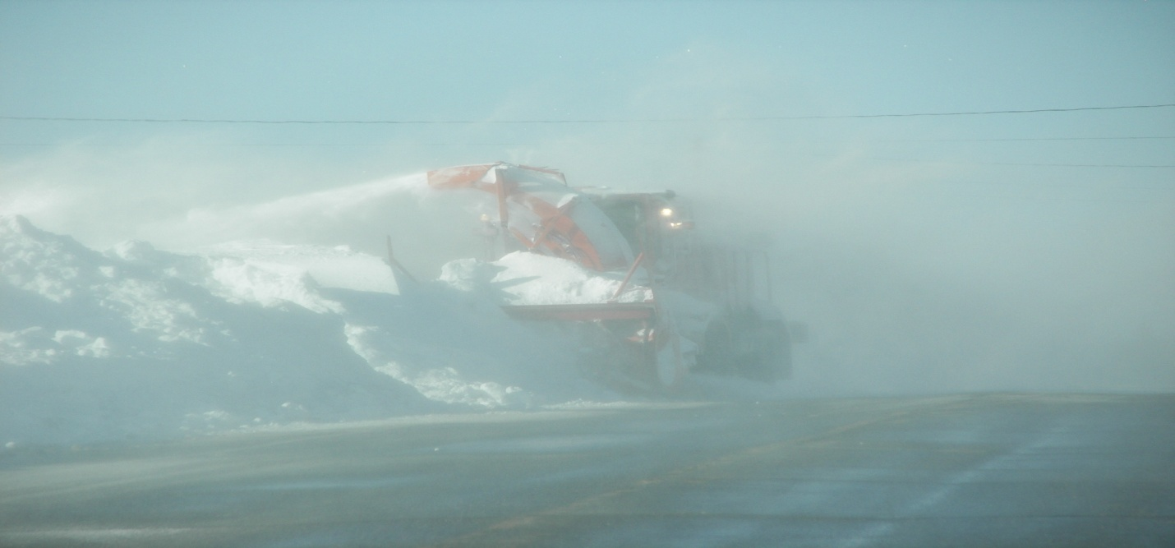
Caribou - Jan. 2008 Photo courtesy of Vern Ouellette

Precipitation amounts can exceed several inches of water equivalent (20-30 inches of snow or more). Loss of electrical power and communication services can impede the response of ambulance, fire, police and other emergency services, especially to remote or isolated residents. Roads can become impassable as the result of snow accumulation and drifting. Business closings can occur due to road conditions and loss of power. Structural failures are possible as the result of snow loads on roofs. This is of particular concern with respect to older structures built prior to the advent of snow-load design standards. Heavy snow loads can also result in the formulation of ice dams on roofs, leakage and damage to building interiors.

Location of Severe Winter Storm Hazard. The entire county is subject to severe storms every winter, but there have been a number of storms that have been worse than others.

Location of Severe Winter Storm Impact areas. The following is a summary of areas that are susceptible to severe winter storms, as identified in the Aroostook County Hazard Mitigation Planning Municipal Survey 2015 and susequently modified in 2021 and 2026.

- Allagash: We do occasionally have power outages because of trees falling on power lines.
- Amity: The entire town often loses power in storms.
- Ashland: All areas of our community are susceptible to severe winter storms and power outages. Areas along the Aroostook River would be susceptible to ice jams
- Blaine: Ice jam, dam at Robinson Pond.
- Bridgewater: Route 1 by fire station is susceptible to ice jams under the bridge of Dead Brook and Route 1; ice jams under Whitney Brook bridge and Route 1; Whitney Brook bridge on Tannary Street. Power outages at Wicklow Place senior housing complex, and throughout town if it is an extended outage. Drifting snow on many secondary roads, on the Route 1 corridor the length of town and especially on the Bunker Hill area around Bunker Hill.
- Caribou: Grimes Road.
- Castle Hill: All the north/south roads are problems for blowing and drifting snow.
- Caswell: All of Caswell.
- Chapman:
West Chapman Road (DOT) – inadequate ditching and culvert sizing, creating issues with water flow from drainage, flooding the road.
Grendell Road – catch basin is in a sharp corner, unable to handle fast water drainage, floods into nearby neighbor yard, washing out their driveway.
Chapman Road – inadequate ditching and culvert size, unable to handle water flow, flooding road.
Chapman Road – Dockendorf Brook, washout in 2024.
- Crystal: Crystal has an aging population, making snow removal and clean up of roofs and yards, difficult. Most residents live on state roads or local maintained/plowed roads, but some live on privately owned roads.
Severe snow storms: may disrupt all residents from accessing local services, or leave residents without power for extended periods. Most residents do not have back up power systems, and less people are using wood stoves as primary and/or and back-up heating sources.
Ice jams: mostly cause road closures due to flooding of 24 hours or less. Very few residences see property damages by flood waters, unless severe.
- Cyr Plantation: Omer Dumond Road; Madore Road.
- Dyer Brook: The whole town especially with power outages.
- Eagle Lake: There is risk of ice jams on Fish River thoroughfare in the Plaisted area of Eagle Lake.
- Easton: Conant Road, Route 1A, Ladner Road, and Mahany Road all are problematic for snow blowing over the road and stranding motorists, most notably transports to and from McCain Foods and Huber. Power outages have severe consequences as Easton does not have warming and other generator-driven shelters.
- Fort Fairfield: Ice james occur during the winter months after a thaw. Ice build-up from the Caribou/Fort Fairfield town line contributes to a blockage of ice at Tinker Dam. The backflow of water creates a substantial hazard to the town if the pumping system at the dike were to fail. Severe winter storms have been known to shut off travel and strand residents in rural areas of the community. Areas on Forest Avenue, Center Limestone, and West Limestone Roads and their connecting roads have lost access to emergemncy services in the past due to heavy snow.
- Fort Kent: The entire community is subject to severe storms each year, with some storms having greater impacts than others. The area is also susceptible to ice jams along the St. John River particularly at the mouth of the Fish River and upstream from the St. John River bridge.
- Frenchville: We experience snow drifting on several of the roads located in the southwest section of town.
- Grand Isle: Heaavy and wet snow always a major factor but again very limited concerns, just have to monitor when melting occurs ijn the spring.
- Hamlin: Unknown
- Haynesville: Camp off maintained roads. No known ice jams. Power outages expected during all storms.
- Hodgdon: We have not had any issues with ice jams and minimal issues with power outages.
- Houlton: Smyrna Street/Meduxnekeag bridge area is susceptible to ice jams. Due to the rural wooded nature of farm areas in Houlton, massive power outages have been experienced throughout town. Disruption in the electrical transmission system from New Brunswick due to winter storms and downed trees can cause major disruption to power services.
- Houlton Band of Maliseet Indians: Power outages and winter storms in the Clover Circle area are of primary concern. With a high percentage of elderly population who are food assistant dependent, and unable to travel in snow conditions, there is a need to provide them with basic needs.
- Island Falls: Island Falls has an aging population, making snow removal and clean up of roofs and yards difficult.
Most residents live on state roads or locally maintained roads, but some live on privately owned roads (especially on Mattawamkeag Lake and Pleasant Pond). Severe snow storms: may disrupt all residents from accessing local services, or leave residents without power for extended periods. Most residents do not have back-up power systems and there are less people using wood stoves as primary and/or back-up heating source.
Ice jams: mostly cause road closures due to flooding of 24 hours or less. Very few residents see property damages by flood waters, unless severe.
- Limestone: None identified.
- Linneus: All areas of the town. Power outages from wind, overloaded power lines-snow; downed trees from wind, or snow load or a combination of both. Loss of access from heavy snow events, particularly on privately maintained roads such as the South Shore Road which provides access to varioius homes on Meduxnekeag Lake; or the Fire Road which provides access to a few individuals who are living off the grid.
- Littleton: None.
- Ludlow: The western side of town has issues with power failures. The east is served by Houlton Water Company and seems fine. All the roads running north and south can experience problems from blowing and drifting snow and possible blockages. The entire town could be at risk for a power outage.
- Madawaska: The boat landing is susceptible to ice jams. It happened on April 18, 2019 where the the ice had jammed, and water backed up into the public bathrooms.
- Mapleton: Highes Road (DOT) – inadequate ditching and culvert sizing, creating issues with water flow from drainage, flooding the road.
- Mars Hill: We have several roads that run in a north/south orientation that are susceptible to drifting snow during and immediately after severe winter weather. These roads include, but are not limited to all or portions of the West Ridge Road, the East Blaine Road, the Westfield Road, the East Ridge Road, the Boyd Road and the Kearney Road.
- Mi’kmaq Nation: Littleton and Connor are the most susceptible to storm damages and a loss of power and access due to road closures.
- Masardis: Route 11, Main Street in town, Aroostook River, and St. Croix Stream all converge onto Main Street. Also Garfield Road in spring when flats flood.
- Monticello: The town has several roads that have drifting snow. We have some wind breaks to help, but a big storm forget it. The town is mostly agricultural acres, so open fields and distances between residents makes plowing difficult as you are unable to stop plowing any one road in order to keep another one open.
- Nashville: None.
- New Canada: The entire community experiences severe winter storms each year, with some storms having greater impact than others. New Canada Road and Cemetery Hill Road are our3e worst roads in the winter.
- New Limerick: None.
- New Sweden: None, unless severe wind storm taking down trees
- Orient: The town has had a number of power outages this year. We are small so this affects the whole town.
- Perham: None.
- Portage Lake: Ice jams: the south end of the lake where ice tends to get pushed up during spring thaw. Power outages: sporadically throughout town – there are several pole-mounted transformers that could malfunction and cause localized outages.
- Presque Isle: Entire community is susceptible to power outages, Washburn Road and at times Dyer Street may be a hazard for flooding depending on snow amounts and spring thaw. Reed Plantation: The entire town is susceptible to power outages.
- Sherman: N/A
- St Agatha: This is not a huge issue. Our biggest struggle is the wind on Flat Mountain. We struggle with visibility and keeping the road open.
- St. Francis: The town has not had any issues with severe winter storms. Occasional power outages have occurred but duration is minimal.
- St. John Plantation: All areas.
- Stockholm: Power outages in the area.
- Unorganized Territory: County-wide in the Unorganized Territory.
- Van Buren: Our entire community is susceptible to severe winter storms. Wade: The North Wade Road and the Howe Road are very hard roads to keep open during the winter. With wide open spaces, heavy snow and wind cause these two roads to become plugged during a heavy storm.
- Wade: The North Wade Road and the Howe Road are very hard roads to keep open during the winter. With wide open spaces, heavy snow and wind cause these two roads to become plugged during a heavy storm. We currently made windrows in fields of the critical places which has helped greatly with this issue.
- Wallagrass: The area of Wallagrass on Strip Road is extremely susceptible to high winds, blowing snow and power outages. Additionally, on Route 11, in Pinette Hill, winter storms present a significant issue almost all winter long.
- Washburn: Basically the entire town. We have several roads that if left for any extended period of time during a large snow storm with wind will get plugged. Cross Road, Tabor Road, Everett Road are the main worries during a storm.
- Westfield: Shorey Road.
- Westmanland: Power outages happen on a regular basis and create the biggest hazard for our residents.
- Weston: Ice jams are N/A. Power outages to those in lake neighborhoods; generally, on private roads would be the last to be restored.
- Winterville Plantation: Winter storms – Winterville. Ice jams – areas around lake.
- Woodland: Pratt Road, Bondeson/Margison Road.
- Caribou Utilities District: Power supply issues.
- Presque Isle Utilities District: Extended power loss. Crew accessibility due to road conditions. Frozen water supply lines. Extensive electrical interference can adversely impact electronics used to operate the water and wastewater plants.

Extent. Total snowfall in Aroostook County typically ranges between 90 to 110 plus inches. The county’s largest average seasonal snowfall totals from lengthy records are 116 inches per winter season in Caribou. January is usually the snowiest month throughout, with many stations averaging over 20 inches of snow during that month. December usually averages out to be the second snowiest month. The extent of severe winter storms is dependent on factors such as temperature, snow fall, ice cover, sustained wind speed wind gust speed, duration of event, and time between events. The extent of one winter weather event can be exacerbated if it occurs shortly after a previous event.

Extreme cold events in Aroostook County have produced air temperatures as low as -50 degrees (January 2009) and wind chills ranging from -35 degrees to -55 degrees, with individual events lasting from one day to over a week.

The NCEI (National Centers for Environmental Information) Storm Events Database documents 193 hail events in Aroostook County since 1958 with a maximum recorded diameter of 3.00 inches (baseball size) and $1.5 million in total documented property damage – including a single August 2016 Caribou storm that caused an estimated $1 million in vehicle damage from 1.50-inch hail.

The following map depicts the extent of snowfall in Aroostook County as well as Maine and the rest of New England for the period 1991-2020.

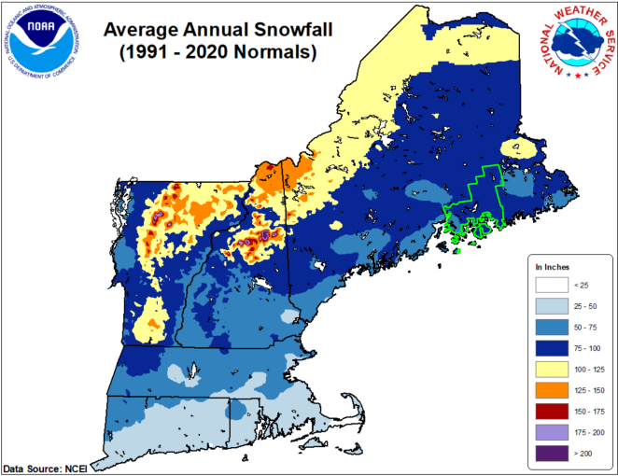

Previous Occurrences. Some of the most significant storms over the past 30 years are summarized in the table below.

Historical Summary of Major Winter Storms in Aroostook County

Year | Month | Day | Estimated Damage | Type of Damage | Declaration
1978 | Jan | 10 | Unknown | Winter storm –snow, rain , ice | n/a
1993 | Mar | 13-14 | Unknown | Winter storm | EM-3099
1998 | Jan | 5-25 | $1,496,635 | Ice storm, power outages, loss of heat, refrigeration, sanitary services, forestry damages | DR-1198
2001 | Mar | 5-31 | $139,226 | Severe winter storm | EM-3164
2003 | Dec 02 –Jan 03 | 17  1 | $312,475 | Severe winter conditions: frozen pipes | DR-1468
2003 | Feb | 2-4 | $345,182 | Severe winter storm | EM-3174
2003 | Dec | 6-7 | $202,126 | Severe winter storm | EM-3190
2003 | Dec | 14-15 | Unknown | Severe winter storms and severe cold | EM 3194
2005 | Feb | 10-11 | $334,405 | Severe winter storm | EM-3206
2005 | Mar | 9 | $498,000 | Severe winter storm | EM-3209
2005 | Dec | 25-27 | $512,603 | Severe winter storm | EM-3265
2010 | Dec |  | TBD | Severe winter storms, widespread flooding | DR-1953
2017 | Feb | 13 | Unknown | Statewide blizzard, winter storm | n/a
2017 | Mar | 14 | Unknown | Statewide blizzard | n/a
2018 | Jan | 4-5 | Unknown | Blizzard with heavy snow accumulation | n/a
2018 | Jan | 13 | Unknown | Winter storm – heavy snow and ice | n/a
2019 | Jan | 20-21 | Unknown | Winter storm – record breaking snowfall | n/a
2019 | Feb | 26 | Unknown | Severe winter storm – near blizzard conditions and heavy drifting | n/a
2019 | Apr | 3-4 | Unknown | Blizzard, traffic accidents, road closures | n/a
2019 | Nov | 11 | Unknown | Winter storm, power outages | n/a
2020 | Jan | 11-12 | Unknown | Winter storm – heavy snow and ice accumulation | n/a
2020 | Apr | 9-10 | Unknown | Heavy snow, power outages | n/a
2021 | Mar | 2 | Unknown | Winter storm – near blizzard conditions, road closures, traffic accidents | n/a
2024 | Jan | 9-13 | Unknown | Maine severe storms and flooding | DR 4764 -ME

The NCEI (National Centers for Environmental Information) Storm Events Database documents 24 distinct extreme cold/wind chill episodes in Aroostook County between 2000 and 2018 – defined as events meeting National Weather Service Wind Chill Warning criteria of -35 degrees or colder, including EM-3194 (December 2003, “severe winter storms and severe cold”), the January 2009 arctic outbreak during which Big Black River recorded -50 degrees, and a February 2016 event that forced cancellation of the Biathlon World Cup in Presque Isle.

Major hail events include August 4, 2007 (2.50-inch hail across 16 reports from Fort Kent to Caribou, destroying vehicles at a car dealership), August 2016, and numerous multi-community events producing golf-ball size hail in 2012, 2013, 2014, 2015 and 2020.

Probability of Occurrence. No probability studies have been done, but Aroostook County’s location in the Northeast, and its long experience with winter storms, indicate that between November and April of every year, such storms will occur. The locations where such storms are the most intense will vary from year to year.

Neither the State of Maine, nor the National Weather Service (NWS), maintain data on snowfall and ice accumulation on a town-by-town basis. The locations where such storms are the most intense will vary from year to year. Climate models suggest that Maine is likely to get more ice storms in the future because of warmer temperatures, but it is not known whether the severity of ice storms will be affected by warmer temperatures. A likely event is expected at least once every two years. NWS-warned extreme cold events occurred in 11 of 19 years (58%) in the NCEI record, and there is no indication that this pattern will change.

If colder temperatures prevail, the precipitation will be in the form of snow, as was the case in the record-breaking “snow year” of 2014-2015 that blanketed the Northeast. The winter of 2014-2015 also produced the coldest February in Maine since 1934 due to an unusually persistent atmospheric ridge trough pattern over North America that repeatedly brought Arctic flow into the region.

Hail events were documented in every year from 2010 through 2020 at an average rate of 8 reports per year, with significant hail (equal to or great than 1.5 inches) occurring in approximately 60-70% of years and a damaging event estimated at roughly once per 5-10 years.

Severe Summer Storms

For the purposes of this plan, severe summer storms are defined as those characterized by violent weather phenomenon producing winds, heavy rains, excessive heat, lightning, and hail that can cause injuries, and destruction of property, crops, and livestock. Severe summer storm damages typically involve downed overhead utility lines, flooding from heavy rain, and debris in the roads. Severe summer storms can have an immediate impact on flooding, primarily as a result of heavy downpours.

Types of Severe Summer Storms in Aroostook County: A severe summer weather event storm is a violent weather phenomenon producing winds, heavy rains, lightning, and hail that can cause injuries and destruction of property, crops and livestock. There are several different types of summer weather events in Aroostook County:

- Extreme heat. Summertime temperatures that are much hotter and/or humid than local and seasonal average conditions. Maine’s Center for Disease Control classifies an extreme heat event as one with temperatures above 90 degrees lasting for three or more days.

- Hail. A form of precipitation that occurs when updrafts in thunderstorms carry raindrops upward into extremely cold areas of the atmosphere where they freeze into ice. Hailstones then grow by colliding with liquid water drops that freeze onto the hailstone’s surface. The hail falls when the thunderstorm's updraft can no longer support the weight of the hailstone, which can occur if the stone becomes large enough or the updraft weakens. Hailstones larger than 1 inch in diameter are capable of causing property damage.

- Lightning. An electrical discharge that results from the buildup of positive and negative charges within a thunderstorm. When the buildup becomes strong enough, lightning appears as a ”bolt.” This flash of light usually occurs within the clouds or between the clouds and the ground. A bolt of lightning reaches a temperature approaching 50,000°F in a split second. The rapid heating and cooling causes thunder.

- Microburst. A small, extremely intense downdraft which descends to the ground creating strong wind divergence. Microbursts are typically limited to an area less than 2.5 miles across. This weather phenomenon is capable of producing damaging surface winds in excess of 100 mph. Generally, a microburst event will last no longer than 15 minutes.

- Thunderstorm. A violent, short-lived weather disturbance that is almost always associated with lightning, thunder, dense clouds, heavy rain or hail, and strong winds. A thunderstorm is formed from a combination of moisture, rapidly rising warm air, and a force capable of lifting air such as a warm or cold front, or a sea breeze. All thunderstorms have lightning and can occur singly, in clusters or in lines. Lightning is an electrical discharge that results from the buildup of separated positive and negative charges within a thunderstorm. When the buildup becomes strong enough, an electric current forms between the separated charges, commonly known as a 'bolt' of lightning. This flash of light usually occurs within the clouds or between the clouds and the ground. A bolt of lightning reaches a temperature approaching 50,000°F in a split second. The rapid heating and cooling causes thunder.

- Tornado. A violently rotating column of air extending downward from a thunderstorm to the ground. The distinctive slender, funnel shaped cloud, with wind velocities of up to 300 miles per hour at the central core, destroys everything along its narrow ground path.

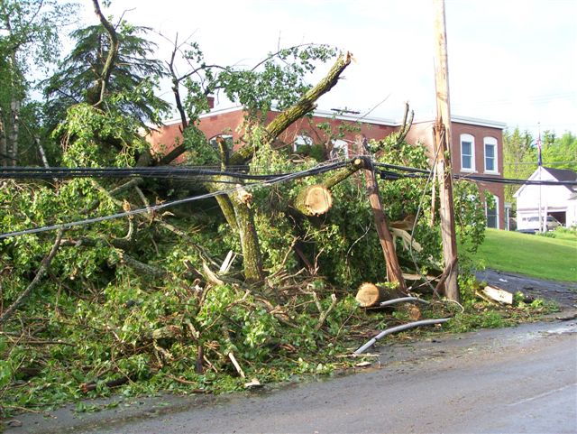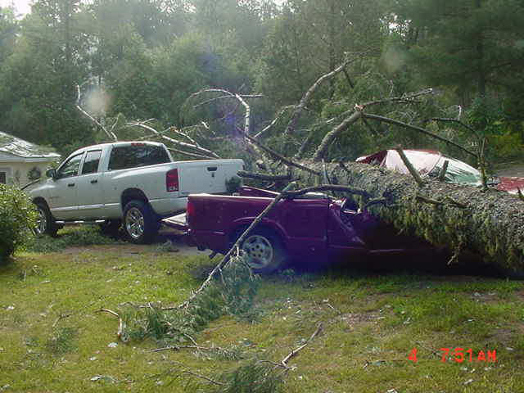
Microburst in Fort Kent – 2008 Photos courtesy of John Bannen

Aroostook County is subject to summer storms. During summer months, southwest to southerly winds become quite prevalent. When severe summer storms arrive, high winds can fell trees and branches onto power lines, causing power and communication outages. Large hail can damage structures, vehicles and crops. Heavy rains that often accompany thunderstorms can result in flash flooding or erosion. Lightning strikes can start fires. Any of these weather events can cause personal injury or property damage.

The impact of summer storms in Aroostook County is usually restricted to flooding and erosion caused by the large amounts of moisture these storms can carry, as well as downed power lines and tree branches.

Location of Severe Summer Storms. All of Aroostook County is vulnerable to one or more severe summer storms each year, usually in the form of thunderstorms. The following is a summary of areas that are susceptible to severe summer storms, as identified in the Aroostook County Hazard Mitigation Planning Municipal Survey 2015 and susequently modified in 2021 and 2026.

- Allagash: If we have strong winds, we can have trees fall on power lines in Pordash.
- Amity: There are areas of Estabrook Road that often have trees come down on the lines.
- Ashland: All areas of our community are susceptible to severe summer storms including power outages and debris removal. Areas along the Aroostook River would be susceptible to flash flooding.
- Blaine: All major areas on E Plantation Road and Kinney Road.
- Bridgewater: Flooding and debris Dead Brook bridge on Route 1 by fire station; Whitney Brook bridge on Route 1; Whitney Brook bridge on Tannary Street. Power outages throughout town for an extended period especially Wicklow senior housing complex. All areas of the community are vulnerable to high wind events with downed trees and power lines.
- Caribou: Unknown.
- Castle Hill: Portions of MacDonald Road and Richardson Road are heavily wooded areas that are problems during summer storms.
- Caswell: All of Caswell.
- Chapman: Grendell Road – debris washes down to catch basin, plugging the basin and flooding the road. Littlefield Road – culverts unable to handle extreme storms, local pests plugging culverts.
- Crystal: Severe summer storms usually lead to power outages, and create road closures due to debris or flash flooding. Lightning strikes can cause wildland and forest fires in remote areas. Crystal has an area known as Crystal Station on the southeast side of town, which can experience severe summer storms, but only very few residents are located in that area.
- Cyr Plantation: Madore Road.
- Dyer Brook: The Town Line and the Pond Road would have more potential for debris removal and flooding.
- Eagle Lake: We have had trees down on Sly Brook Road, erosion on Gilmore Brook Road, Makayka Drive.
- Easton: All areas of Easton can be affected. West Ridge Road frequently has field runoffs. The industrial area suffers in high winds.
- Fort Fairfield: Low lying areas and crop fields have suffered damage due to summer storms and heavy rain. Temporary flooding on the North Caribou Road has shut down the route during summer storm events. The Aroostook River is a common recreational area and has had to be evacuated previously due to severe lightning storms. Unfortunately, there is no standard way to warn users of the river before a pending storm. Part of our community center has a backup generator, where the new addition does not. The building serves as our emergency shelter.
- Fort Kent: The entire community is subject to severe summer storms, which can lead to increased flooding in low-lying areas, particularly near the S.W. Collins Lumberyard, the Blockhouse picnic area, and Riverside Park.
- Frenchville: Sections of Church Avenue are susceptible to spring runoff and severe summer storms. Sections of Pelletier and Starbarn Avenues are susceptible to flash flooding during extreme weather.
- Grand Isle: No major issues have been happening to local folks, just have to keep a close eye on snow melt and any major power concerns. Back-up generator is available if needed.
- Hamlin: Unknown.
- Haynesville: All dirt/gravel roads susceptible. Power outages expected during major storms. No known instances of debris removal or flash flooding.
- Hodgdon: Areas susceptible to downed trees and debris removal: Summer roads located on Westford Hill; Hillview Avenue, Horseback Road and South McIntyre Road.
- Houlton: Farmers’ crop fields typically suffer from severe summer storms and heavy rain. Calais Road to White Settlement Road, Hillview Avenue, B-Road, Ludlow Road areas are especially susceptible areas of Houlton.
- Houlton Band of Maliseet Indians: Summer storms are not a large concern other than typical basement floooding, or the occasional high winds causing roof damage.
- Island Falls: Severe summer storms usually lead to power outages, and create road closures due to debris or flash flooding. Lightning strikes can cause wildland and forest fires in remote areas.
- Limestone: No areas that would be abnormal in the case of a severe event beyond what would ordinarily be expected from low lying areas or those areas impacted by high wind events.
- Linneus: All areas of the town. Power outages from downed trees on power lines; high wind and heavy rain in combination or by themselves. Flash flooding along roads and cross culverts. Tree and branch removal from power lines and roads during and after a storm. Repair of road surfaces.
- Littleton: None.
- Ludlow: Western side of town.
- Madawaska: The areas of Morneault Road and Lavertu Road, are more remote areas that we typically see power outages.
- Mapleton:
Creasey Ridge – flash flooding washing the road out.
Hughes Road – flash flood washing out nearby fields, plugging ditches and culverts, washing out road.
Griffin Ridge – pond and brook crossing.
- Mars Hill: There are areas, mostly located in the rural parts of town that can be susceptible to flash flooding, particularly in the watersheds draining from Mars Hill Mountain. Other hazards include downed trees, primarily along the Mountain Road.
- Mi’kmaq Nation: All Tribal locations are susceptible.
- Monticello: The town does ditching, brush cutting and culvert cleaning for storm water runoff dependiong on type of storm does not work. The cost of maintaining our town has more than tripled. We have an aging population on fixed income, a huge amount of tax exempt properties creating a tax burden, increase in county tax and education budgets have made it difficult to increase the town budget. Road repairs are made in small increments, trying to maintain what roads are good, if any left over then work is done on the most needed.
- Nashville: None.
- New Canada: The entire community is vulnerable to severe summer storms.
- New Limerick: None.
- New Sweden: Bondeson Road and Hedmen Road.
- Orient: Most of the town. We are very rural and wooded.
- Perham: None.
- Portage Lake: All areas of town are vulnerable to falling trees/branches. Flash flooding could occur anywhere along the lakeshore or river, especially where springs or streams empty into them. As with winter storms, power outages could be localized due to the presence of several pole-mounted transformers.
- Presque Isle: All of the community is suscceptible to power outages, and storm, however downed trees or debris would mostly occur outside the urban compact zone.
- Sherman: N/A
- St. Agatha: We see this more along the water. Cleveland Road and the Island.
- St. Francis: On occasion, summer storms affect an area known as Sunset Drive due to its hilly terrain. Occasionally, flash flooding occurs on a few intermittent streams which connect to one brook that crosses Sunset Drive. Debris sometimes clogs three-foot culverts. Last occurrence was October, 2019.
- St. John Plantation: All areas.
- Stockholm: Power outages in the area.
- Unorganized Territory: County-wide in the Unorganized Territory.
- Van Buren: Our entire community is susceptible to severe summer storms. High winds and downed trees in a storm can cause outages throughout the municipality. Flash flooding primarily on Violette Stream could cause high risk for those who live along its pathway.
- Wade: The Town of Wade does not really have too much worry for summer flooding. Power outages happen town-wide when they occur.
- Wallagrass: The areas of town outlined for general flooding also present issues during summer storms. Soldier Pond lies in a valley, therefore, all the water runoff created by any storm, ends up in Soldier Pond area.
- Washburn: Any areas with heavy tree coverage. There is always the issue of falling trees in these locations.
- Westfield: None.
- Westmanland: Downed trees and power ines have the potential to isolate most of our residents.
- Weston: Power outages and debris (trees) removal town wide but may impact private roads more.
- Winterville Plantation: Red River Road brook areas; Pinette Brook has caused road and culvert damage due to micro bursts; Also Birch Road, Goss Brook.
- Woodland: Areas on Margeson Road, Brown Road.
- Caribou Utilities District: Power supply issues.
- Presque Isle Utilities District: Extended power loss. Extensive electrical interference can adversely impact electronics used to operate the water and wastewater plants.

Extent. The most damaging types of summer storms in Aroostook County are F1 tornados and microbursts with winds in excess of 100 miles per hour, and thunderstorms of more than an inch of rain per hour that can wash out roads and result in flash flooding.

Previous Occurrences. A summary of recent damaging summer thunderstorms and tornadoes can be found in the table below:

Historical Summary of Major Summer Storms in Aroostook County

Year | Month | Day | Estimated Damage | Type of Damage | Declaration
2016 | Aug | 11 | $1.0 M | Large hail | n/a
2018 | Aug | 5 | Unknown | EF1 tornado | n/a
2020 | Sep | 9 | Unknown | Severe thunderstorm, winds | n/a
2023 | Sept | 14-15 | Unknown | Hurricane (statewide) | EM 3598

Probability of Occurrence

There are no probability studies available of summer storms; however, based on past experiences, the county can expect thunder, thunderstorms and lightning every year. Therefore, the probability of thunderstorms is 100% every year.

Based on the last 75 years of past occurrences, there is a high probability that Maine can expect at least one hurricane or major tropical storm per decade to track over the state. The probability of a major tropical storm is therefore 10% in any given year. This could change depending on such factors rising global temperatures, warming oceans and jet stream movements. The locations where such storms are the most intense will vary from year to year. The most severe forms of summer storms, hurricanes and tornadoes, occur very infrequently (a non-zero percent chance) in Aroostook County.

Climate change projections indicate a growing prevalence of warm, moist air conducive to thunderstorm activity in Maine. The occurrence of thunderstorms in Maine is therefore expected to increase through the next five years and through future plan updates, although we do not know for sure.

Predicting whether climate change will have an effect on the frequency and power of tornadoes is a challenge. The brief, highly localized damage caused by tornadoes is challenging to capture in broad scale climate projection models. Scientists therefore instead focus on how climate change might affect the individual weather “ingredients” that support the development of supercell thunderstorms (the type that produce tornadoes), including the co-occurrence of warm, moist air; an unstable atmosphere; and sufficient wind shear.
Wildfire

Definition: A Wildfire is an unplanned fire that burns vegetative cover such as grass, timber, blueberry crops or slash. Wildfire is a natural phenomenon initially finding its origin in lightning. However, humans have become the greatest cause of wildfire in Aroostook County. There are two types of wildfires:
- Wildland fires are defined as those fires that burn vegetative cover: grass, brush, timber, blueberry barrens or slash.

- Wildland urban interface (WUI) fires are created where homes or other structures meet with highly volatile forest fuels.

Wildfire can have an impact on flooding, primarily by denuding the landscape which, in turn can lead to erosion and sedimentation. Sedimentation of streams and rivers can block the natural flow of water, resulting in flooding. In 2006, erosion and sedimentation from a logging operation caused minor flooding in Frenchville.

Aroostook County is subject to wildfires. A wildfire in October, 1825, burned 3,000,000 acres in Maine and New Brunswick, Canada. A severe wildland fire occurred in October of 1947. This fire burned 205,678 acres statewide and caused 16 deaths.

Several demographic factors make Aroostook County’s rural areas vulnerable to the threat of wildfires. Out-migration from rural areas often leaves an older, more vulnerable population and shrinking tax bases to fund local, usually volunteer fire departments. In Aroostook County, as in all of New England, the housing stock is also aging. When old farm homes and wood frame buildings are located in remote areas, it can be very challenging for volunteer fire fighters to respond before the structures are destroyed.

Location of Wildfire Hazard.

Although wildfires are a common occurrence in Maine, the state has a low risk for large, damaging wildfires due to its temperate climate, strong preparedness and response capabilities at the local, county and state levels, and a growing interest in wildfire mitigation actions.

All parts of the county are subject to wildfire/wildland fires. However the Unorganized Territory has the least accessibility to emergency services due to the lack of proper roads.

The most common causes of wildfire are man-made due to debris burning, machine uses, campfires, arson and smoking. The Maine Forest Service has made great strides in educating the public, through the internet and media outlets, on the dangers of wildland fires and mitigation activities.

Location of Wildfire Impact areas. The following is a summary of areas that could be susceptible to wildfires, as identified in the Aroostook County Hazard Mitigation Planning Municipal Survey 2015 and susequently modified in 2021 and 2026.

- Allagash: We are located in a wooded area, therefore we are susceptible to forest fires.
- Amity: Paricularly the private roads like Williams, Emily Miller Road as there are less people to notice if a brush fire gets out of hand.
- Ashland: Areas that are located along heavily wooded areas and fields that abut heavily wooded areas are most susceptible to wildfires/forest fires.
- Blaine: All roads have homes that would be vulnerable.
- Bridgewater: Several properties throughout the commuinity are very susceptible to fire spread as there has been a lot of logging in the recent past causing a massive amount of slash adding to the risk and spread of fire.
- Caribou: Unknown.
- Castle Hill: Several Properties are located in the wildland urban interface.
- Caswell: Willard Road.
- Chapman:
Chapman Road- Forest area on State land.
West Chapman Road – Forest area owned by logging companies and highly utilized trail systems, and camp owners.
Alder Lake – Private road, by camp owners living in the fortested area.
- Crystal: Crystal is a rural community with mostly wooded with large fields. Most of the town would be susceptible to wildland and forest fires. Homes that are located close to those areas could become affected. Most brooks, streams and rivers are low in the summer months making water supply and access difficult for fire suppression.
- Cyr Plantation: Omer Dumond Road.
- Dyer Brook: We have a lot of wooded area common and undivided with Irving; therefore we would be susceptible to wildfires/forest fires.
- Eagle Lake: Large wooded areas along most town roads.
- Easton: All of Easton. There are many wildland places and fields of grass.
- Fort Fairfield: The majority of Fort Fairfield is farm and woodland. Fires have caused damage to crops and forested areas in the past.
- Fort Kent: Certain homes located along North and South Perley Brook, as well as those near the upper portions of First, Second and Third Avenue, are situated within forested areas and could be considered susceptible to potential wildfire risk.
- Frenchville: While any forested areas in our community could be considered susceptible to wildfires/forest fires, I am unaware of any specific area.
- Grand Isle: Very limited concerns for the local community, just a close eye is kept on any minor concerns.
- Hamlin: Forested areas.
- Haynesville: All forested areas (80%).
- Hodgdon: Camps located on lower end of South Town Line Road by the State of Maine game reserve and a subdivision located off Skedgell Road.
- Houlton: Houlton consists of, predominantley, potatoes and vegetable farm and woodland. In the past, fires have caused major damage to crops and the woodland/forested areas of Houlton.
- Houlton Band of Maliseet Indians: The residential area near Clover Circle is in an agricultural community. During periods of drought, the fine fuels associated with hay and grain fields can be of concern.
- Island Falls: Island Falls is a rural community with mostly wooded land and large fields. Most of the town would be susceptible to wildland and forest fires. Homes that are located close to those areas could become affected. Most brooks, streams and rivers are low in the summer months making the water supply and access difficult for fire supression.
- Limestone: None of note.
- Linneus: Area south of the South Oakfield Road and the Hodgdon Mills Road; also the Northwest quarter of the town, west of the New Limerick Road. These areas are more heavily covered with unbroken forest.
- Littleton: None.
- Ludlow: North edge of town.
- Madawaska: Outside of downtown, we have rural areas that could be susceptible to wildfires.
- Mapleton: Hanson Lake area – Bagley Road, Flagstone Ridge Road, Creasey Ridge Road; Moose Ridge subdivision off of the State Road (wooded area around development).
- Mars Hill: Although we have wooded areas throughout the community, the residential areas on the eastern slopes of Mars Hill Mountain could be adversely impacted by wildfire.
- Masardis: Any wooded area.
- Mi’kmaq Nation: All Tribal locations are susceptible.
- Monticello: We have 2,640 acres in tree growth and quite a few that are not. We also have open fields that are used rotation.
- Nashville: None.
- New Canada: The Sly Brook area of New Canada would be most susceptible.
- New Limerick: Areas around the lakes and most areas in town – very rural and a lot of trees.
- New Sweden: None.
- Orient: Most of the town. We are very rural and wooded.
- Perham: Salmon Lake Bog.
- Portage Lake: All areas of our community are susceptible to wildfires/forest fires.
- Presque Isle: Echo Lake area, East on Route 10, Cleaves Road, Conant Road are heaviest forest areas.
- Reed Plantation: The entire town is rural in nature and thus susceptible to wildfire and forest fires.
- St. Agatha: NA.
- St. Francis: 90% of the structures on the south side of Route 161 are built close to the tree line which is mostly softwood stands of either mature or natural softwood regeneration. Some properties may have hayfields or tall grass between the structure and the tree line which are susceptible to wildfire in the forest in the high risk months.
- St. John Plantation: All areas.
- Sherman: N/A
- Stockholm: No areas susceptible to wildfires.
- Unorganized Territory: Northwestern Aroostook County Unorganized Territory (North Maine Woods).
- Van Buren: Not a common issue but the community is certainly vulnerable in the event of a wildfire.
- Wade: The Town of Wade sits on the outer edge of the North Maine Woods. We have several thousand acres of woods. The threat of wildfire is great for this town. These would be on the ends of the North Wade Road, Howe Road, New Dunntown Road, Gardner Creek Road, South Wade Road and Haynes Road.
- Wallagrass: Wallagrass does have many camps and year-round homes along the lake and river which present a challenge in providing adequate fire protection. These areas are densely wooded and the population is increasing, specifically during the higher fire danger seasons, Spring and Fall.
- Washburn: Any areas that have any large amounts of trees. Not too much in the Town of Washburn.
- Westfield: All lands in western half of town.
- Westmanland: Wildland fires are a big concern in our area due to most structures in our area being very close to woodland.
- Weston: The entire town is a rural wildland interface area. The most susceptible would be those in lake neighborhoods where the buildings are more surrounded by forested areas. Several large tracts of forest have public access via logging roads and ATV trails.
- Winterville Plantation: The Winterville woodlot. 11,000 acres of working forest. The plantation relies on the woodlot income for taxes.
- Woodland: Route 228, Woodland Center Road.
- Caribou Utilities District: No known impact.
- Presque Isle Utilities District: None known.

Extent

The entire county remains at risk for wildfires. Well-distributed rainfall normally reduces forest fire risks, but seasonal variations, rapidly draining soils and unusually dry periods can induce major blazes. In addition, insect damage diseases, severe weather, and residential and commercial developments in wooded areas greatly increase the potential for catastrophic fires. Over time, a considerable fuel supply can accumulate from the ignitable slash of some timber harvesting operations and/or from dead trees left standing on the forest floor after insect infestations. With an increase in drought conditions, wildfires could originate anywhere.

There was a major wildfire in Aroostook County in May 1992 that burned 1,150 acres. There were six separate wildfires in Aroostook County in October of 1994 which burned a total of 225 acres, but there have been no major wildfires (over 1,000 acres) since then. The most severe forest fire in the State of Maine’s recent history was in October, 1947, devastating 205,687 acres and causing 16 deaths. However, most of the damages were confined to Cumberland, Hancock, Oxford and York Counties.

With 17.52 million acres of forestland covering 90 percent of the State of Maine, the entire state remains at risk for wildfires. With an increase in drought and other extreme conditions driven by climate change and seen across the state, wildland fires could originate anywhere, potentially placing a large burden on the state’s limited resources. While historically major wildfires have correlated more with a higher number of acres burned, wildfire trends now reflect a higher number of smaller, more destructive fires due to an increase of people living in the wildland-urban interface.

The Maine Forest Service (MFS) provides wildfire protection services for all Maine’s forest lands. In the Unorganized Territory, MFS is the only fire suppression entity and is often requested to respond to structure and vehicle fires as well as wildland fires. The goals of the MFS are to keep the number of forest fire starts to less than 1,000 and annual acreage loss to less than 3,500. The MFS has met these goals in recent years because of:
- Quick and effective initial attack on all fires;
- Effective air detection and aerial suppression;
- Modern forest firefighting equipment;
- Strong emphasis on fire prevention, including state control of statewide burning permits;
- Aggressive training and preparation;
- Improved access to remote areas of the state;
- Northeast Forest Fire Compact membership, providing resources during periods of high fire danger;
- Proactive public information campaigns;
- Law enforcement; and
- Extensive automated weather stations providing accurate daily information used to assist in planning fire operations.
In addition to the above initiatives, the MFS has launched a community assessment program aimed at focusing its fire prevention efforts on geographical areas of the state with high concentrations of wildfires. The assessment involves working with local officials and the public to identify vulnerable homes in the wildland/urban interface. The MFS then prepares a community wildfire protection plan that contains guidelines that homeowners can use to protect their homes. The emphasis is on maintaining a 30-foot defensible space around the homes.

Previous Occurrences. Historically, forest fires were one of the State’s most significant hazards. Maine averages about 700 low acreage forest fires annually. However, in 2020, the Maine Forest Service responded to 800 fires, affecting close to 900 acres, as of July 25, 2020. The increase in the number of fires is due to widespread drought conditions. Today, about 90% of all forest fires are caused by human activity, while 10% are caused by lightning. During dry periods, fire danger increases rapidly. The following table summarizes the most significant wildfires that have occurred in Aroostook County.

Historical Summary of Major Wildfires in Aroostook County
Year | Month | Day | Estimated  Damage | Acreage | Declaration
1992 | May | 19 | Aroostook - Allagash | 1,150 | no

The May 1992 wildfire burned 1,150 acres near the Town of Allagash and St. Francis, requiring evacuation of 400 people and construction of a fire lane in an effort to protect the communities.

Based on information obtained from the Maine Forest Service, there have been no major fires in Aroostook County in recent years. All of the wildfires known to have occurred were confined to relatively small land areas.

Probability of Occurrence

The probability of a major wildfire is 10% in any given year, or once every 10 years, as calculated by the Maine Forest Service. There is insufficient climate change data to revise this probability. It is expected that low acreage wildland fire events will cause damages in Aroostook County several times each year. However, they do not rise to the level of the 1947 fire as there have been considerable mitigation efforts through suppression and training. Aroostook County has an active countywide fire fighters’ association, automatic mutual aid, up-to-date fire-fighting resources and communication systems in place. The Maine Forest Service has made contributions in public education.

The MFS anticipates that, based on historical records of fires, there will be an average of 550 low acreage fires in Maine from all causes. A low acreage fire is less than 1,000 acres. While the probability of a major wildfire, based on the last 115 years of wildfire data, is once a decade, it is currently unclear as to how changing climate conditions may either contribute to or inhibit future wildfire events. Most wildfires, however, are likely to occur between the months of April and October.

The landscape of wildfire control in Maine is rapidly changing on several fronts. These changes are presenting very significant challenges to the Forest Protection Division of the Maine Forest Service, as well as to Maine’s rural municipal fire services. Changes in the ownership and timber management practices of Maine’s commercial timber land base are presenting new challenges for the state’s wildfire control program. Additionally, climate change, reductions in the forest ranger force and a reduced number of available firefighters are all concerning when considering the wildfire hazards for Maine.

Drought

Although Maine is considered a “wet” state, drought conditions can occur about every decade. During late summer to early fall, these conditions can also lead to a very high forest fire threat.

“Drought is the number one risk factor for the state’s agricultural economy which provides over $1.2 billion of food and fiber products annually. It employs 22,000 workers across the state, supports 5,500 families and provides stewardship of over 1.5 million acres of land and wildlife habitat. Since about 45% of the state’s population relies on dug or shallow wells, a prolonged drought increases the risk of wells going dry.” (Maine Emergency Management Agency)

In 2020, Aroostook County experienced severe drought conditions that began in the spring and extended into October when rainfall was sufficient to bring the county close to coming out of drought status. Impacts throughout the county included private wells going dry, public water systems strained, and crop yields diminished. The Maine Department of Environmental Protection reported that water levels in many streams, rivers, lakes, ponds and wetlands were below the summer season August median since early June. In September, the U.S. Department of Agriculture designated Aroostook County as a drought disaster area, making farm operators in Aroostook and its four contiguous counties eligible for assistance from the Farm Service Agency.

General Definition. Drought is a prolonged period of below-average precipitation in a given region, resulting in prolonged shortages in its water supply.

Nature of Hazard. Drought is a normal recurring feature in all of Maine’s climatic regions. While all droughts originate with a deficiency of precipitation, drought is a unique hazard due to the usually slow progression of the phenomenon. Drought impacts respond to precipitation anomalies on varied timescales. This makes it difficult to determine a clear beginning or end to any drought event, particularly ones that are prolonged. The duration of drought can vary from several weeks to several years.

Location of Drought Hazard. Due to the fact that drought classification is relative to average local precipitation, surface and ground water levels, the entire county is susceptible to drought. Most of Aroostook County was affected by severe drought conditions in 2020.

- Amity: Most of Amity is wetland or swamp, unless we have a real dry year.
- Bridgewater: The farming community in our area is very susceptible to a drought as there are few bodies of water that will allow for extended irrigation operations, thereby jeopardizing the local food chain.
- Caribou: In the areas outside the urban compact zone, citizens rely on wells which can be an issue during droughts.
- Chapman: Alder Lake.
- Crystal: All of Crystal’s residents rely on drilled/dug wells for water supply.
- Dyer Brook: With a drought, everyone would be susceptible to their wells going dry as we don’t have city water.
- Eagle Lake: Outside the hydrant district.
- Easton: Easton does not have a public water facility so all private wells are susceptible. Also farm crop losses and erosion Also increases wildland fire risk exponentially.
- Frenchville: Agricultural land as a whole could be considered susceptible to drought.
- Fort Fairfield: Areas of the community that are not in the water district have experienced dry wells due to drought. Crop fields have suffered damage due to water restrictions.
- Fort Kent: Periods of drought, such as wells running dry in certain areas, have occurred but have not been severe enough to create disaster conditions. However, these conditions can increase the risk of wildfires.
- Grand Isle: No major issues for the local community.
- Hamlin: Croplands.
- Haynesville: Unknown.
- Hodgdon: The triangle (center of town) Calais Road to Hodgdon Mills Road to Corner Road to Calais Road.
- Houlton: The parts of the Houlton community not served by Houlton Water Company (not a municipal department) are the most susceptible to drought. Crops have suffered damage due to the drought conditions severely affecting crop yields.
- Houlton Band of Maliseet Indians: homes and buildings in the Tribal community are often surrounded by agricultural crops or grassland. When droughts occur, grass fires can be of great concern.
- Island Falls: The town itself has a water department – surrounding residences rely on drilled/dug wells for water supply.
- Limestone: High farm plateau areas with high drainage capability that require farmers to move water to these areas during drought conditions.
- Linneus: All areas of town. Those most vulnerable are the properties that rely on shallow wells, or surface springs for water supply. Fire-fighting capability is also impacted, as the Fire Department relies on a ready supply of surface water to effectively fight any fire.
- Littleton: None.
- Madawaska: This year 2025, Maine was in the worst drought ever. A lot of wells were drying up. Fire dangers were high. Lakes and rivers were very low. This affected a lot of people in rural areas outside of town.
- Mapleton: Mill Pond – town’s water supply with pump station (need to monitor farmers in the summer with irrigation on fields).
- Mars Hill: We have several large areas of agricultural land, primarily to the north of town which are dependent upon sufficient rainfall for potato/broccoli/grain crops.
- Mi’kmaq Nation: The Tribe’s Farm had issues last year with drought conditions and it provides a substantial amount of food for the community.
- Monticello: Most of area is agricultural – irrigation for crops. Town wide – rely on private wells. Fire suppression – dry hydrants.
- New Canada: Periods of drought, such as wells running dry in certain areas, have occurred but have not been severe enough to create disaster conditions.
- New Limerick: Everyone.
- Perham: None.
- Portage Lake: All areas of our community are susceptible to drought, as all wells are personally owned. There is no town reservoir tank.
- Presque Isle: City water supply is on aqua wells across the river, severe drought could impact city water supply. Same concern for outside the urban compact zone home private wells could be affected.
- Sherman: N/A
- St. Agatha: NA.
- St. John Plantation: All areas.
- Stockholm: No droughts in the area that we know of.
- Unorganized Territory: County-wide in the Unorganized Territory.
- Van Buren: Not a common issue. Those outlying areas which do not benefit from municipal water supplies (i.e. house wells).
- Wade: Town-wide.
- Wallagrass: Wallagrass has the potential for drought, however, has never seen any issues surrounding drought events.
- Washburn: Town-wide.
- Westfield: Entire town.
- Westmanland: All areas in our community are susceptible to drought as evidenced in 2020.
- Weston: The majority of the dwellings with wells have drilled ones. The couple of dozen “dug” wells have experienced very low or no water in the past.
- Winterville Plantation: Private wells for residents.
- Woodland: Evidenced by 2020 drought.
- Caribou Utilities District: Decreased pumping capacity in public water system well field.
- Presque Isle Utilities District: Drought conditions can put water supply resources at risk of being depleted.

Extent. The extent of drought can vary significantly from localized events in a specific watershed to a statewide occurrence, from short term (one summer) to long germ duration (several years), or from an abnormally dry spell to a drought of exceptional intensity.

Maine uses the U.S. Drought Monitor’s (USDM) classification method to measure the extent of drought events as they occur. A partial summary of USDM’s classification system is shown in the following table.

USDM Drought Classification System (partial criteria)
Category and Description | Possible Impacts
DO  Abnormally Dry | Short term dryness – slowing planting growth of crops or pastures
D1  Moderate Drought | Some damage to crops, pastures; Streams, reservoirs, or wells low, some water shortages developing or imminent
D2  Severe Drought | Crop/pasture losses likely, water shortages common
D3  Extreme Drought | Major crop/pasture losses, widespread water shortages
D4  Exceptional Drought | Exceptional and widespread crop/pasture losses, shortage of water creating emergencies

Previous Occurrences. Maine’s 1992-2002 drought period was very damaging. There were an estimated 17,000 private wells that ran dry in the nine months leading to April 2002, and farmers lost more than $32 million in crop yields between 2001 and 2002.

The 2016 drought was a result of three (3) years of below average precipitation which led to low ground water levels statewide, but particularly in the southern portion of Maine. The severe drought of 2020 may have exceeded conditions in prior drought years. Maine’s Drought Task Force convened, actively monitored and reported on the droughts of 2016 and 2020.

Chronology of Major Droughts in Maine
Date | Affected  Areas | Remarks
1938-1943 | Western Areas | Severe in Androscoggin and Kennebec River Basins
1947-1950 | Statewide | Severe in central coastal region
1955-1957 | Nearly entire state | Severe in northern and eastern parts of state
1963-1969 | Statewide | Longest endured drought, stream flows in southern portions of Maine reached 100 year lows
1984-1988 | Statewide | Severe in Northern Maine
1999-2002 | Statewide | 2001 was driest year on record (to date) August 2002 was driest month on record
2015-2016 | Statewide | Most severe in York and parts of Cumberland Counties
2020 | Statewide | Severe drought conditions in Aroostook County
Source: Maine Emergency Management Agency

Probability of Occurrence. Similar to floods, which are driven primarily by precipitation, meteorologists and hydrologists define the extent of drought by probability of occurrence. While there are widely accepted occurrence levels for flooding, there is not extensive historical data for drought events. Most USGS ground water monitoring stations in Maine have been installed within the past 40 years.

Furthermore, it is difficult to determine probability of occurrence for future drought events because the global hydrological cycle is exhibiting significant variability, especially in the geographic distribution and intensity of precipitation, the availability of water resources and prolonged periods of drought. There is considerable uncertainty whether drought will become more frequent in the future, presenting challenges for mitigation strategies. However, there is a concern that drought may become a more prominent event in the future.

B1-f. Hazard Risk Differences Between Jurisdictions

The following is a summary of the jurisdictions subject to the five hazards profiled in this plan. Detailed information for each jurisdiction, where applicable, is contained in the profile for each of the hazards (under location).

Jurisdiction | Flooding | Winter Storms | Summer Storms | Wildfire | Drought
Allagash | X | X | X | X
Amity | X | X | X | X
Ashland | X | X | X | X
Blaine | X | X | X | X
Bridgewater | X | X | X | X | X
Caribou | X | X | X |  | X
Cary Plantation
Castle Hill | X | X | X | X
Caswell
Chapman | X | X | X | X
Crystal | X | X | X | X | X
Cyr Plantation | X | X | X | X
Dyer Brook |  | X | X | X | X
Eagle Lake | X | X | X | X | X
Easton | X | X | X | X | X
Fort Fairfield | X | X | X | X | X
Fort Kent | X | X | X | X | X
Frenchville
Garfield Plantation
Glenwood Plantation
Grand Isle | X | X |  | X
Hamlin | X | X | X
Hammond
Haynesville
Hersey
Hodgdon | X |  | X | X | X
Houlton | X | X | X | X | X
Houlton Band of Maliseet  Indians | X | X | X | X | X
Island Falls | X | X | X | X
Limestone | X | X | X | X
Linneus | X | X | X | X | X
Littleton | X
Ludlow | X | X | X | X
Macwahoc Plantation
Madawaska | X | X | X | X | X
Mapleton | X |  |  | X | X
Mars Hill | X | X | X | X | X
Masardis
Merrill
Mi’kmaq Nation | X | X | X | X | X
Monticello | X | X | X | X | X
Moro Plantation
Nashville Plantation
New Canada | X | X | X | X | X
New Limerick |  |  |  | X | X
New Sweden | X |  | X
Oakfield
Orient | X | X | X | X
Oxbow Plantation
Perham | X | X | X | X | X
Portage Lake | X | X | X | X
Presque Isle | X | X | X | X | X
Reed Plantation | X | X |  | X
Saint Agatha | X | X | X | X
Saint Francis | X |  | X | X
Saint John Plantation | X | X | X | X | X
Sherman | X
Smyrna
Stockholm | X | X | X
Van Buren | X | X
Wade | X | X |  |  | X
Wallagrass | X | X | X |  | X
Washburn | X | X | X |  | X
Westfield | X | X |  |  | X
Westmanland | X | X | X |  | X
Weston |  | X | X |  | X
Winterville Plantation | X | X | X
Woodland
Unorganized | X | X | X | X | X

B2. Assessing Vulnerability and Impacts

Does the plan include a summary of the jurisdiction’s vulnerability and the impacts on the community from the identified hazards? Does this summary also address NFIP structures that have been repetitively damaged by floods? (Requirement 44 CFR §201.6(c)(2)(ii)

B2-a. Vulnerability. The plan must describe the vulnerability of each participant to the identified hazards. The description must include current and future assets (including people) and the risk that makes them susceptible to damage from the identified hazards.

Vulnerability of Aroostook County to Each hazard

- Flooding. Some of the county’s most serious flooding has been in areas where there are residential and/or commercial structures including along the Aroostook River and St. John River. With the exception of the aforementioned areas, most of the developed areas in Aroostook County are located outside of designated flood plains, and are thus not very vulnerable to flooding. On the other hand, much of the county is very rural in nature, and is served by a network of rural roads that do not have proper storm drainage systems. These roads are very vulnerable to flooding caused by heavy downpours and/or the blockage of drainage systems by ice or debris, even though these roads may not be in an identified flood plain. Some of the county’s worst flooding has occurred along the following rivers and in the following communities:

- Aroostook River: Masardis, Washburn, Fort Fairfield
- St. John River: 9 Mile Bridge, Dickey, Fort Kent
- St. Francis River: Connors
- Fish River: Fort Kent
- Allagash River: Allagash
- Severe Winter storms. Aroostook County’s location in Northern New England places it in a high-risk area for winter storms. While the majority of winter storms in Aroostook County occur during the winter season of December through March, there are occasional winter storms in the late fall (November and early December) and in the spring (March – April). However, the severity of storms is typically most serious in January and February, with storms in the earlier and later parts of the seasons usually being of lesser magnitudes.

The time of day at which storms occur is also important, as overnight storms allow for the closure of schools, and businesses, whereas storms during the day force people to travel home during storm conditions. Based on past experience, storms are most likely to occur overnight or during the morning, but afternoon storms are still somewhat likely.

A major blizzard of the severity that occurred in 1998 would impact nearly all of Aroostook County and threaten the overhead electric and telephone lines. Roads may be closed due to washouts and debris in roads from trees and utility lines.

As noted earlier in this Assessment, Aroostook County has been included in a number of Presidential Disaster Declarations for winter storms. Aroostook County contains at-risk populations that could be impacted by a major winter storm.

- Severe Summer Storms. The entire county is vulnerable to thunderstorms, microbursts, and high winds. During the summer months, southwest to southerly winds are prevalent in the county. Severe high winds generally fell trees and branches onto power lines, causing power and communication outages. Heavy rains usually result in flash flooding or erosion. As previously noted, there have been more occurrences of severe summer storms in recent years.

- Wildfires. The western part of Aroostook County is heavily forested, and could be vulnerable to forest fires. However, all of the organized municipalities in Aroostook County are served by capable fire departments. The Maine Forest Service has been very active in forest fire prevention activities, and, through meetings convened by the Aroostook County Emergency Management Agency, meets periodically with municipal fire chiefs on matters related to wildfire prevention and response activities.

The western part of Aroostook County consists of large forests with no homes. Well-distributed rainfall normally reduces forest fire risks, but seasonal variations, rapidly draining soils and unusually dry periods can induce major blazes. In addition, insect damage (such as the hemlock woolly adelgid and spruce budworm) diseases, severe weather, and residential and commercial developments in wooded areas can greatly increase the potential for catastrophic fires. Over time, a considerable fuel supply can accumulate from the ignitable slash of some logging operations and/or from dead trees left standing on the forest floor after insect infestations.

- Drought. The entire county is vulnerable to drought. During summer months, below average precipitation can lead to declining water levels in rivers, streams, lakes, ponds and wetlands, as well as declining ground water levels.

Impacts of Each Hazard on Aroostook County

- Flooding. In addition to damages to residential and commercial structures in some locations, the typical damages resulting from flooding in Aroostook County include damages to roads and their respective drainage systems. Historically, flood damages have included partial or complete road washouts, as well as severe erosion of roadside ditches, resulting in hazards to motorists if their vehicles go off the road. In some cases, entire communities have been partly or completely isolated because the only road serving the town has been damaged by floods.

- Severe Winter Storms. The impacts of severe winter storms include road closures (and the subsequent inability of emergency vehicles to provide help), the loss of power for extended periods of time, high costs to local governments for snow removal efforts, and loss of income to businesses and individuals due to business closures. Roof collapses, both residential and commercial, are rare but they can occur when snow loads become extreme.

The snow pack makes an important contribution to both surface and groundwater supplies, and years with a low snow pack can lead to water shortages by late summer. Melting of the snow pack in March and April is usually gradual enough to prevent serious flooding. However, in Aroostook County, when melting snows combine with rainstorms, the volume of water can overwhelm watersheds, ditches and culverts, leading to road and property damages. Such was the case in 2008, when major flooding resulted in Disaster Declaration DR-1755.

- Severe Summer Storms. The damages from summer storms typically involve the washout of roads, downed utility lines and debris clearance. If severe enough, this could result in the loss of income to businesses and individuals due to business closures.

- Wildfires. The primary impacts include damages to homes located in the wildland-urban interface and loss of valuable timberland. A larger percentage of homes in rural towns are located in the wildland-urban interface than homes in village areas. The western part of the county includes vast tracts of forestland that could be damaged by wildfires.

- Drought. The primary impacts include damages to crop yields, private wells running dry, public water supplies running low and/or experiencing water quality problems, and forested areas of the county threatened by wildfires.

General Summary of the Hazards

Flooding: local roads, ditches and culverts, road closures due to flooding, housing and businesses located on lands subject to flooding, properties and structures, located along rivers, streams and ponds and downstream of high hazard and significant hazard dams, and elderly people who may become isolated due to flooding of roads.

Winter storms: ice jams and frozen culverts resulting in flooding of roads, homes and businesses, power outages impacting everyone but especially the elderly, road closures due to blowing and drifting snow resulting of isolating people including the elderly. Winter storm damages can include burst water pipes during power outages, interior water damages due to ice dams forming on roofs, and occasionally, roof collapses due to heavy snow loads.

Summer storms: roads blocked due to storm debris resulting in isolating people including the elderly, power outages, flooding of roads, lightning strikes resulting in wildfires, property damage and crop failures due to hail.

Wildfires: homes, camps and businesses located in forested areas, crops, roads located in remote wooded areas that could become dangerous during a wildfire.

Drought: Wooded areas and fields more susceptible to wildfire, crop damages, people who rely on dug or drilled wells for their water supply.

Vulnerability of Existing People, Structures, Infrastructure, and Critical facilities

Note: A critical facility is defined as a facility in either the public or private sector that provides essential products and services to the general public, is otherwise necessary to preserve the welfare and quality of life in Aroostook County, or fulfills important public safety, emergency response, and/or disaster recovery functions. The critical facilities in Aroostook County are municipal offices, fire, police stations, town garages, hospitals and clinics, water and waste water treatment facilities, and hazardous material sites.

Flooding
- People. People living in flood plains are vulnerable to flooding, as are people travelling on flooded roads.
- Structures. Some of the county’s most serious flooding has been in areas where there are residential and/or commercial structures.
- Infrastructure. Roads and their associated storm drainage systems are the most vulnerable category of infrastructure. Much of the county is very rural in nature, and is served by a network of rural roads that do not have proper storm drainage systems. These roads are very vulnerable to flooding caused by heavy downpours and/or the blockage of drainage systems by ice or debris.
- Critical facilities. Due to the varied topography within the county and the availability of higher elevation sites within all municipalities, nearly all critical facility structures are located outside of floodplains. Possible exceptions include some wastewater treatment plants, due to the need to locate these facilities at lower elevations.

Severe Winter Storms.
- People. People living in older homes are vulnerable to damages caused by winter storms, as are people travelling during winter storms.
- Structures. All structures in Aroostook County are vulnerable to winter storms. Damages can include burst water pipes during power outages, interior water damages due to ice dams forming on roofs, and occasionally, roof collapses due to heavy snow loads.
- Infrastructure. Roads and their associated storm drainage systems are the most vulnerable category of infrastructure. They can become temporarily blocked due to heavy snow falling over a short period of time, or ice which can build on their surfaces. Water main breaks due to cold weather can also occur. Roads and their storm drainage systems can become blocked due to heavy snow and ice and debris such as tree limbs.
- Critical facilities. All critical facilities in Aroostook County are vulnerable to winter storms in the same manner that individual buildings are vulnerable. However, some of the critical facilities throughout the county have back-up generator systems which allow heating systems to continue operating during a power outage.

Severe Summer Storms.
- People. People in their homes are vulnerable to damages caused by severe summer storms, as are people working outside or travelling on the county’s roads.
- Structures. All structures in Aroostook County are vulnerable to summer storms. Damages can include debris like tree limbs; and from high winds, and interior water damages due to wind- driven heavy rain.
- Infrastructure. Roads and their associated storm drainage systems are the most vulnerable category of infrastructure. They can become temporarily blocked due to heavy rain and debris over a short period.
- Critical facilities. All critical facilities in Aroostook County are vulnerable to summer storms in the same manner that individual buildings are vulnerable. However, some of the critical facilities throughout the county have back-up generator systems, which allow building systems to continue operating during a power outage.

Wildfires
- People. People living in remote wooded areas are subject to wildfires
- Structures. Structures located in the wildland/urban interface are vulnerable to wildfires. Damages can include fire, smoke and water from fire-fighting efforts.
- Infrastructure. Power, phone and cable lines can be damaged during a wildfire. Roads and their storm drainage systems are much less vulnerable, although road access to certain areas can be blocked by fires and by emergency fire-fighting vehicles.
- Critical facilities. Wildfires in Aroostook County have tended to be relatively small, and have not been a threat to critical facilities. In the event of a very large wildfire, some critical facilities could be damaged by fire and smoke.

Drought
- People. People on dug or drilled wells can be subject to wells running dry during a drought.
- Structures. Structures in Aroostook County are not directly vulnerable to droughts, but buildings in the wildland/urban interface are vulnerable to wildfires resulting from dry conditions.
- Infrastructure. Power, phone and cable lines are not directly vulnerable to droughts, but can be damaged by wildfires resulting from dry conditions. Roads and drainage system are much less vulnerable, although roads can be blocked by fires and emergency fire-fighting vehicles.
- Critical facilities. Critical facilities are not directly vulnerable to droughts, but any that are located in the wildland/urban interface may be vulnerable to wildfires resulting from dry conditions.

Vulnerability of Future Population, Structures, Infrastructure and Critical Facilities

There has been very little growth in Aroostook County in the last ten (10) years, and very little growth is expected during the next ten (10) years. Between 2010 and 2020, Aroostook County’s population declined from 71,870 to 67,105, a loss of 4,765 people or 7%. The Office of the State Economist released population projections in for the state and its counties in April, 2025. These projections included a population estimate for Aroostook County of 67,322 people in 2022, And projections of 67,300 in 2027 and 66,774 in 2032. Based on these negative growth projections, it is likely that there will be very few if any future population, structures, infrastructure or critical facilities that will be vulnerable to the identified hazards.

Flooding:

- People. Given the population decline projected for Aroostook County, it is unlikely that the county’s population will be any more likely to be vulnerable to floods beyond the vulnerabilities that already exist.
- Structures. The municipalities in Aroostook County that are in the flood insurance program all have municipal shoreland zoning ordinances that generally prohibit the construction of residential, commercial and industrial structures in floodplains. Unlike other parts of the country, Maine does not experience the cycle of widespread flooding devastation in its floodplains, followed by intensive development pressures and subsequent rebuilding. Very little, if any growth is expected. Therefore, flooding of future buildings is not likely to be a serious flooding issue in Aroostook County.
- Infrastructure. Future roads and their associated storm drainage systems would seem to be the most likely category of infrastructure that would be vulnerable to flooding. However, State and local road construction standards generally ensure that new roads are properly constructed with adequate storm drainage systems. Most if not all roads in the public domain must be designed by a registered professional engineer. Therefore, flooding of future roads is not likely to be a serious issue in Aroostook County.
- Critical facilities. Because of the requirements of the Flood Insurance Program, as well as shoreland zoning requirements and a greater awareness of flooding in all communities, future critical facilities will continue to be located outside floodplain areas. The exception may be wastewater treatment plants, due to the need to locate these facilities at lower elevations.

Severe Winter storms

- People. Given the population decline projected for Aroostook County, it is unlikely that the county’s population will be any more likely to be vulnerable to winter storms beyond the vulnerabilities that already exist.
- Structures. New structures in Aroostook County will be less vulnerable to winter storms. Damages may include burst water pipes, but many newer buildings will be better insulated than older ones, thus being better able to retain heat during longer periods of time when there is a power outage. There will be less interior water damage due to ice dams forming on roofs because the roofs of newer buildings generally are properly vented, which allows the roofs to remain cold. Roof collapses due to heavy snow loads will be very rare because newer roofs are designed to withstand heavy snow loads.
- Infrastructure. Roads will continue to be the most vulnerable category of infrastructure. New roads can be just as easily blocked on a temporary basis due to heavy snowfall, ice building up on the road surface, and debris such as tree limbs accumulating on the road surface during a storm event. Blizzard conditions and whiteouts caused numerous road closures and multi-vehicle pile-ups and accidents, hampering First Responder efforts due to the severity of winds and snow throughout the county. It is unlikely that Aroostook County will experience much new road construction, with the possible exception of small road segments serving subdivisions.
- Critical facilities. Future critical facilities in Aroostook County will be vulnerable to winter storms in the same manner that individual buildings will be vulnerable. However, some of them will have back-up generator systems which will allow heating systems to continue operating during a power outage.

Severe Summer Storms

- People. Given the population decline projected for Aroostook County, it is unlikely that the county’s population will be any more likely to be vulnerable to severe summer storms beyond the vulnerabilities that already exist.
- Structures. New structures in Aroostook County will be less vulnerable to summer storms. There may be damage to roofs, windows, and electrical during a severe summer storm. However, new roofs are designed to withstand high winds and heavy rain.
- Infrastructure. Roads will continue to be the most vulnerable category of infrastructure. New roads can be just as easily blocked on a temporary basis due to heavy rainfall, water building up on the road surface, and debris such as tree limbs accumulating on the road surface during a summer storm event. However, it is unlikely that Aroostook County will experience much new road construction, with the possible exception of small road segments serving subdivisions.
- Critical facilities. Future critical facilities in Aroostook County will be vulnerable to summer storms in the same manner that individual buildings will be vulnerable.

Wildfires

- People. Given the population decline projected for Aroostook County, it is unlikely that the county’s population will be any more likely to be vulnerable to wildfires beyond the vulnerabilities that already exist.
- Structures. New structures located in the wildland/urban interface may be vulnerable to wildfires. Damages can include fire, smoke and water from fire-fighting efforts. However, given the very low growth rate projected for Aroostook County, there will not be many new buildings located in the wildland/urban interface.
- Infrastructure. Future power, phone and cable lines can be damaged during a wildfire, although the level of future development is expected to be minimal, primarily because of the very low growth rate projected for the county.
- Critical facilities. Future critical facilities may be vulnerable to a very large wildfire. However, the expectation is that there will be very few new critical facilities constructed during the life of this plan.

Drought
- People. Given the population decline projected for Aroostook County, it is unlikely that the county’s population will be any more likely to be vulnerable to droughts beyond the vulnerabilities that already exist.
- Structures. New structures in Aroostook County may not be directly vulnerable to droughts, but if located in the wildland/urban interface, may be vulnerable to wildfires resulting from dry conditions.
- Infrastructure. Future power, phone and cable lines may not be directly vulnerable to droughts, but if located in the wildland/urban interface, might be damaged by wildfires resulting from dry conditions. Future roads and drainage systems are much less vulnerable, although roads can be blocked by fires and emergency fire-fighting vehicles.
- Critical facilities. Future critical facilities may not be directly vulnerable to droughts, but any that are located in the wildland/urban interface may be vulnerable to wildfires resulting from dry conditions.

B2-b. Impacts. The plan must describe the potential impacts on each participating jurisdiction and its identified assets.

Assessing Impacts: Estimating Potential Losses

This section of the plan relies on historical damages as the basis for estimating future losses.

    - Historical damage estimates have been updated, using the Consumer Price Index shown below.
    - Presidential Disaster Declarations have been used where possible, updated for inflation using the Consumer Price Index.
    - Where statewide or county damages are used to determine damages for a specific jurisdiction, the damages are pro-rated using the 2020 Census.

The average annual Consumer Price Index for various years is shown below based on a value of 100 for the years 1982 – 1984.

Consumer Price Index
1982-1984 = 100
1947 = 22.3 | 1995 = 152.4 | 2011 = 224.9
1980 = 82.4 | 1996 = 156.9 | 2012 = 229.6
1981 = 90.9 | 1997 = 160.5 | 2013 = 233.0
1982 = 96.5 | 1998 = 163.0 | 2014 = 236.7
1983 = 99.6 | 1999 = 166.6 | 2015 = 237.0
1984 = 103.9 | 2000 = 172.2 | 2016 = 240.0
1985 = 107.6 | 2001 = 177.1 | 2017 = 245.1
1986 = 109.6 | 2002 = 179.9 | 2018 = 251.1
1987 = 113.6 | 2003 = 184.0 | 2019 = 255.7
1988 = 118.3 | 2004 = 188.9 | 2020 = 258.8
1989 = 124.0 | 2005 = 195.3 | 2021 = 271.0
1990 = 130.7 | 2006 = 201.6 | 2022 = 292.7
1991 = 136.2 | 2007 = 207.3 | 2023 = 304.7
1992 = 140.3 | 2008 = 215.3 | 2024 = 313.7
1993 = 144.5 | 2009 = 214.5 | 2025 = 321.9
1994 = 148.2 | 2010 = 218.1
Source: Federal Reserve Bank of Minneapolis

Potential Flood Losses

Worst-case, real-life damages were used to calculate potential flooding damages, and it was assumed that historic patterns will hold for the future. For Aroostook County, the worst recorded flooding was the Fort Fairfield flood of April 15, 1994, which resulted in flood damages amounting to $5,700,000.

Using the Consumer Price Index, the damages in 2025 dollars would be $12,380,800 ($5,700,000 x 321.9, the CPI for 2025, divided by 148.2, the CPI for 1994). Fort Fairfield’s 2020 population was 3,322, which is a per capita flood loss of $3,727.

The following table includes a town-by-town estimate of potential flooding damages based on the 2020 Census and a per capita damage figure of $3,727.

Potential Flood Losses in Aroostook County
Town/City | Year Round  Population In 2020 | Potential Flood Losses (population x $3,727)
Allagash | 237 | $883,297
Amity | 253 | $942,931
Ashland | 1,202 | $4,479,854
Blaine | 667 | $2,485,909
Bridgewater | 532 | $1,982,764
Caribou | 7,396 | $27,564,892
Castle Hill | 373 | $1,390,171
Caswell | 293 | $1,092,011
Chapman | 491 | $1,829957
Crystal | 248 | $924,296
Cyr Plantation | 78 | $290,706
Dyer Brook | 215 | $801,305
Eagle Lake | 772 | $2,877,244
Easton | 1,320 | $4,919,640
Fort Fairfield | 3,322 | $12,381,094
Fort Kent | 4,067 | $15,157,709
Frenchville | 1,052 | $3,920,804
Garfield Plantation | 79 | $294,433
Glenwood Plantation | 5 | $18,635
Grand Isle | 366 | $1,364,082
Hamlin | 166 | $618,682
Hammond | 91 | $339,157
Haynesville | 97 | $361,519
Hersey | 73 | $272,071
Hodgdon | 1,290 | $4,807,830
Houlton | 6,055 | $22,566,985
Island Falls | 758 | $2,825,066
Limestone | 1,526 | $5,687,402
Linneus | 947 | $3,529,469
Littleton | 997 | $3,715,819
Ludlow | 434 | $1,617,518
Macwahoc Plantation | 62 | $231,074
Madawaska | 3,867 | $14,412,309
Mapleton | 1,886 | $7,029,122
Mars Hill | 1,360 | $5,068,720
Masardis | 204 | $760,308
Merrill | 208 | $775,216
Monticello | 737 | $2,746,799
Moro Plantation | 44 | $163,988
Nashville Plantation | 27 | $100,629
New Canada | 310 | $1,155,370
New Limerick | 574 | $2,139,298
New Sweden | 577 | $2,150,479
Oakfield | 621 | $2,314,467
Orient | 156 | $581,412
Perham | 371 | $1,382,717
Portage Lake | 359 | $1,337,993
Presque Isle | 8,797 | $32,786,419
Reed Plantation | 129 | $480,783
Saint Agatha | 730 | $2,720,710
Saint Francis | 438 | $1,632,426
Saint John Plantation | 263 | $980,201
Sherman | 815 | $3,037,505
Smyrna | 439 | $1,636,153
Stockholm | 250 | $931,750
Van Buren | 2,038 | $7,595,626
Wade | 229 | $853,483
Wallagrass | 519 | $1,934,313
Washburn | 1,527 | $5,691,129
Westfield | 455 | $1,695,785
Westmanland | 79 | $294,433
Weston | 245 | $913,115
Winterville Plantation | 194 | $723,038
Woodland | 1,217 | $4,535,759
Unorganized Territory | 1,976 | $7,364,552
TOTAL | 67,105 | $250,100,335
Source: U.S. Census

Potential Severe Winter Storm Losses

Worst-case, real-life damages were used to calculate potential winter storm damages. It was assumed that historic patterns would hold for the future. The ice storm of 1998, which resulted in a Presidential Disaster Declaration, was one of the worst such storms to affect the State of Maine. The Ice Storm of 1998 resulted in a total of $47,748,466 in damages to the state. The Disaster Declaration did not cover damages to power lines and private structures. Using the Consumer Price Index, the $47.7 million in the disaster declaration damages in 2025 dollars would be $94.2 million ($47.7 x 321.9, the Consumer Price Index for 2025 divided by 163.0, the CPI for 1998). The per capita cost of winter storm damages would be $69.1 The $69.1 figure is calculated by taking the 2020 population of the state’s 16 counties (1,362,359) and dividing it into the 1998 ice storm damages in 2025 dollars of $94.2 million.

The following table includes a town-by-town estimate of potential severe winter storm damages based on the 2020 Census and a per capita damage figure of $69.1.

Potential Severe Summer Storm Losses

Worst-case, real-life damages were used to calculate potential winter storm damages. It was assumed that historic patterns would hold for the future. The hail storm of August 11, 2016, was one of the worst such storms to affect Aroostook County. This storm resulted in estimated damages of $1.0 million although it did not result in a disaster declaration. The $1.0 million in damages would be $1.34 million in 2025 dollars ($1.0 million x 321.9, the consumer price index for 2025 divided by 240.0, the consumer price index for 2016). The per capita cost of a similar hailstone in Aroostook County would be $20 (Aroostook County’s 2020 population of 67,105 divided into the updated hailstorm cost of $1.34 million).

The following table includes a town-by-town estimate of potential severe summer storm damages based on the 2020 Census and a per capita damage figure of $20.

Potential Winter and Summer Storm Losses in Aroostook County
Town/City | Year Round  Population In 2020 | Potential Winter Storm Losses  (population x $69.1) | Potential Summer Storm Losses  (population x $20)
Allagash | 237 | $16,377 | $4,740
Amity | 253 | $17,482 | $5,060
Ashland | 1,202 | $83,058 | $24,040
Blaine | 667 | $46,090 | $13,340
Bridgewater | 532 | $36,761 | $10,640
Caribou | 7,396 | $511,064 | $147,920
Castle Hill | 373 | $25,774 | $7,460
Caswell | 293 | $20,246 | $5,860
Chapman | 491 | $33,928 | $9,820
Crystal | 248 | $17,137 | $4,960
Cyr Plantation | 78 | $5,390 | $1,560
Dyer Brook | 215 | $14,857 | $4,300
Eagle Lake | 772 | $53,345 | $15,440
Easton | 1,320 | $91,212 | $26,400
Fort Fairfield | 3,322 | $229,550 | $66,440
Fort Kent | 4,067 | $281,030 | $81,340
Frenchville | 1,052 | $72,693 | $21,040
Garfield Plantation | 79 | $5,459 | $1,580
Glenwood Plantation | 5 | $346 | $100
Grand Isle | 366 | $25,291 | $7,320
Hamlin | 166 | $11,471 | $3,320
Hammond | 91 | $6,288 | $1,820
Haynesville | 97 | $6,703 | $1,940
Hersey | 73 | $5,044 | $1,460
Hodgdon | 1,290 | $89,139 | $25,800
Houlton | 6,055 | $418,401 | $121,100
Island Falls | 758 | $52,378 | $15,160
Limestone | 1,526 | $105,447 | $30,520
Linneus | 947 | $65,438 | $18,940
Littleton | 997 | $68,893 | $19,940
Ludlow | 434 | $29,989 | $8,680
Macwahoc Plt. | 62 | $4,284 | $1,240
Madawaska | 3,867 | $267,210 | $77,340
Mapleton | 1,886 | $130,327 | $37,720
Mars Hill | 1,360 | $93,976 | $27,200
Masardis | 204 | $14,096 | $4,080
Merrill | 208 | $14,373 | $4,160
Monticello | 737 | $25,774 | $515,480
Moro Plantation | 44 | $3,040 | $880
Nashville Plantation | 27 | $1,866 | $540
New Canada | 310 | $21,421 | $6,200
New Limerick | 574 | $39,663 | $11,480
New Sweden | 577 | $39,871 | $11,540
Oakfield | 621 | $42,911 | $12,420
Orient | 156 | $10,780 | $3,120
Perham | 371 | $25,636 | $7,420
Portage Lake | 359 | $24,807 | $7,180
Presque Isle | 8,797 | $607,873 | $175,940
Reed Plantation | 129 | $8,914 | $2,580
Saint Agatha | 730 | $50,443 | $14,600
Saint Francis | 438 | $30,266 | $8,760
St. John Plantation | 263 | $18,173 | $5,260
Sherman | 815 | $56,317 | $16,300
Smyrna | 439 | $30,335 | $8,780
Stockholm | 250 | $17,275 | $5,000
Van Buren | 2,038 | $140,826 | $40,760
Wade | 229 | $15,824 | $4,580
Wallagrass | 519 | $35,863 | $10,380
Washburn | 1,527 | $105,516 | $30,540
Westfield | 455 | $31,441 | $9,100
Westmanland | 79 | $5,459 | $1,580
Weston | 245 | $16,93 | $4,900
Winterville Plt | 194 | $13,405 | $3,880
Woodland | 1,217 | $84,095 | $24,340
Unorganized Territory | 1,976 | $136,542 | $39,520
TOTAL | 67,105 | $4,636,956 | $1,342,100
Source: U.S. Census

Potential Wildfire Losses

This plan uses worst-case, real-life damages to calculate potential wildfire losses, and assumes that historic patterns will hold for the future. The 1947 fire was the worst on record, although it was actually a series of wildfires that flared over Eastern and Southern Maine. The 1947 fire caused an estimated $30,000,000 in damages to Cumberland, Hancock, Oxford and York Counties. The damage in 2025 dollars would be about $433 million (multiply $30 million by 321.9, which is the consumer price index for 2025, and divide by 22.3, which is the consumer price index for 1947). There is a non-zero probability that a wildfire such as the 1947 fire will hit Aroostook County during the five-year period covered by this plan.

The methodology for calculating potential wildfire losses in Aroostook County is based on the damages that occurred in the 1947 fire in Cumberland, Hancock, Oxford and York Counties. The 2020 population of the four counties is 628,296. Divide $433 million (the 1947 fire in 2025 dollars) by 628,296 to get a per capita cost of $689. Multiply Aroostook County’s 2020 population, 67,105, by $689 to get potential Aroostook County wildfire damages of $46,235,345.

Given the lack of a major wildfire (defined as 500 acres or larger) in Knox County over the past eight decades and the relatively low-density development in areas prone to wildfires, the real-life worst-case costs of wildfire damages for Knox County over the next five years would probably be lower.

The following table includes a town-by-town estimate of potential wildfire damages based on the 2020 Census and a per capita damage figure of $689.

Potential Wildfire Losses in Aroostook County
Town/City | Year Round  Population In 2020 | Potential Wildfire Losses (population x $689)
Allagash | 237 | $163,293
Amity | 253 | $174,317
Ashland | 1,202 | $828,178
Blaine | 667 | $459,563
Bridgewater | 532 | $366,548
Caribou | 7,396 | $5,095,844
Castle Hill | 373 | $256,997
Caswell | 293 | $201,877
Chapman | 491 | $338,299
Crystal | 248 | $170,872
Cyr Plantation | 78 | $53,742
Dyer Brook | 215 | $148,135
Eagle Lake | 772 | $531,908
Easton | 1,320 | $909,480
Fort Fairfield | 3,322 | $2,288,858
Fort Kent | 4,067 | $2,802,163
Frenchville | 1,052 | $724,828
Garfield Plantation | 79 | $54,431
Glenwood Plantation | 5 | $3,445
Grand Isle | 366 | $252,174
Hamlin | 166 | $114,374
Hammond | 91 | $62,699
Haynesville | 97 | $66,833
Hersey | 73 | $50,297
Hodgdon | 1,290 | $888,810
Houlton | 6,055 | $4,171,895
Island Falls | 758 | $522,262
Limestone | 1,526 | 1,051,414
Linneus | 947 | $652,483
Littleton | 997 | $686,933
Ludlow | 434 | $299,026
Macwahoc Plantation | 62 | $42,718
Madawaska | 3,867 | $2,664,363
Mapleton | 1,886 | $1,299,454
Mars Hill | 1,360 | $937,040
Masardis | 204 | $140,556
Merrill | 208 | $143,312
Monticello | 737 | $507,793
Moro Plantation | 44 | $30,316
Nashville Plantation | 27 | $18,603
New Canada | 310 | $213,590
New Limerick | 574 | $395,486
New Sweden | 577 | $397,553
Oakfield | 621 | $427,869
Orient | 156 | $107,484
Perham | 371 | $255,619
Portage Lake | 359 | $247,351
Presque Isle | 8,797 | $6,061,133
Reed Plantation | 129 | $88,881
Saint Agatha | 730 | $502,970
Saint Francis | 438 | $301,782
Saint John Plantation | 263 | $181,207
Sherman | 815 | $561,535
Smyrna | 439 | $302,471
Stockholm | 250 | $172,250
Van Buren | 2,038 | $1,404,182
Wade | 229 | $157,781
Wallagrass | 519 | $357,591
Washburn | 1,527 | $1,052,103
Westfield | 455 | $313,495
Westmanland | 79 | $54,431
Weston | 245 | $168,805
Winterville Plantation | 194 | $133,666
Woodland | 1,217 | $838,513
Unorganized Territory | 1,976 | $1,361,464
TOTAL | 67,105 | $46,235,345
Source: U.S. Census

Potential Drought Damages. The Aroostook County Hazard Mitigation Planning Team assumed that the primary damages to be expected in Aroostook County during a severe drought would be the loss of crops. While it might be expected that a drought would result in extensive wildfires with subsequent loss of structures, the actual wildfire experience during the severe drought of 2020 was a total of 100 wildfires which burned 428 acres; there were a total of nine structure fires, not necessarily related to drought conditions.

According to the 2022 Census of Agriculture prepared by the United States Department of Agriculture, National Agricultural Statistics Service, a total of 172,979 acres of cropland were harvested in Aroostook County, resulting in crop sales of $276,432,000 or $1,598 per acre. A drought that resulted in a total loss of crops would therefore cause a loss in sales of $276.4 million. Droughts resulting in less widespread loss of crops would result in smaller losses:

- 10% loss in crop sales: $27.64 million
- 25% loss in crop sales: $69.1 million
- 50% loss in crop sales: $138.2 million
- 75% loss in crop sales: $207.3 million.

B2-b. Repetitively flooded NFIP-insured structures. The plan must address repetitively flooded NFIP-insured structures by including the estimated numbers and types (residential, commercial, institutional, etc) of repetitive/severe repetitive loss properties.

Repetitive Loss Properties
Town/City | Residential Structures |  | Non-Residential  Structures
Town/City | #  Properties | #  Losses | # Properties | #  Losses
Eagle Lake | 2 | 4*
Easton | 1 | 1
Fort Fairfield | 0 | 0 | 2 | 7
Fort Kent | 3 |  | 1 | 4**
Island Falls | 1 | 2
Oakfield | 1 | 2
Sherman | 1 | 2
Wade | 1 | 2
Wallagrass | 1 | 2
*Includes 1 Severe Repetitive Loss (SLR)
**includes total of 4 properties with 14 losses including 1 SRL
Source: NFIP Program 2/17/2026

Aroostook County Flood Insurance Info as of 2/17/2026
Number of Policies: 104
Total Premium $111,967

Total Building Coverage: $16,213,000
Total Contents Coverage: $3,746,000
Total Coverage: $19,959,000

Claims since 1978: 382
Total Building Claims: $3,788,939
Total Contents Claims: $1,038,680
Total Claims: $4,827,619

Community Rating System (CRS)

